**Database Design and Implementation**

**MOD002589**





**Element 010**

Portfolio Preparation

**Module Leader:** Arooj Fatima

**Module Tutor:** XXXXX

**Course of Studies:** Computer Science

Table of Contents

Introduction 1

Report Outline 1

Resources used 1

1. Requirement Analysis 2

1.1 Websites description 2

***1.1.1 www.zalando.co.uk*** 2

***1.1.2 www.asos.co.uk*** 2

***1.1.3 www.yoox.co.uk*** 2

1.2 List of data fields 3

***1.2.1 Data – fields from Zalando*** 4

***1.2.2 Data – fields from ASOS*** 10

***1.2.3 Data – fields from Yoox*** 17

1.3 Finalised List 23

***1.3.1 The generic list*** 23

***1.3.2 Attributes rejected*** 24

***1.3.3 Attributes added*** 24

2. Database Design 25

2.1 Entity Relationship Modelling 25

**2.1.1 Initial Entity Relationship Model** 25

**2.1.2 Extended Entity Relationship Model** 26

2.2 Normalised Model 28

2.3 Database Schema 30

***2.3.1 Payment Table*** 30

***2.3.2 Customer Table*** 30

**2.3.3 Address Table** 31

**2.3.4 City Table** 31

**2.3.5 Country Table** 31

**2.3.6 Order Table** 32

**2.3.7 Shipper Table** 32

**2.3.8 Voucher Table** 32

**2.3.9 Voucher_Used Table** 33

**2.3.10 Shopping_Bag Table** 33

**2.3.11 Article Table** 33

**2.3.12 Photo Table** 34

**2.3.13 Colour Table** 34

**2.3.14 Brand Table** 34

**2.3.15 Category Table** 34

**2.3.16 Fashion_Department Table** 34

3. Database Implementation 35

3.1 Tables with Data 36

3.2 Create Table Statements 41

4. SQL Queries 52

4.1 Query 1 52

4.1.1 Business Purpose of this Query 52

4.1.2 Query in natural language 52

4.1.3 SQL and output 52

4.1.4 Explanation of the query output 52

4.2 Query 2 53

**4.2.1 Business Purpose of this Query** 53

**4.2.2 Query in natural language** 53

**4.2.3 SQL and output** 53

**4.2.4 Explanation of the query output** 53

4.3 Query 3 54

**4.3.1 Business Purpose of this Query** 54

**4.3.2 Query in natural language** 54

**4.3.3 SQL and output** 54

4.3.4 Explanation of the query output 54

4.4 Query 4 55

**4.4.1 Business Purpose of this Query** 55

**4.4.2 Query in natural language** 55

**4.4.3 SQL and output** 55

**4.4.4 Explanation of the query output** 55

4.5 Query 5 56

**4.5.1 Business Purpose of this Query** 56

**4.5.2 Query in natural language** 56

**4.5.3 SQL and output** 56

**4.5.4 Explanation of the query output** 57

Conclusion 58

References 59

Table of Figures

Figure 1: Customer Account Page – Your details section 6

Figure 2: Customer Account Page – Your brands section 6

Figure 3: Customer Account Page – Your addresses section 6

Figure 4: Article Page 1 7

Figure 5: Article Page 2 7

Figure 6: Brand List 8

Figure 7: Four-Hierarchical Layer Category 8

Figure 8: Shopping Bag Page / Checkout 9

Figure 9: Payment Details Page 9

Figure 10: Customer Page - My Details 12

Figure 11: Customer Page - Address book 12

Figure 12: Customer Page - Payment Methods 13

Figure 13: Article Page 13

Figure 14: Brand Page 14

Figure 15: Category Page 14

Figure 16: Shopping Bag - Checkout 15

Figure 17: Order -1 15

Figure 18: Order -2 16

Figure 19: Customer Page – Details 18

Figure 20: Customer Page – Address 19

Figure 21: Customer Page – Card Details 19

Figure 22: Article Page 20

Figure 23: Brand Page 20

Figure 24: Category Page 21

Figure 25: Shopping Bag / Order Page -1 21

Figure 26: Shopping Bag / Order Page -2 22

Figure 27: Initial Entity Relationship Diagram 25

Figure 28: Extended Entity Relationship Diagram 27

Figure 29: Normalised Extended Entity Relationship Diagram 29

Figure 30: eCommerce Database's Tables 35

Figure 31: Address Table 36

Figure 32: Article Table 36

Figure 33: City Table 37 Figure 34: Category Table 37

Figure 35: Brand Table 37 Figure 36: Colour Table 37

Figure 37: Country Table 37 Figure 38: Fashion_Department Table 37

Figure 39: Customer Table 38

Figure 40: Order Table 38

Figure 41: Payment Table 38

Figure 42: Photo Table 39

Figure 43: Shipper Table 39

Figure 44: Shopping_Bag Table 39

Figure 45: Voucher Table 40

Figure 46: Voucher_Used Table 40

Figure 47: Details of the implementation of Address Table. 41

Figure 48: Details of the implementation of Article Table. 41

Figure 49: Details of the implementation of Brand Table. 42

Figure 50: Details of the implementation of Category Table. 42

Figure 51: Details of the implementation of City Table. 43

Figure 52: Details of the implementation of Colour Table. 43

Figure 53: Details of the implementation of Country Table. 44

Figure 54: Details of the implementation of Customer Table. 44

Figure 55: Details of the implementation of Order Table. 45

Figure 56: Details of the implementation of Fashion_Department Table. 46

Figure 57: Details of the implementation of Payment Table. 46

Figure 58: Details of the implementation of Photo Table. 47

Figure 59: Details of the implementation of Shipper Table. 47

Figure 60: Details of the implementation of Shopping_Bag Table. 47

Figure 61: Details of the implementation of Voucher Table. 48

Figure 62: Details of the implementation of Voucher_Used Table. 48

Figure 63: Details of the indexes. 49

Figure 64: Details of the indexes. 50

Figure 65: Details of auto increment. 50

Figure 66: Details of the constraints. 51

Figure 67: Details of the constraints. 51

Figure 68: Query 1 SQL Code 52 Figure 69: Query 1 Output 52

Figure 70: Query 2 SQL Code 53 Figure 71: Query 2 Output 53

Figure 72: Query 3 SQL Code 54 Figure 73: Query 3 Output 54

Figure 74: Query 4 SQL Code 55

Figure 75: Query 4 Output 55

Figure 76: Query 5 SQL Code 56

Figure 77: Query 5 Output 56

Figure 78: Query 5 Output proof 57

# Introduction

## Report Outline

The following report shows the steps performed in order to construct and to test a small commercial database.

Following the Database Development Lifecycle, the report is composed by 4 main sections:

1. **Requirement Analysis:** Three eCommerce websites are analysed and their entities and attributes are collected in a generic list.
2. **Modelling and Design:** The generic list extracted from the Requirement Analysis is expanded, resulting in an Entity Relationship Diagram, which serves to the creation of a Table Schema
3. **Implementation:** The database is implemented on phpMyAdmin and the steps are recorded and evidenced using screenshots.
4. **Evaluation:** The final database is tested using 5 different SQL business queries.

## Resources used

* MacBook Pro 2016 running macOS 10.15 Catalina;
* Apple Safari web browser, version 14.0 (15610.1.28.1.9, 15610);
* Microsoft Word, version 2016 for Mac;
* Microsoft Excel, version 2016 for Mac;
* Draw.io, diagramming website, version 13.9.5;
* phpMyAdmin, database server, 5.0.4;
* 10.4.14-MariaDB – Source Distribution.

# 1. Requirement Analysis

## 1.1 Websites description

The websites analysed in this section, offer an online purchasing facility. In more details, they sell different clothing products allowing the users to:

* create their own customer account;
* to browse the product categories and the brands;
* to add an item into the shopping bag;
* to place an order.

### ***1.1.1 www.zalando.co.uk***

*Zalando* is an e-Commerce company founded in Germany in 2008, which offers a wide range of fashion and lifestyle products (Forbes, 2020). It is the 15th in its category rank attracting more than 24 million visits in the last 6 months (SimilarWeb, 2020).

### ***1.1.2 www.asos.co.uk***

*ASOS* is an online commercial store founded in the United Kingdom in 2000, which offers branded and own label products including women and men’s wear, footwear and accessories (Forbes, 2020).

In 2019, it had more than 14 million active customers becoming one of the leading stores in the world and among the top five in the UK (Tubga Sabanoglu, 2020).

### ***1.1.3 www.yoox.co.uk***

*Yoox* is an Italian fashion store which provides more than 100 countries with its services. Founded in 2000 by Federico Marchetti, Yoox grew rapidly listing 13.5 billion in 2013 (Martin Luenendonk, 2016).

## 1.2 List of data fields

In the following section, three different lists of attributes are presented. This information is respectively extracted from Zalando, ASOS and Yoox’s websites performing several actions such as:

* Login/Registration on the website;
* Searching an article by both categories and Brands;
* Adding an article to the shopping bag;
* Simulating the checkout.

Some of the attributes are gathered by looking at the data fields filled by the customer, the information displayed browsing on the website and the various radio buttons and tick boxes.

Since these websites aim at selling the same kind of items, their structure is pretty much similar. Therefore, the most important entities are organised in a spreadsheet and their attributes are listed accordingly.

To improve the readability, the lists are colour coded:

1. **Dark Blue** represents the *Customer entity*;
2. **Green** represents the *Article entity*;
3. **Red** represents the *Brand entity*;
4. **Yellow** represents the *Category entity*;
5. **Purple** represents the *Shopping Bag entity*;
6. **Blue Sky** represents the *Payment entity*;
7. **Orange** represents the *Order entity*;

### ***1.2.1 Data – fields from Zalando***

**LIST OF DATA-FIELDS**

Table 1: General Data - Fields from Zalando

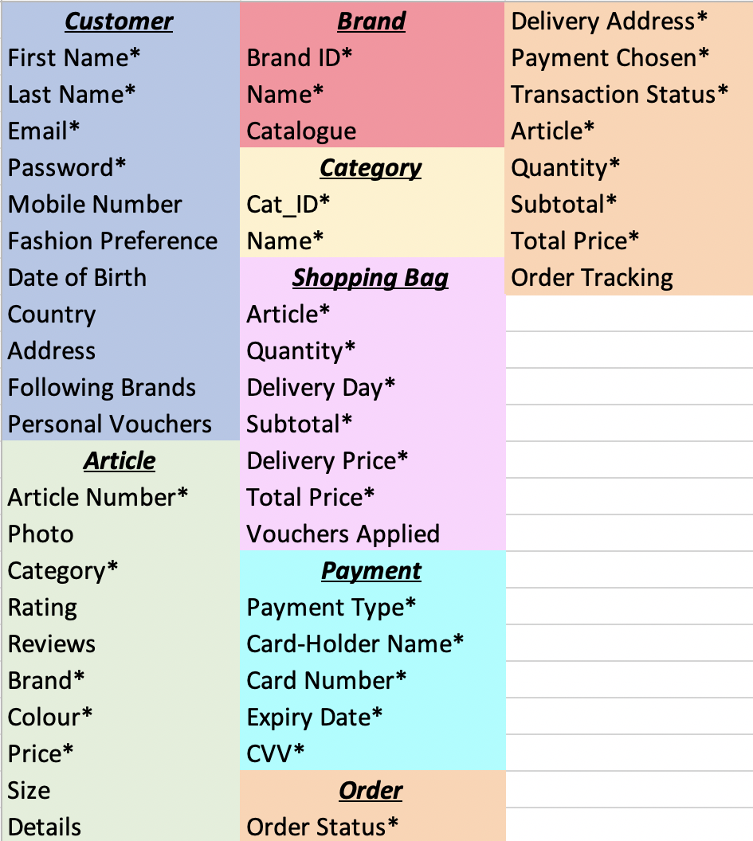

Table 2: Composite attributes

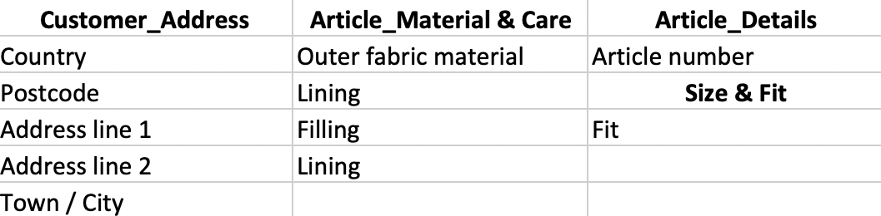

**DESCRIPTION**

Some of the attributes presented in the list are marked with asterisk (*), which means that they cannot be left blank because compulsory fields.

There are three types of data-fields:

* ***user input fields*** such as the Customer’s first name, email and Password;
* ***calculated fields*** such as the Order’s total price and delivery time;
* ***pre-stored fields***such as the Category ID and the Article Number.

Additionally, some ***input fields***, like the “Article Size”, have pre-defined options that can be easily selected by clicking on either tick boxes or radio buttons.

To keep the table clean and easy to read, ***composite attributes*** such as “Address” and “Article are defined in the Table 2.

Some extra features like the Zalando styles, which stores models’ outfits are omitted since they uniquely regard Zalando and they give a level of complexity which is beyond the scope of the following report.

Another extra feature is the complexity of the categories showed in Figure 7. They are segmented in a four-hierarchical layer model (e.g. Man > Clothing > Jackets > Winter Jackets).

**CUSTOMER - Screenshots**

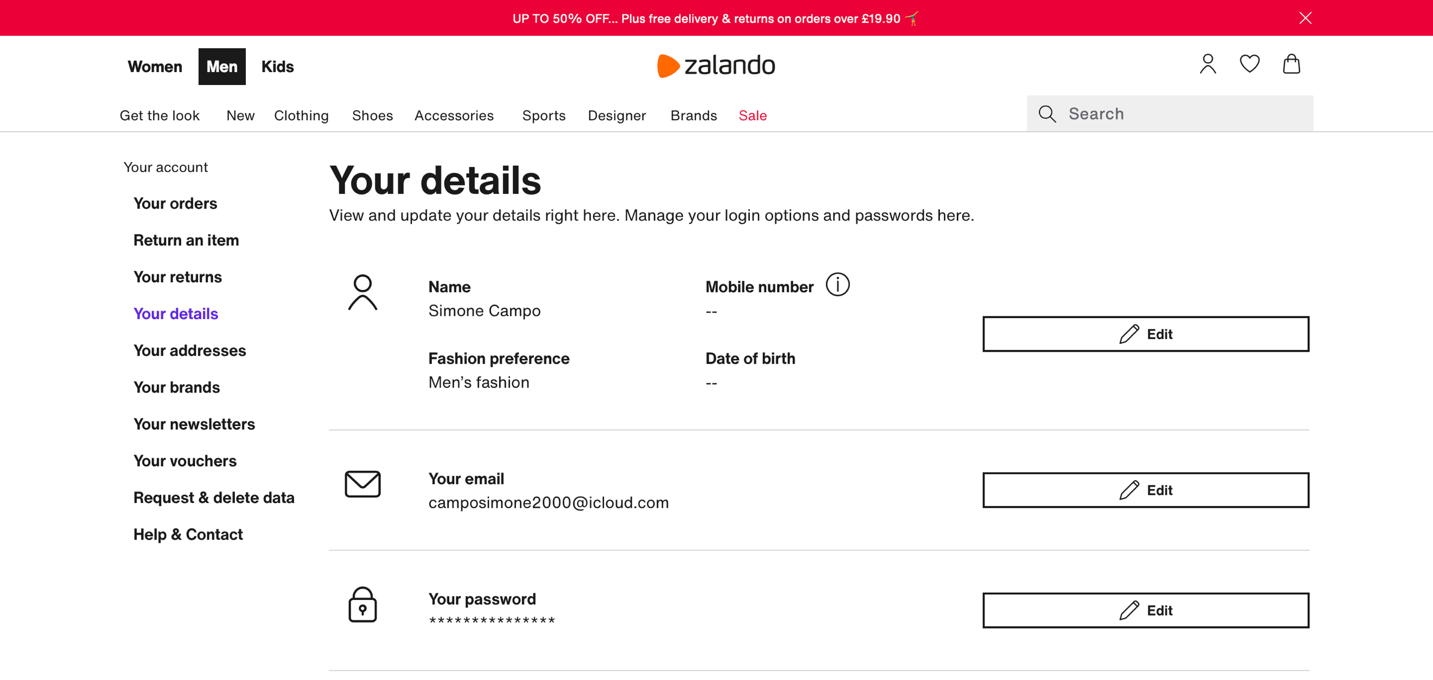

Figure 1: Customer Account Page – Your details section

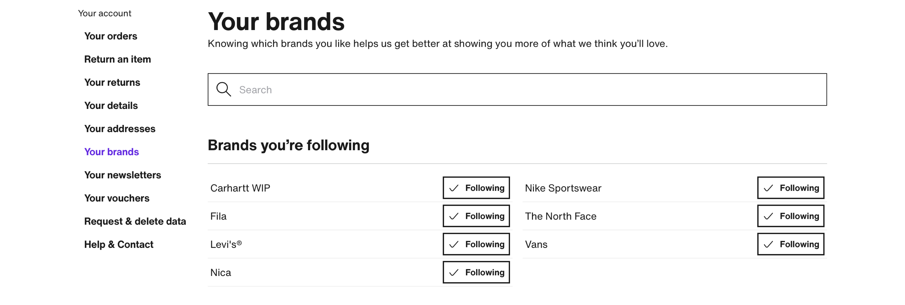

Figure 2: Customer Account Page – Your brands section

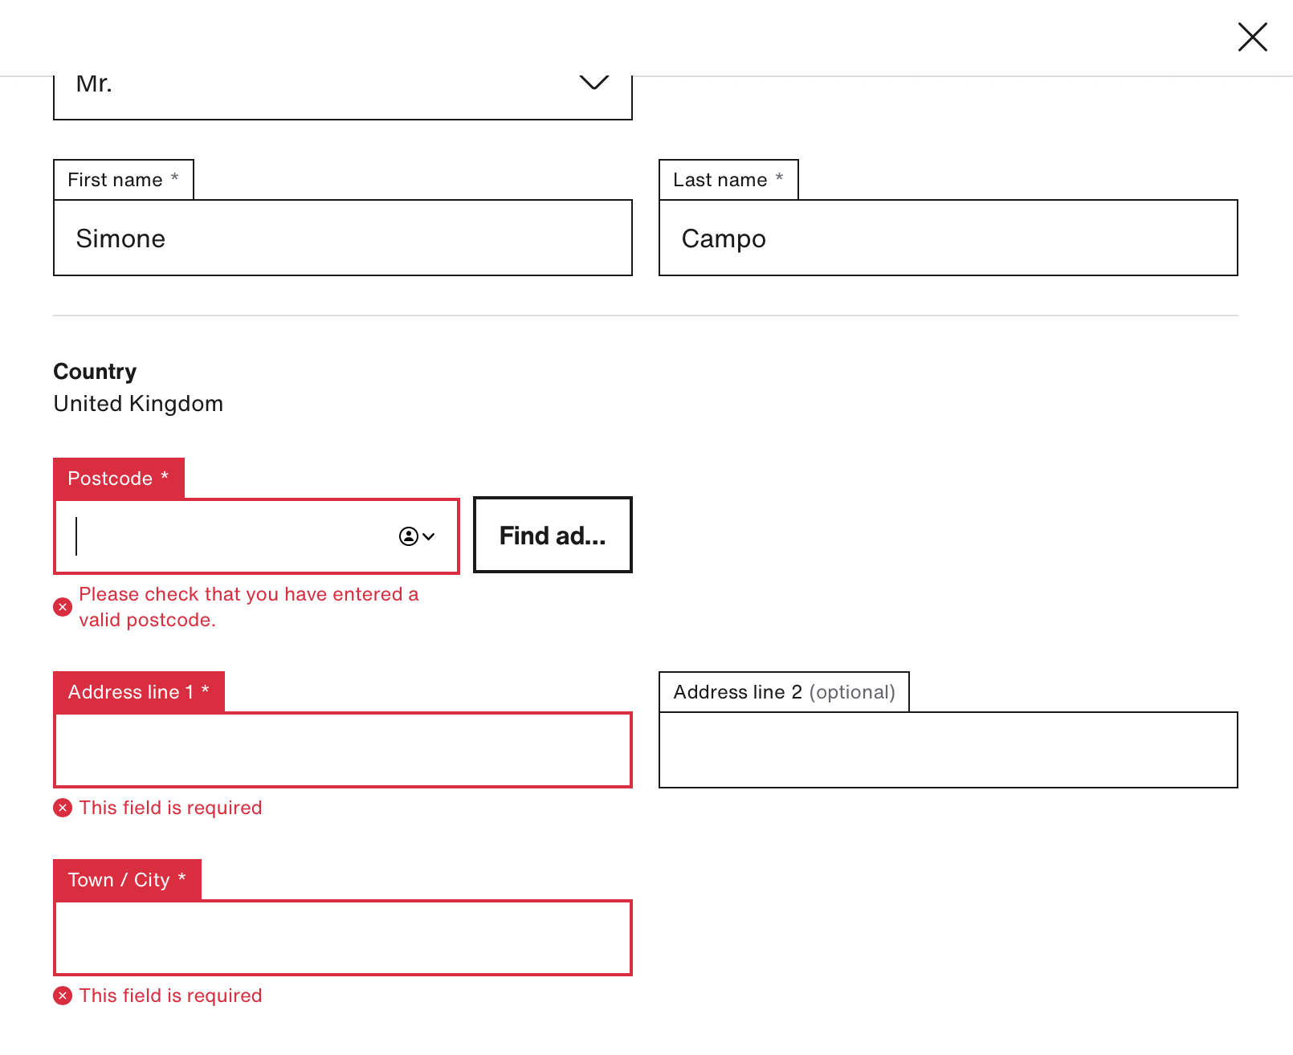

Figure 3: Customer Account Page – Your addresses section

**ARTICLE – Screenshots**

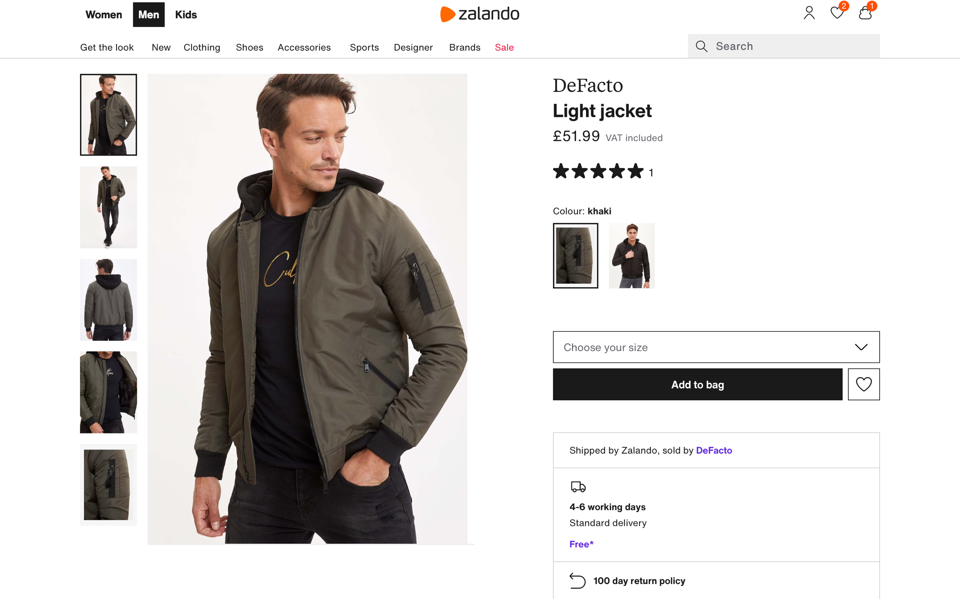

Figure 4: Article Page 1

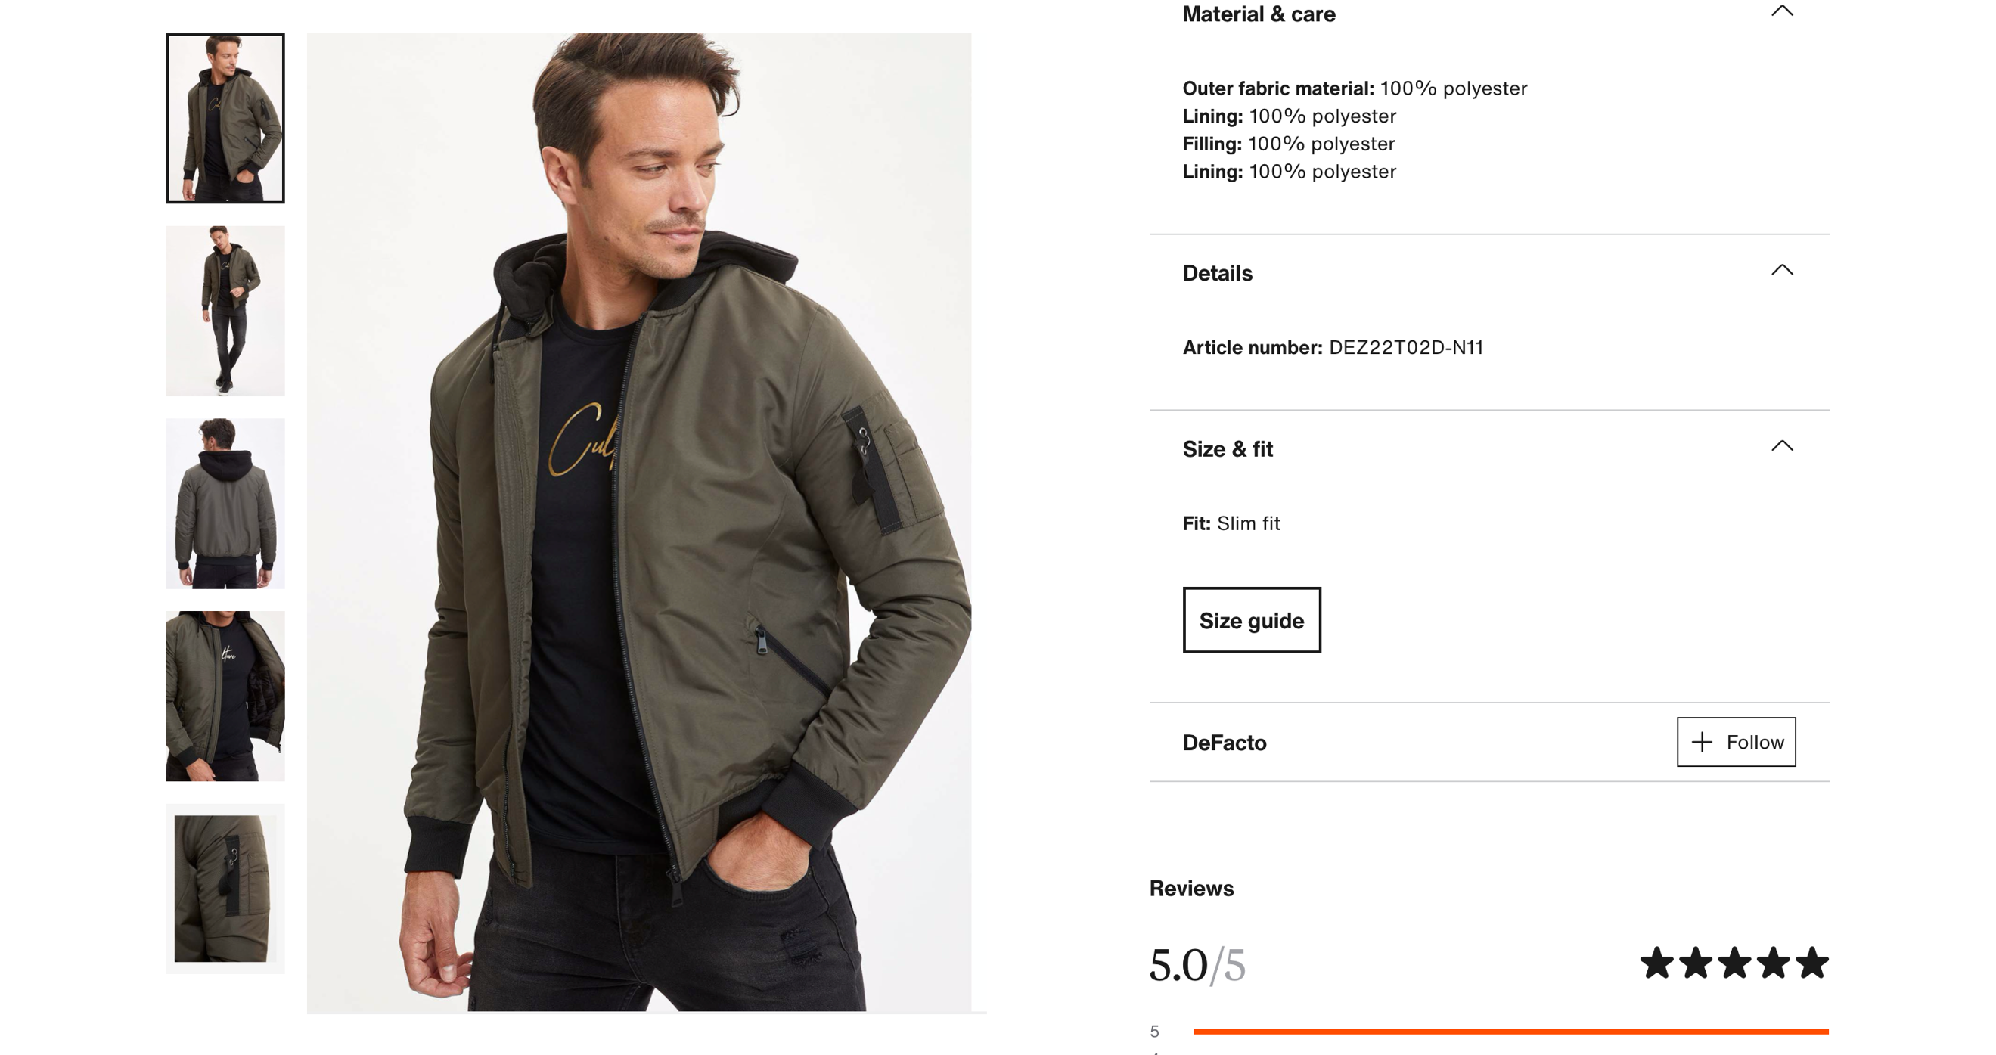

Figure 5: Article Page 2

**BRAND - Screenshot**

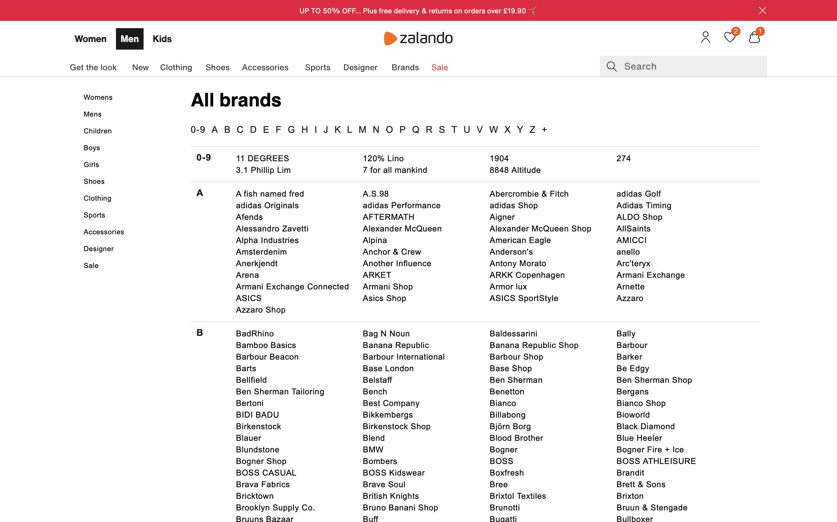

Figure 6: Brand List

**CATEGORY - Screenshots**

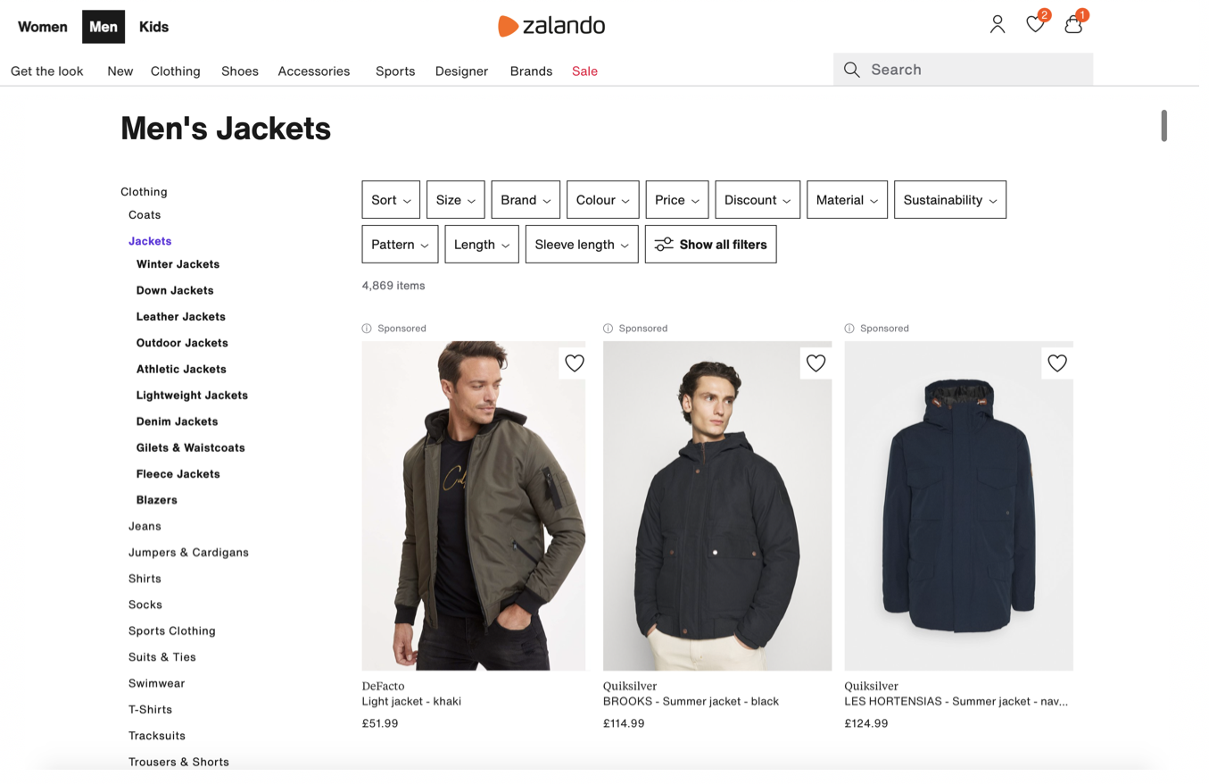

Figure 7: Four-Hierarchical Layer Category

**SHOPPING BAG - Screenshot**

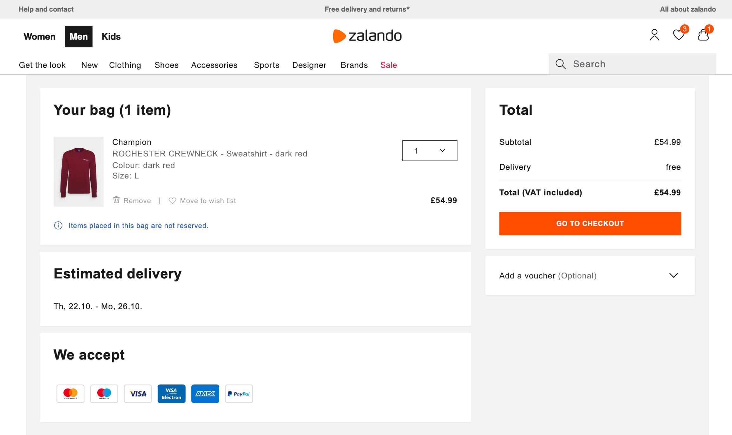

Figure 8: Shopping Bag Page / Checkout

**PAYMENT – Screenshot**

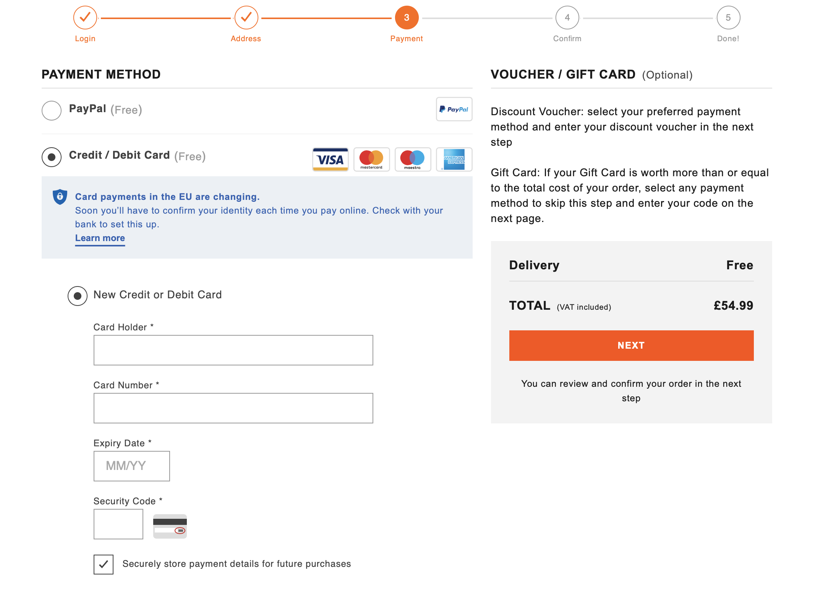

Figure 9: Payment Details Page

### ***1.2.2 Data – fields from ASOS***

**LIST OF DATA FIELDS**

Table 3: General Data - Fields from ASOS

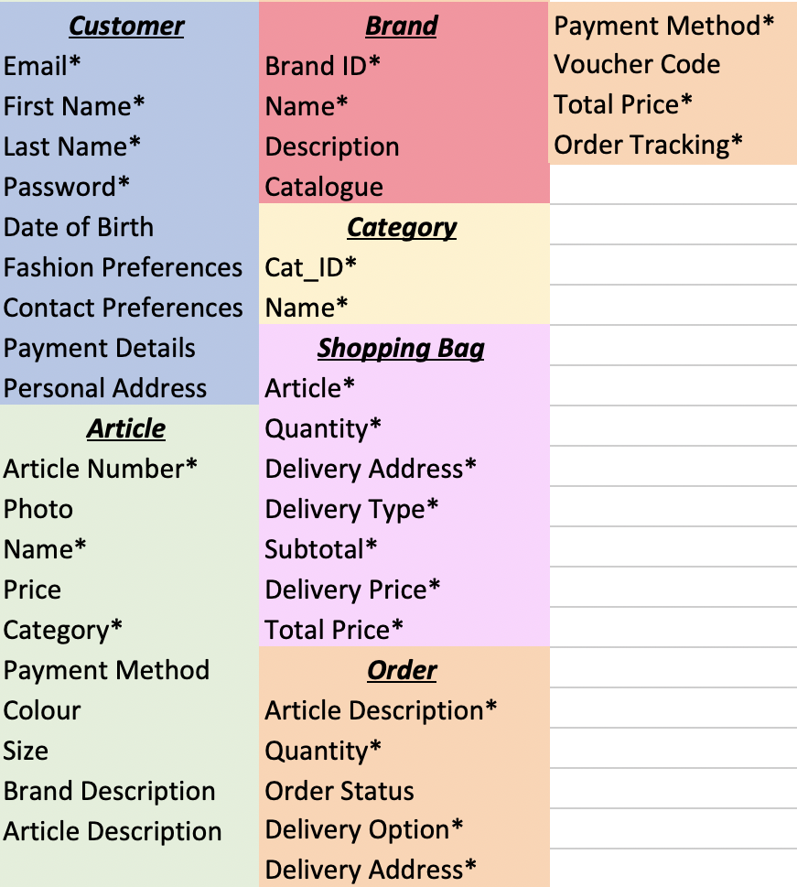

Table 4: Composite Attributes

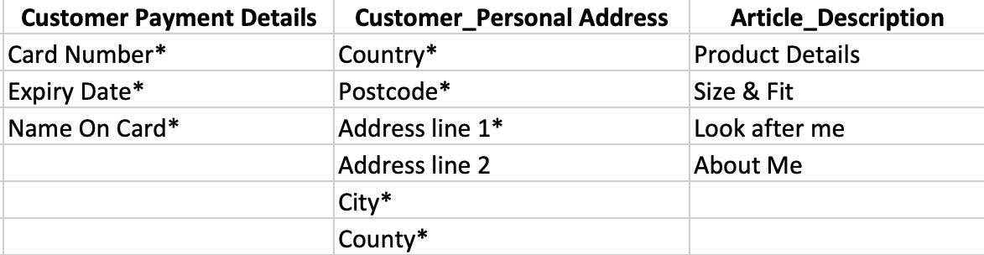

**DESCRIPTION**

Unlike Zalando, ASOS does not allow a customer to neither follow Brands, nor to make reviews. However, customers can choose their contact preferences so that they can receive the most suitable advertisements or business notifications.

Another difference with Zalando is that ASOS’s customers can store their payment method on the account. Therefore, the Payment entity is deleted in favour of a composite attribute (Table 4).

Products sold on the ASOS website have their own name while those ones sold on Zalando are named according to their category and their Brand. Additionally, Brands selling over ASOS have a description which introduces themselves to possible customers.

**CUSTOMER - Screenshots**

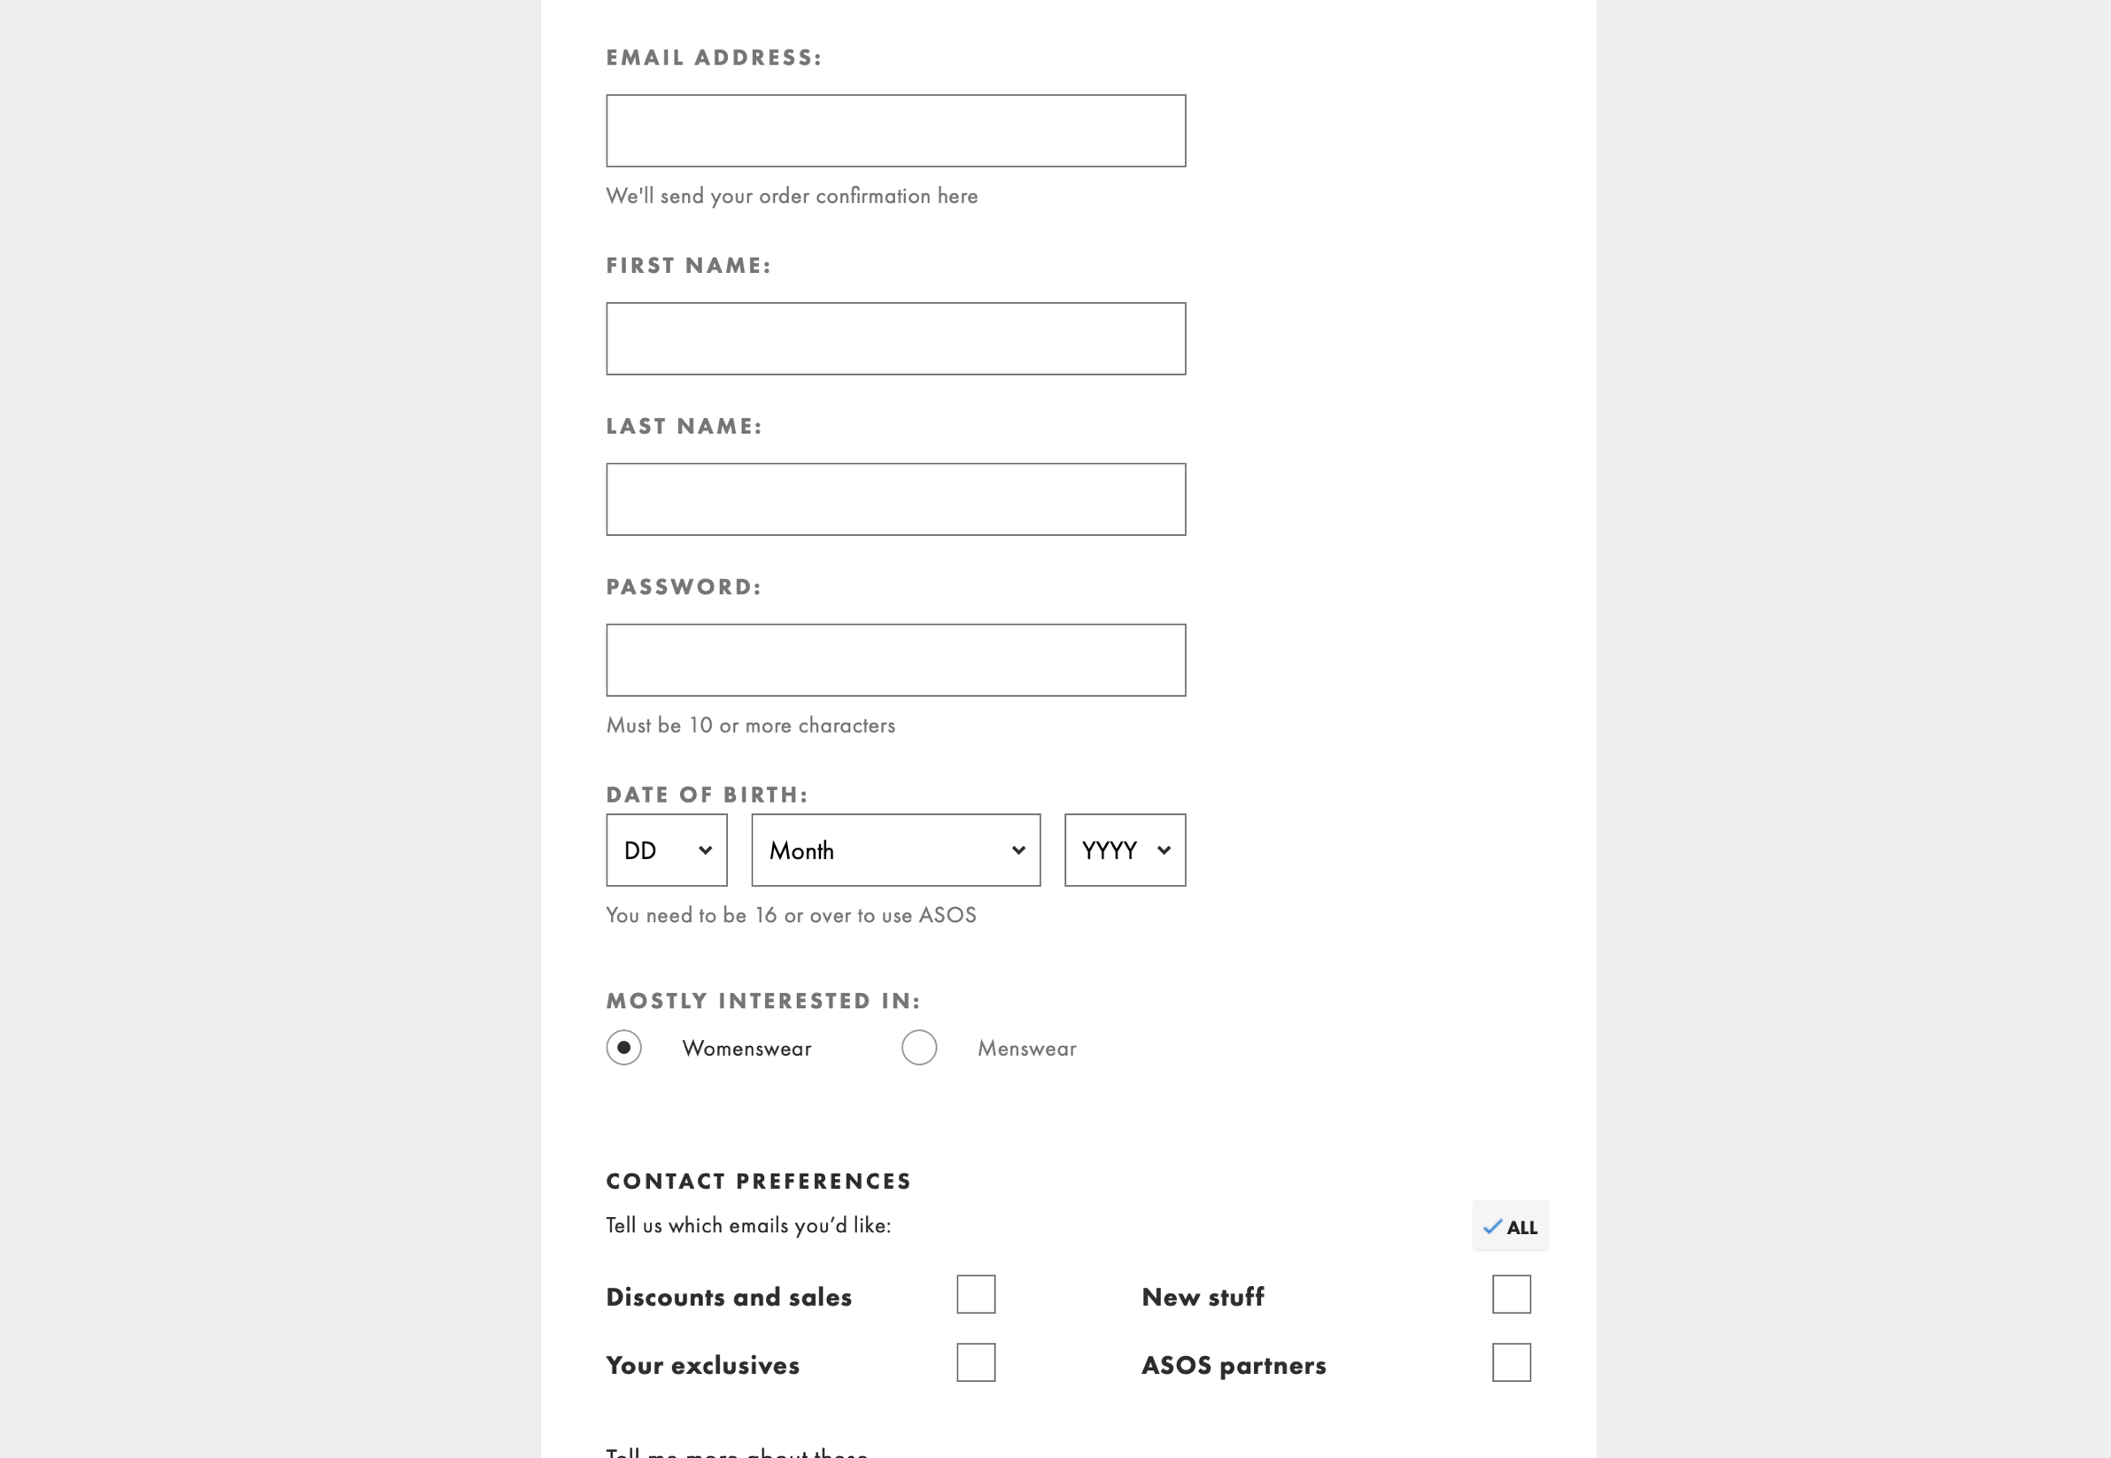

Figure 10: Customer Page - My Details

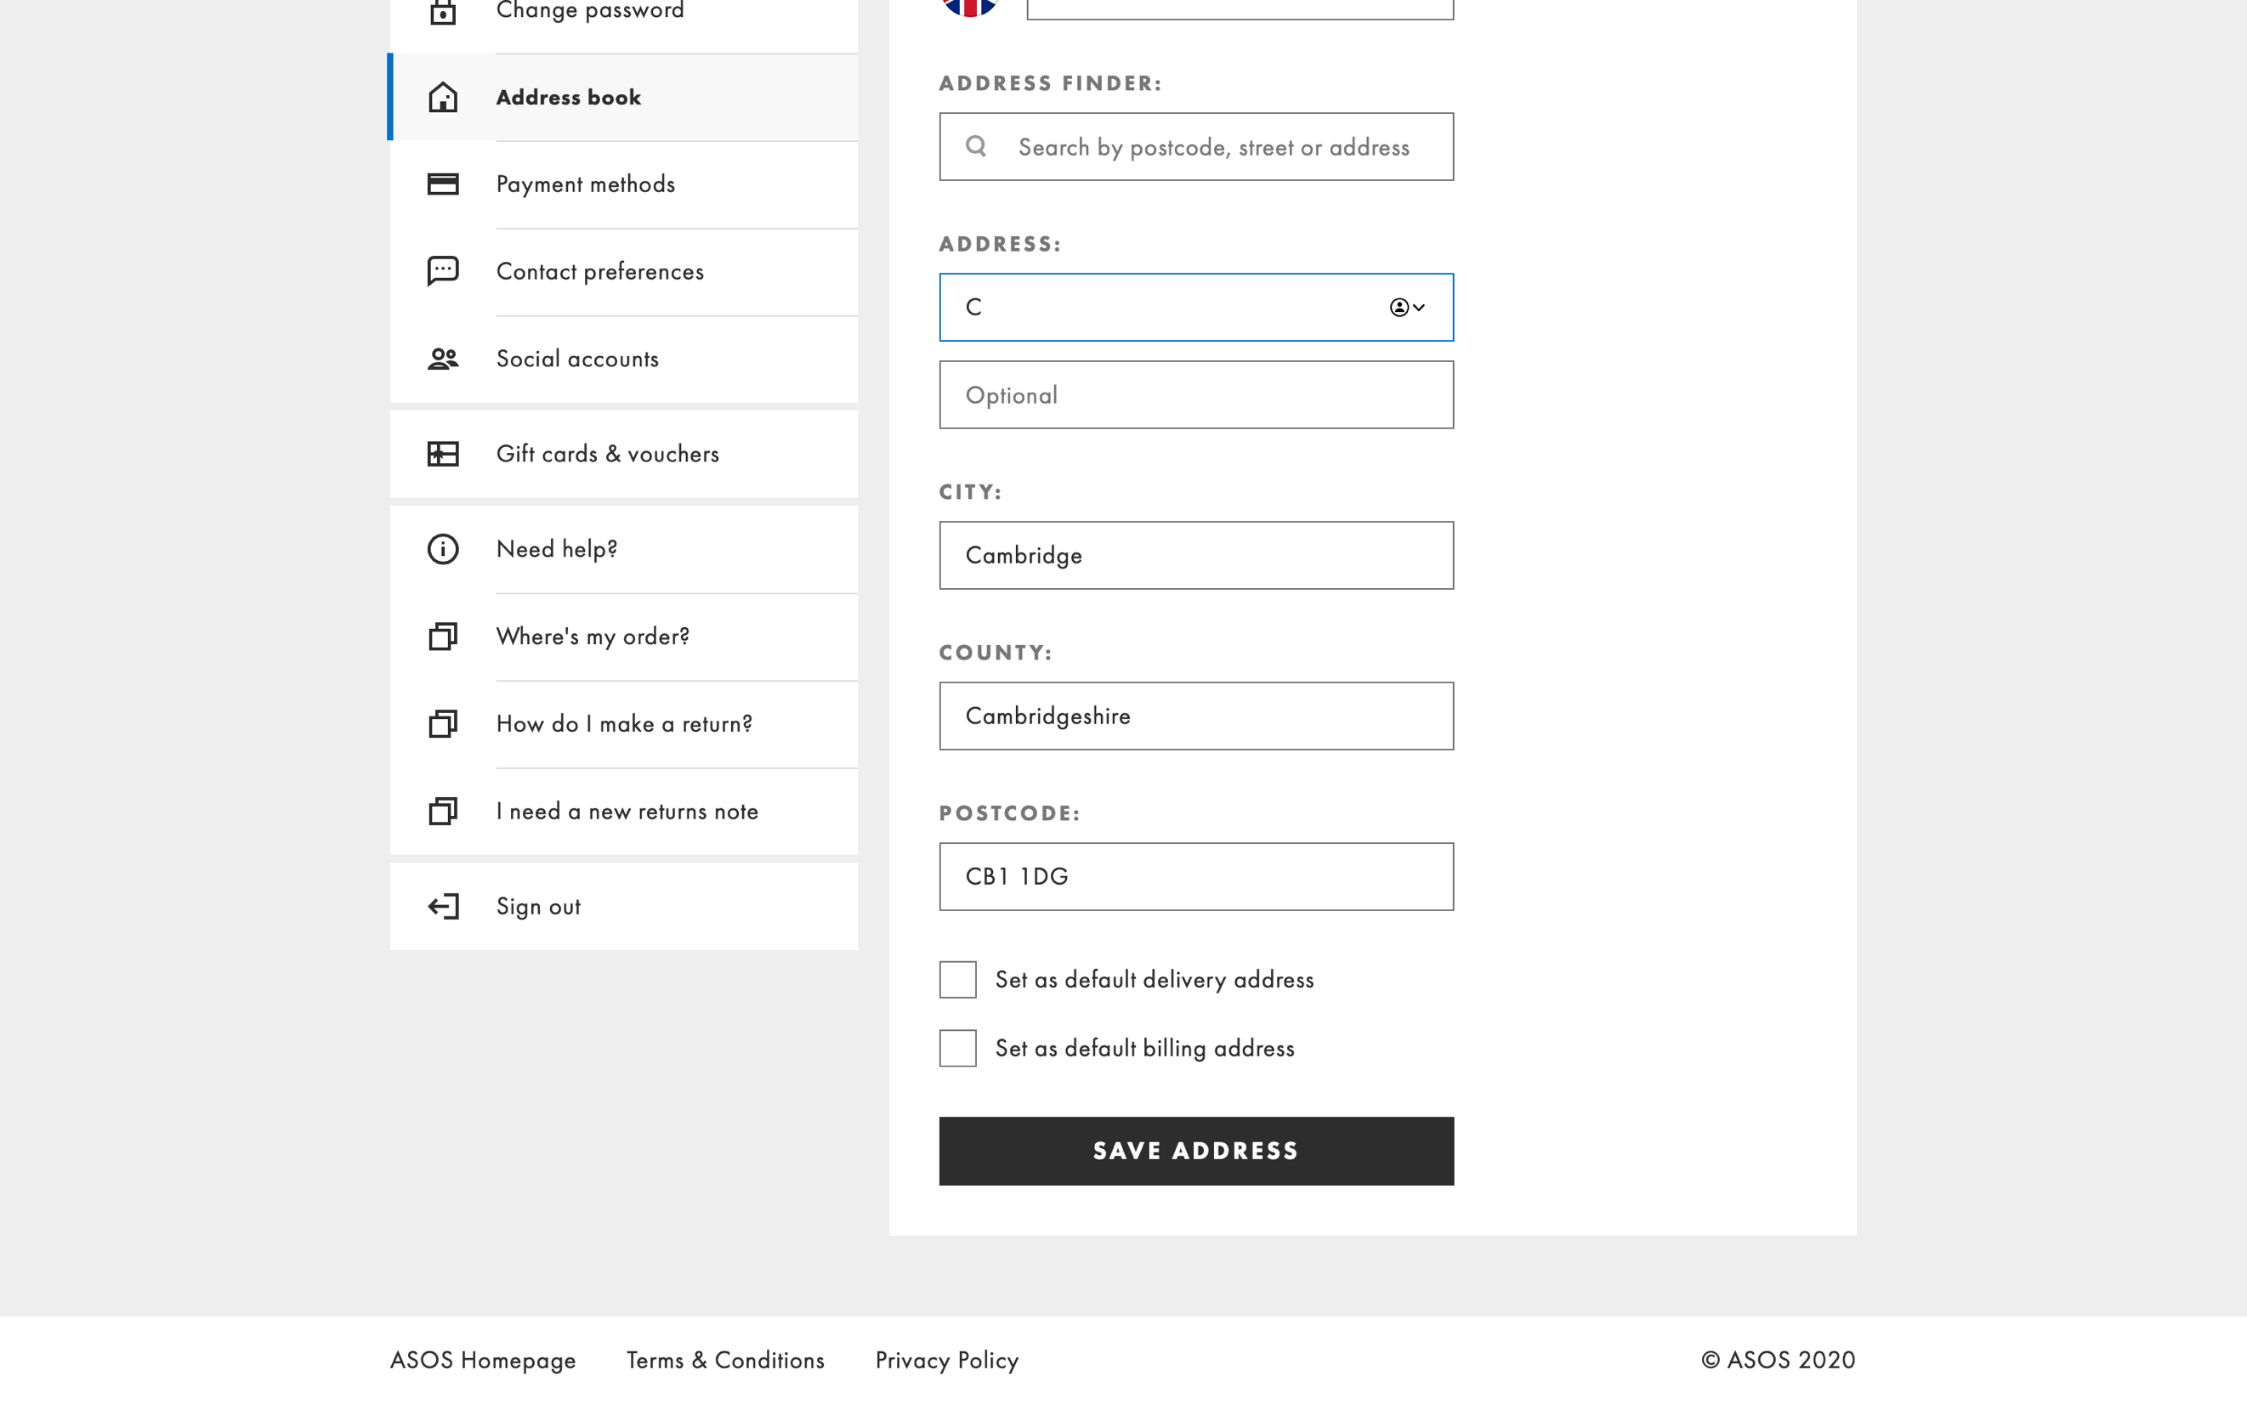

Figure 11: Customer Page - Address book

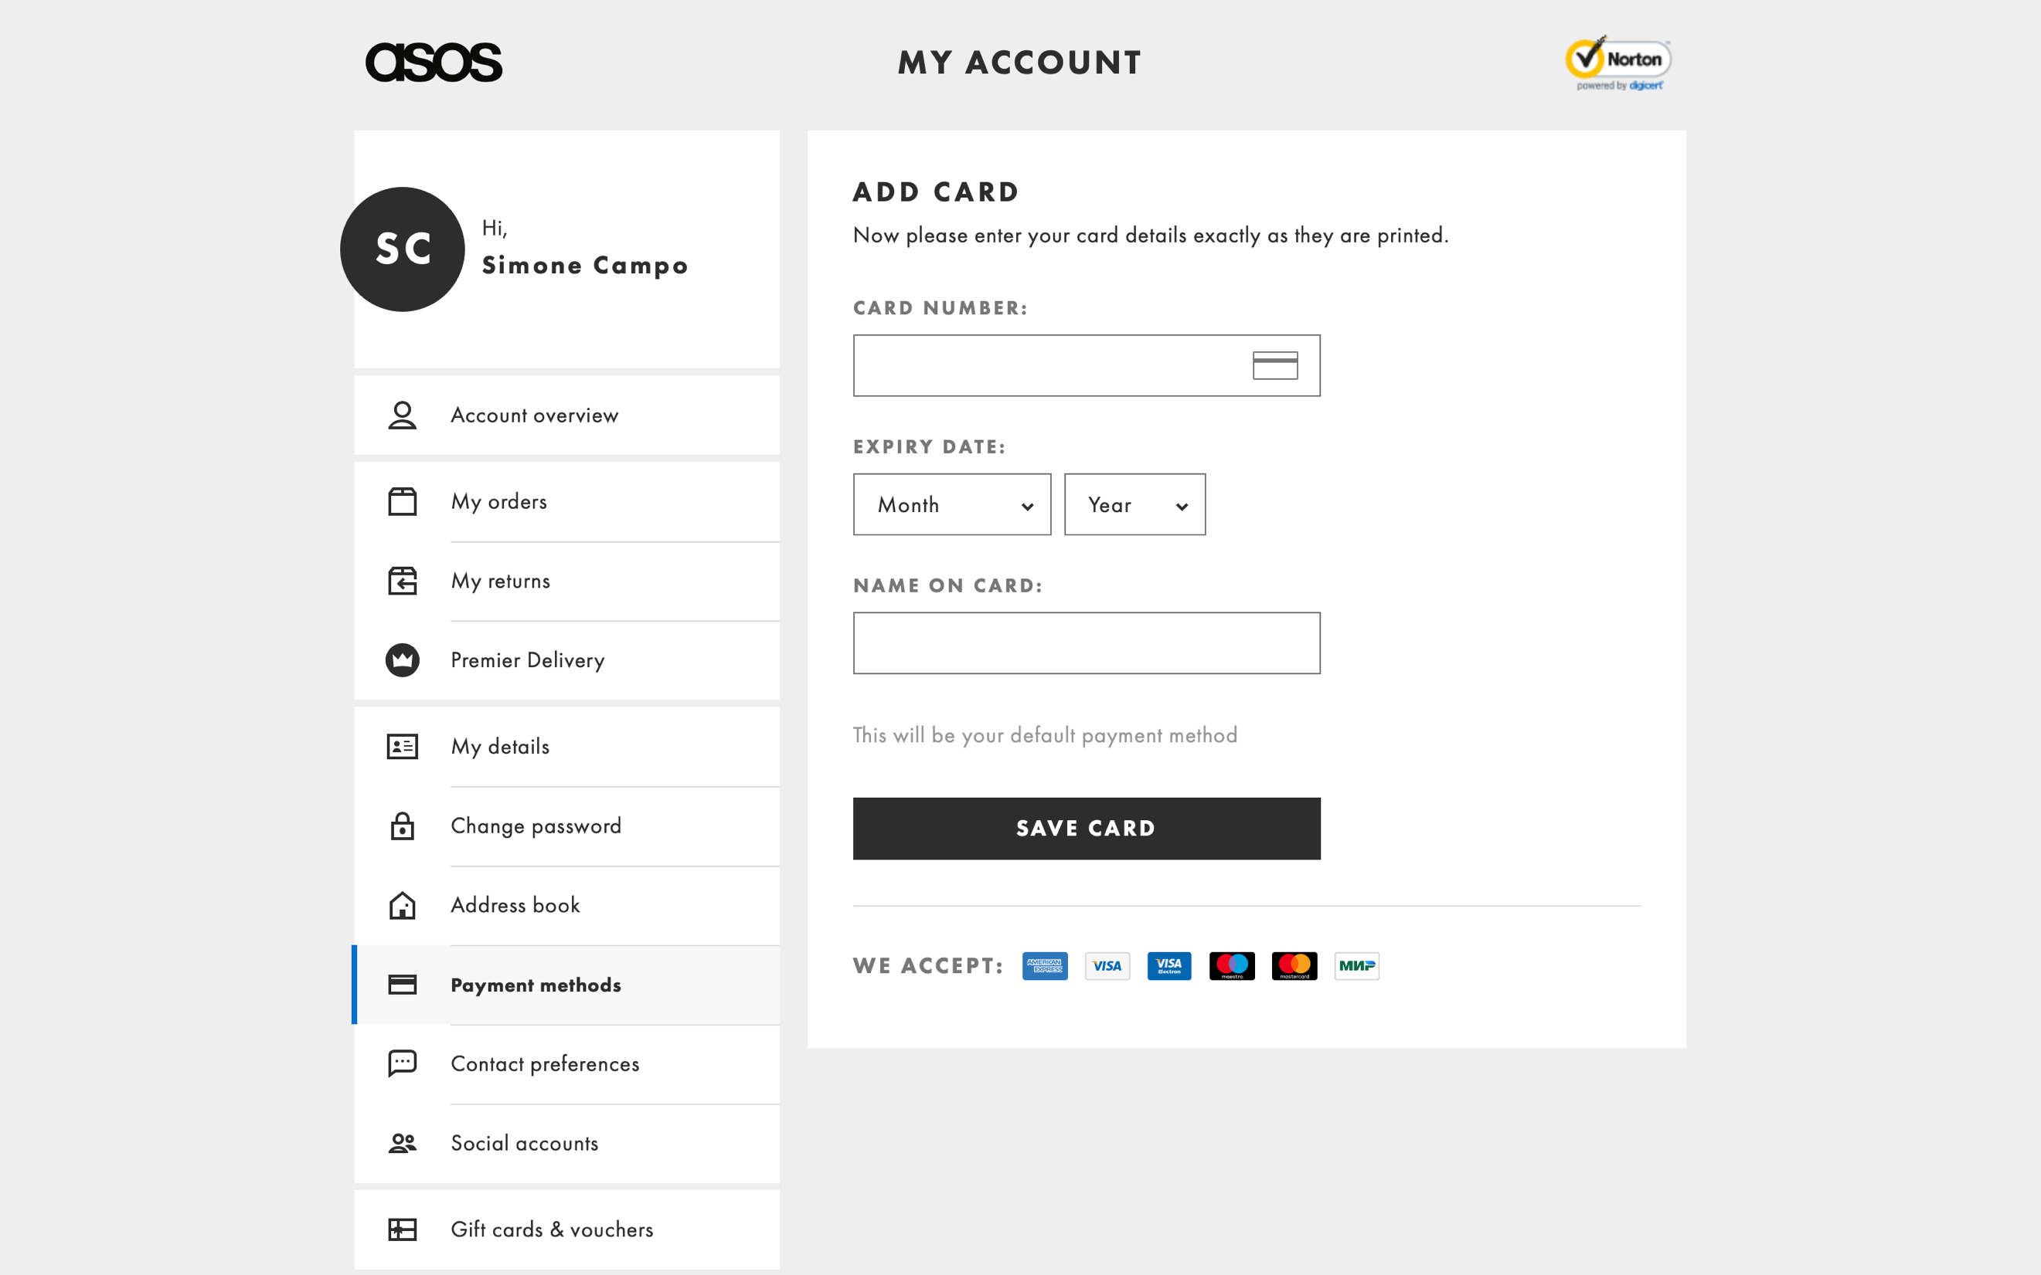

Figure 12: Customer Page - Payment Methods

**ARTICLE – Screenshot**

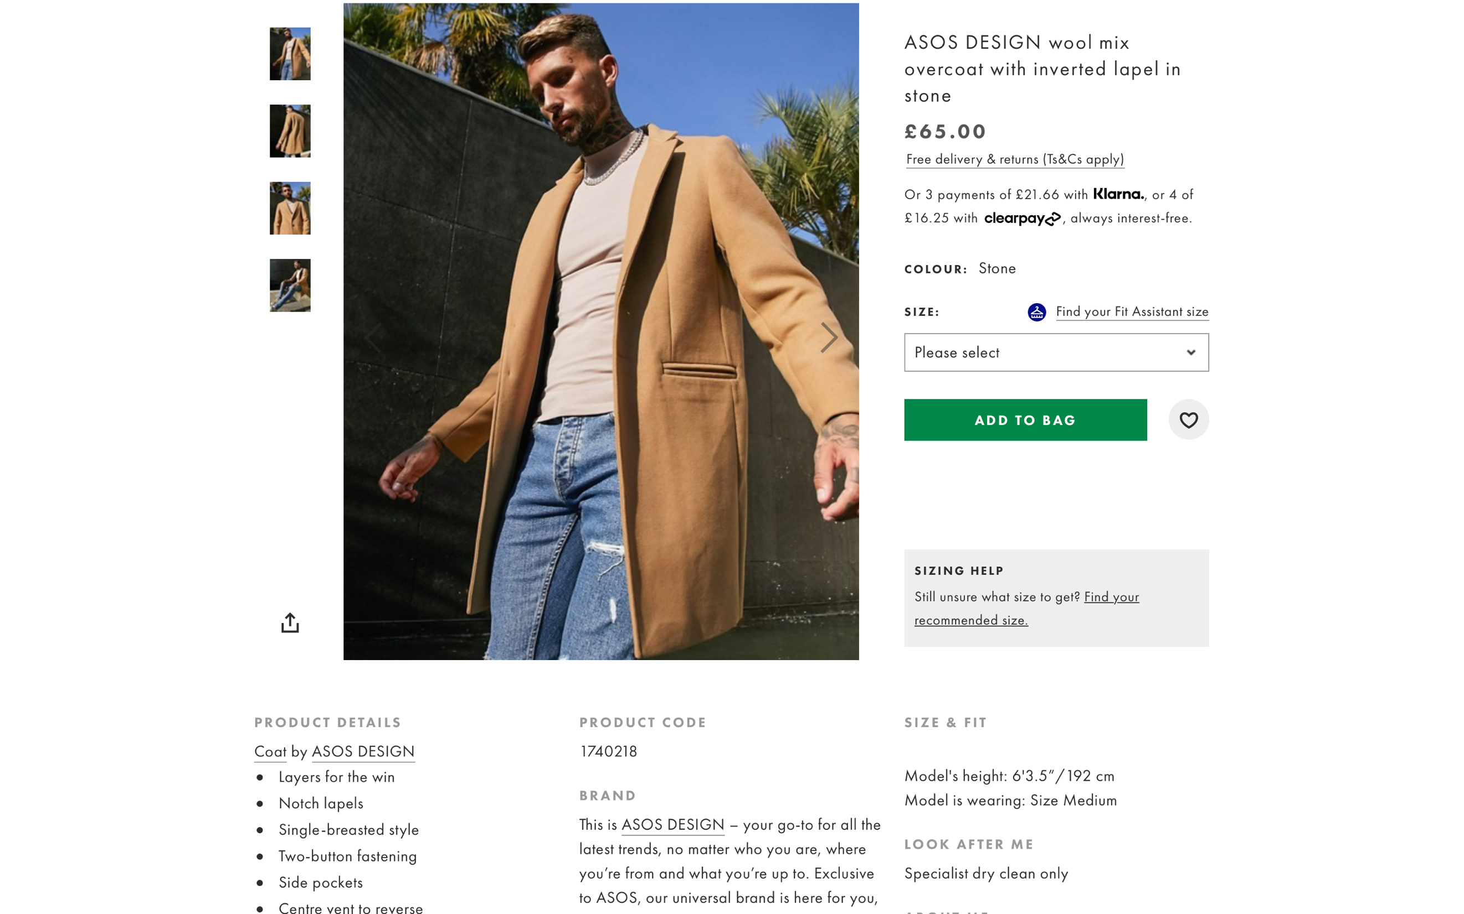

Figure 13: Article Page

**BRAND – Screenshot**

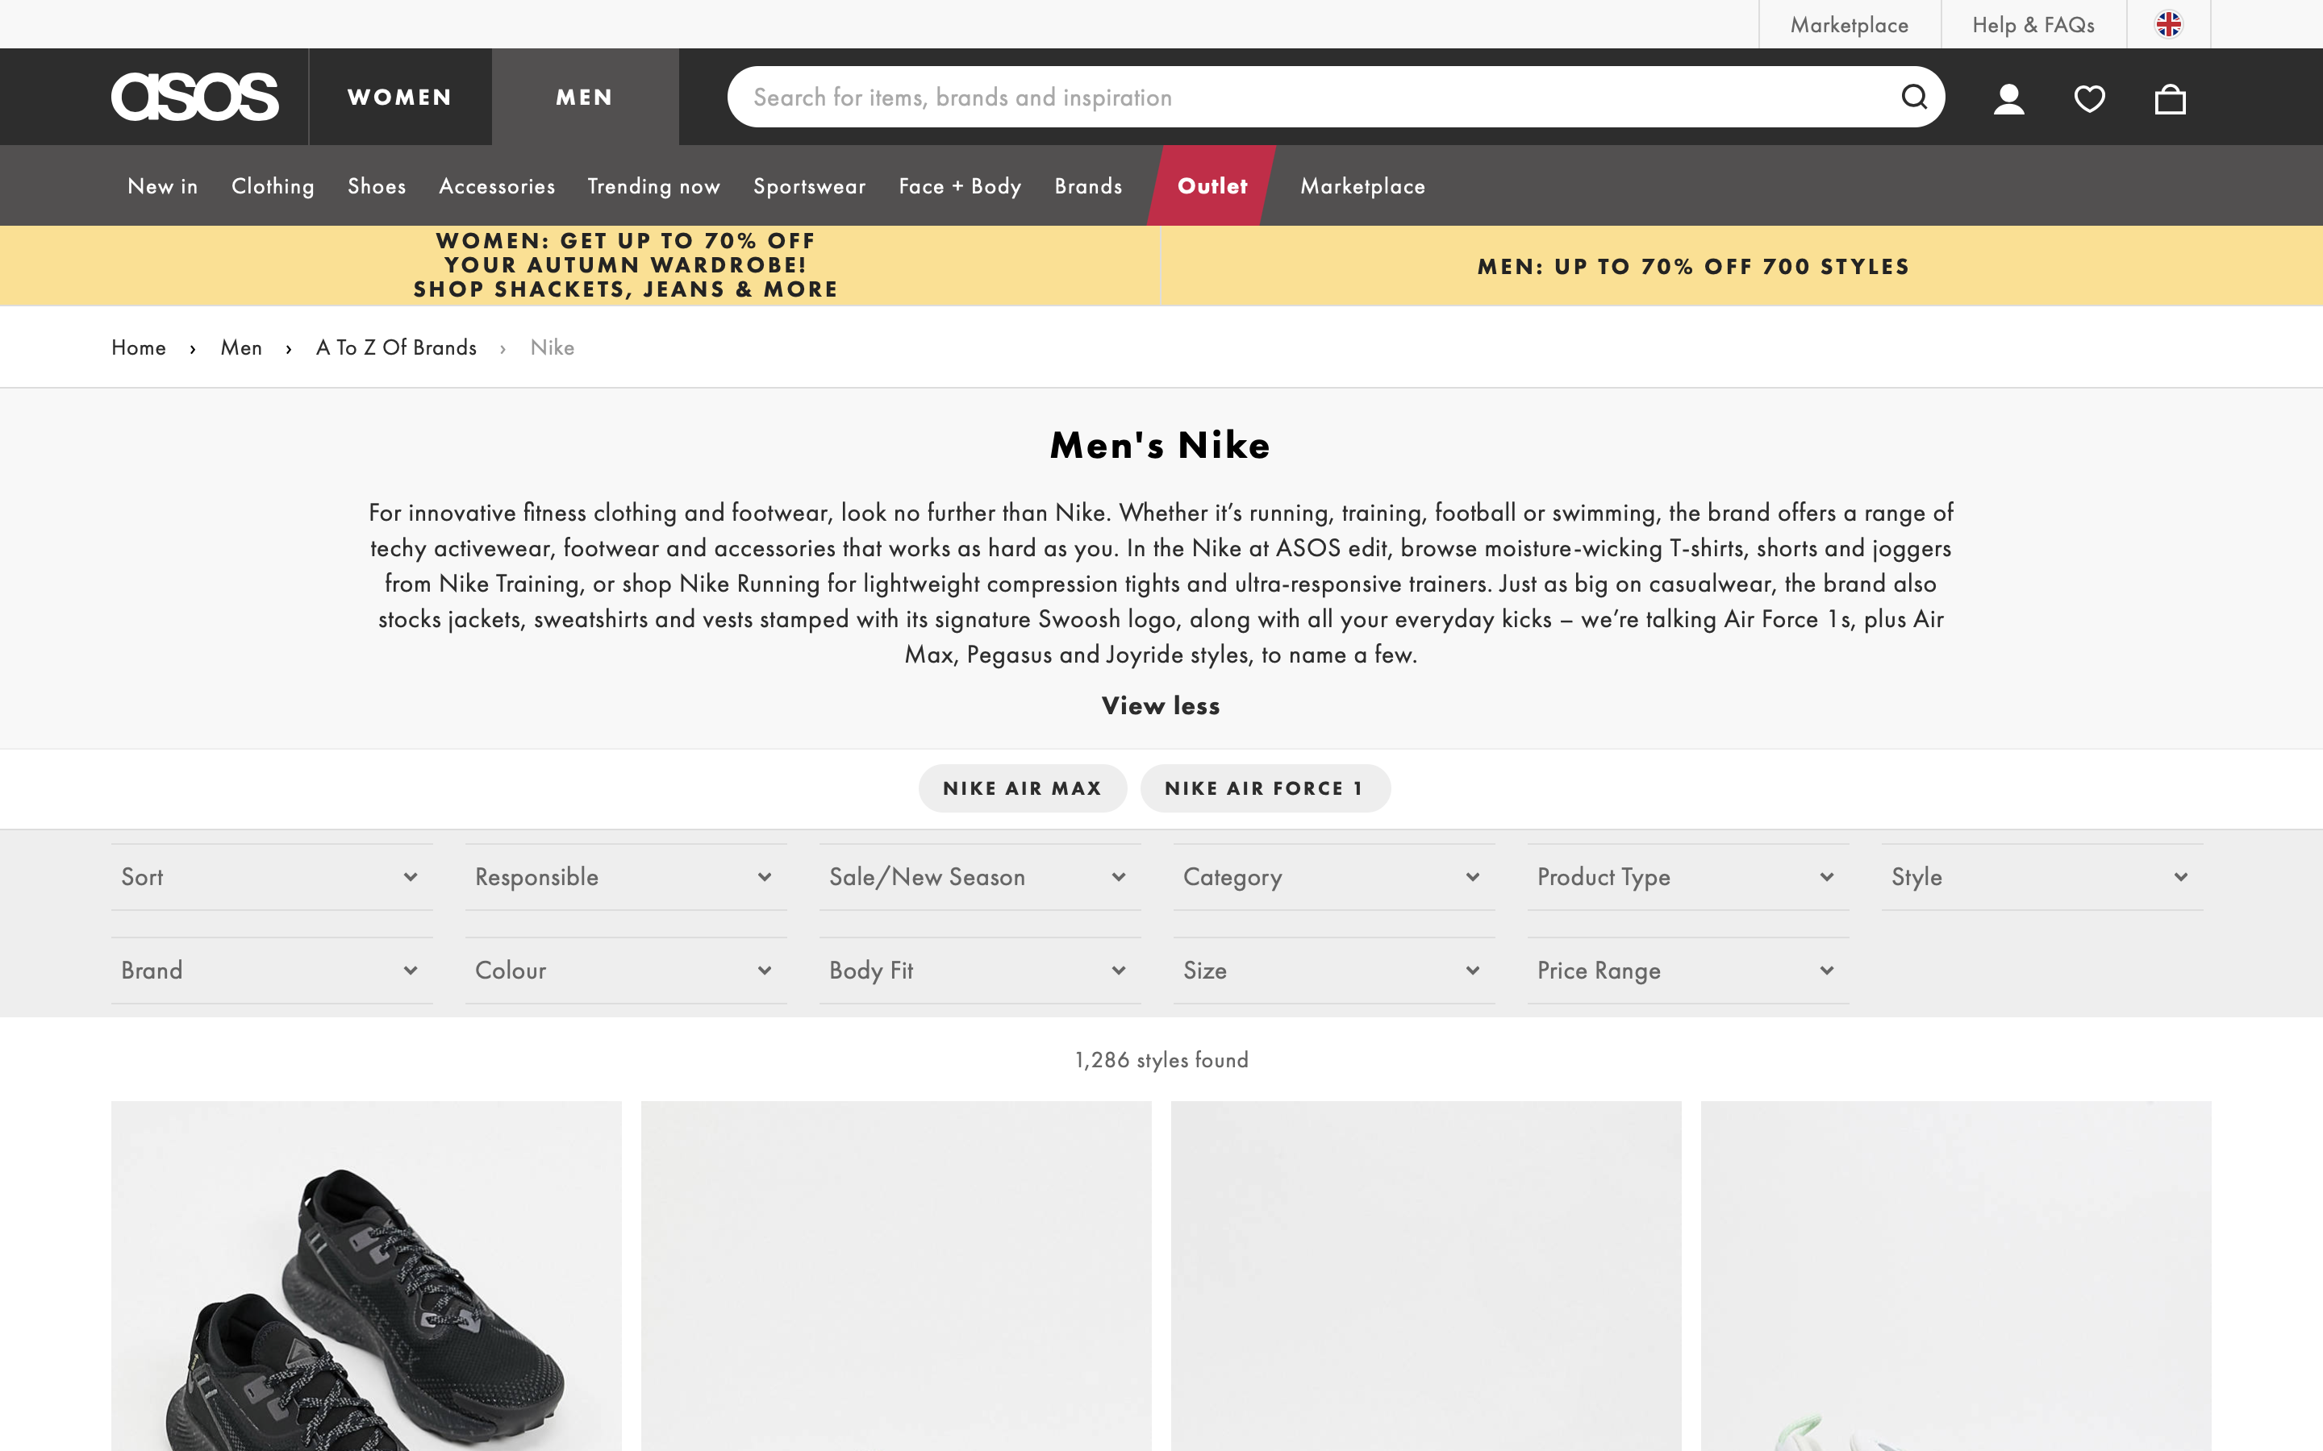

Figure 14: Brand Page

**CATEGORY – Screenshot**

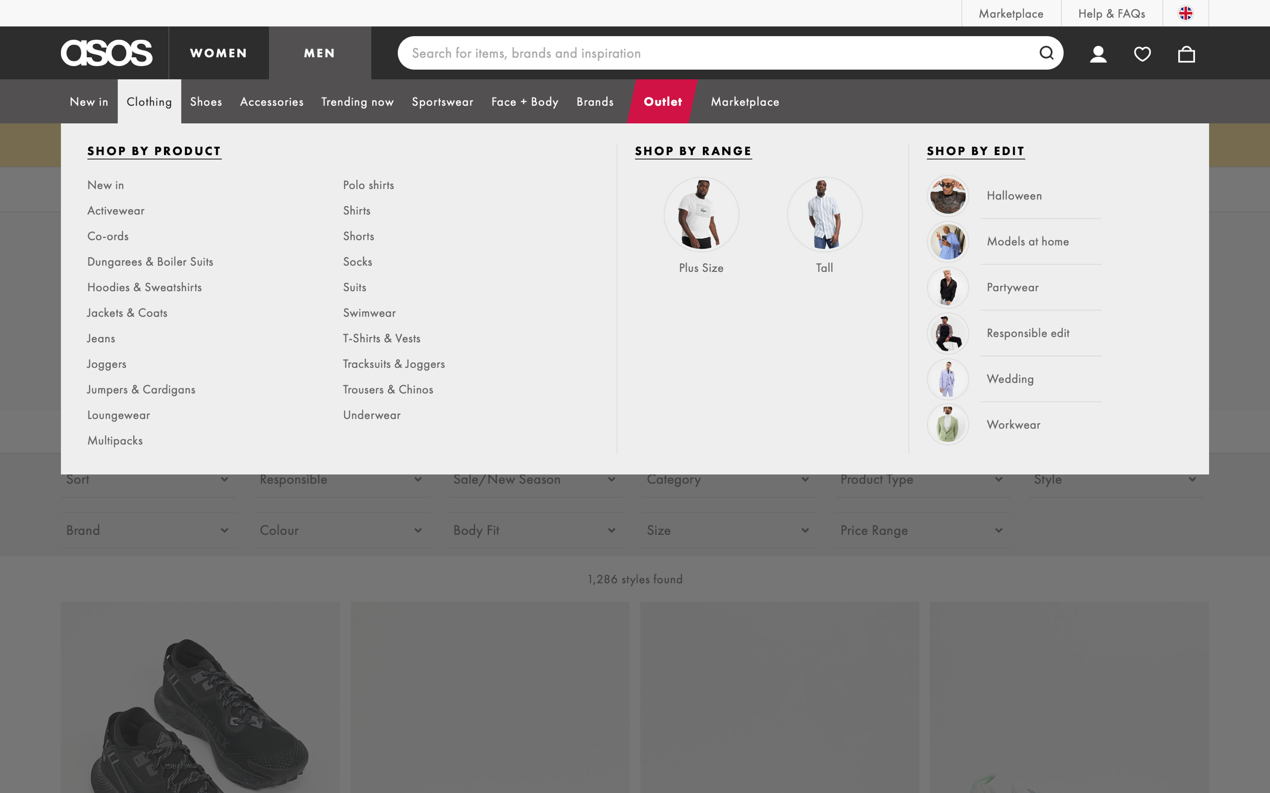

Figure 15: Category Page

**SHOPPING BAG – Screenshot**

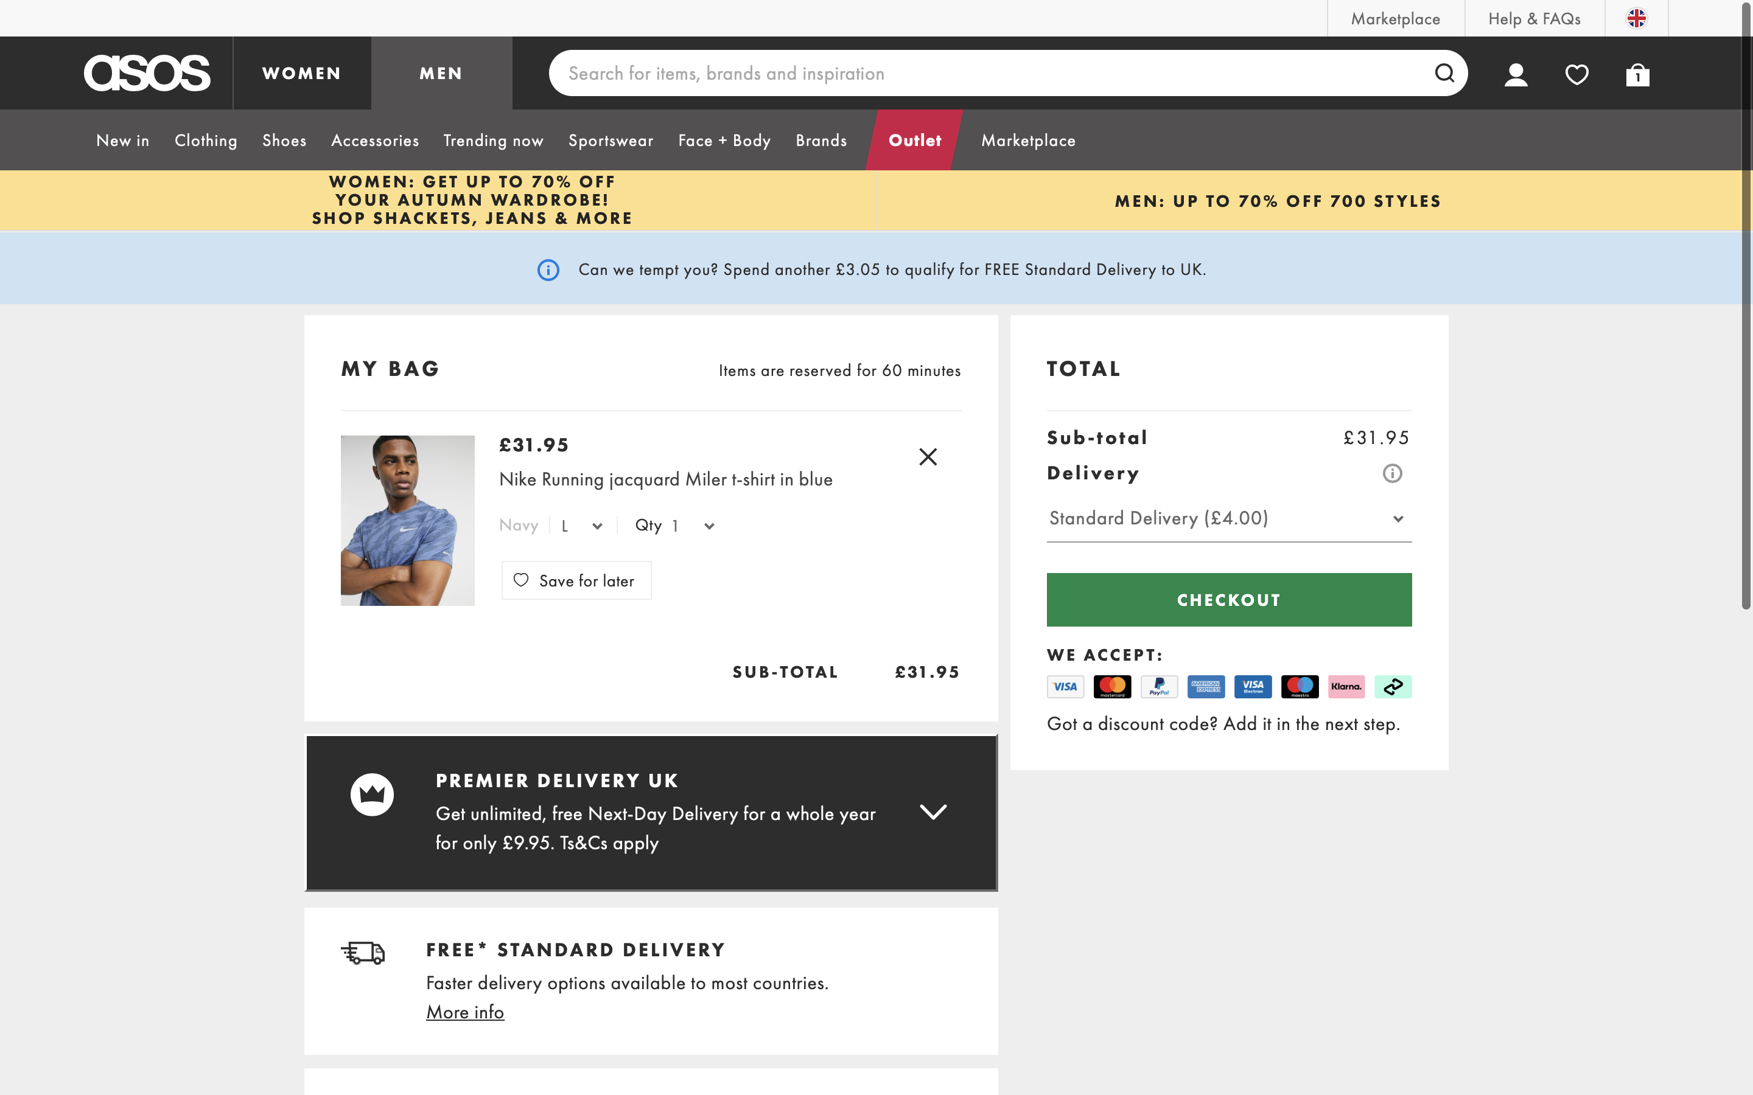

Figure 16: Shopping Bag - Checkout

**ORDER – Screenshots**

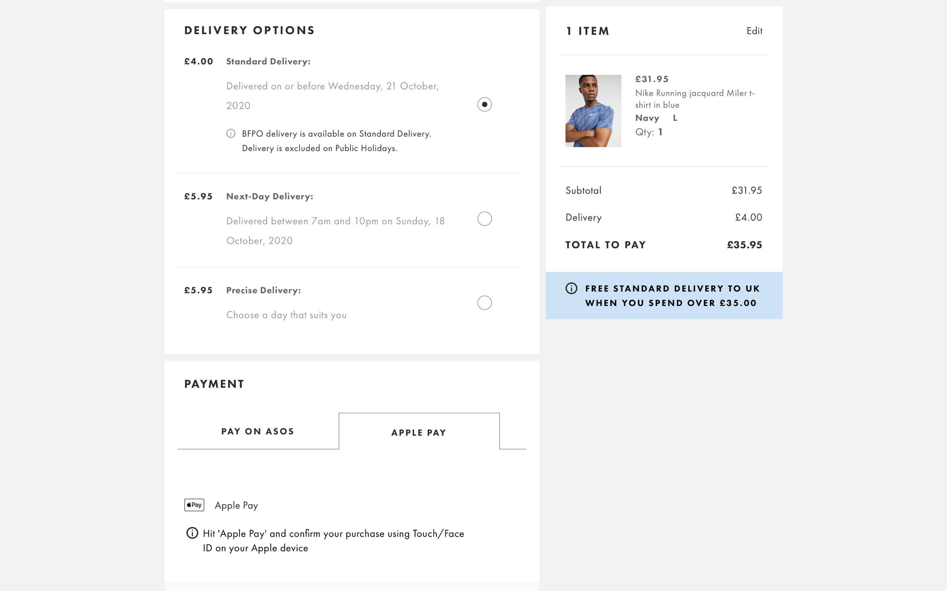

Figure 17: Order -1

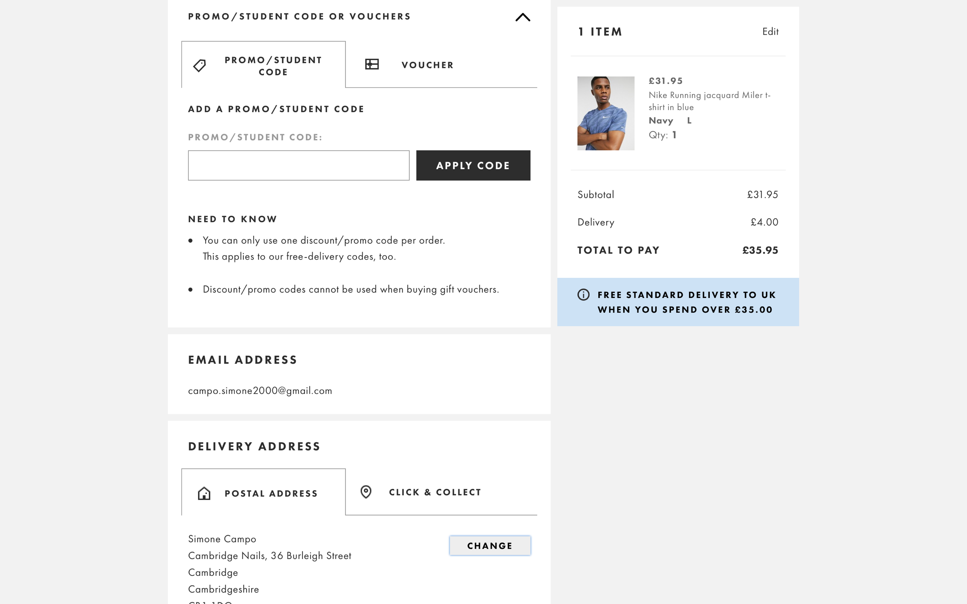

Figure 18: Order -2

### ***1.2.3 Data – fields from Yoox***

**LIST OF DATA FIELDS**

Table 5: Data Fields from Yoox

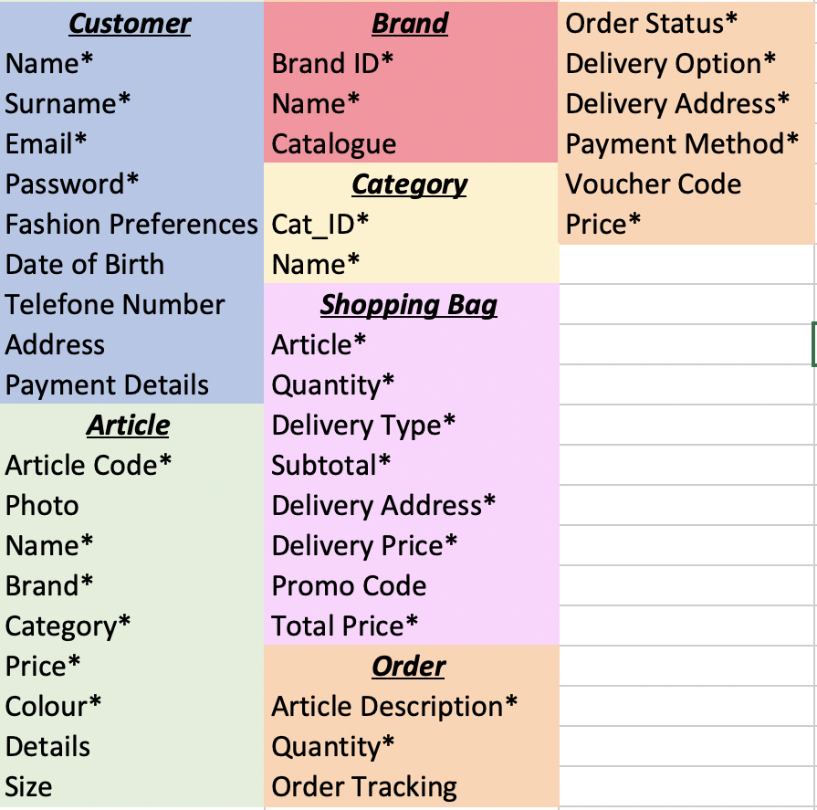

Table 6: Composite Attributes

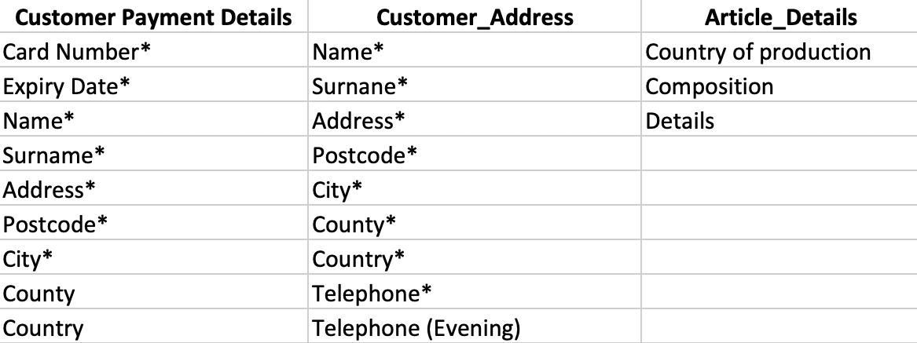

**DESCRIPTION**

Yoox is pretty much similar to ASOS as it does not allow their customers to write reviews but it lets them to store their payment information on the account. Moreover, the items sold by Yoox have their own name.

In Figures 20-21, the attributes are marked as compulsory because necessarily for a correct registration of an address and a payment method. However, they are not mandatory unless the customer decides to place an order.

Similar to Zalando, the categories are segmented in a four-hierarchical layer model (Figure 15).

Since the Shopping Bag pages and the Order pages are graphically the same, they are represented only one time.

**CUSTOMER – Screenshots**

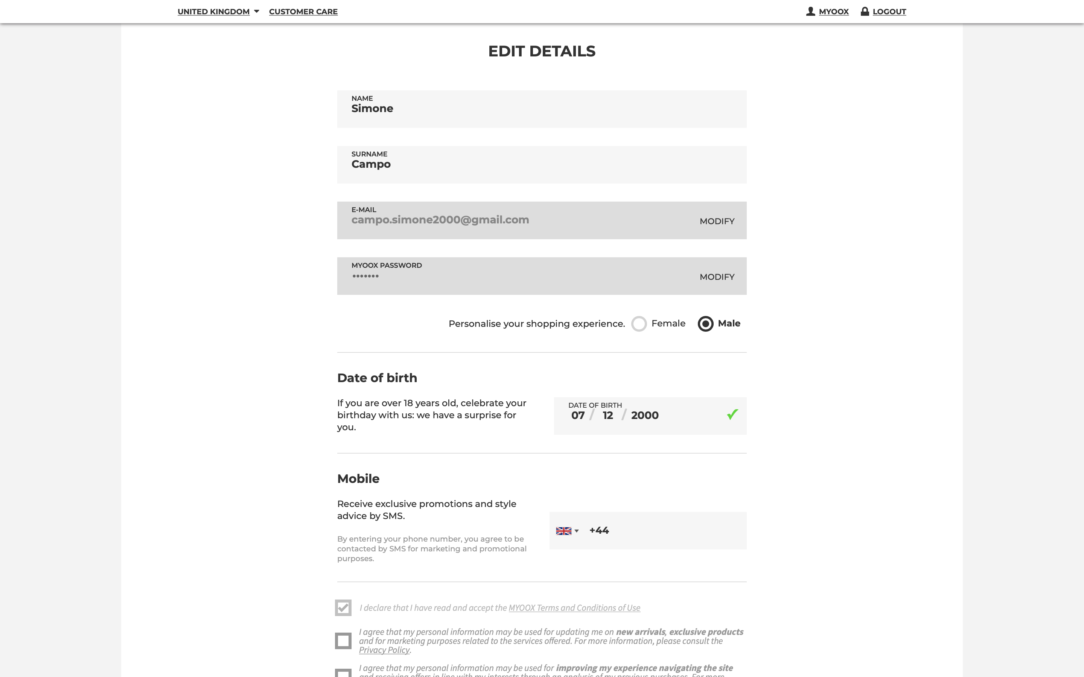

Figure 19: Customer Page – Details

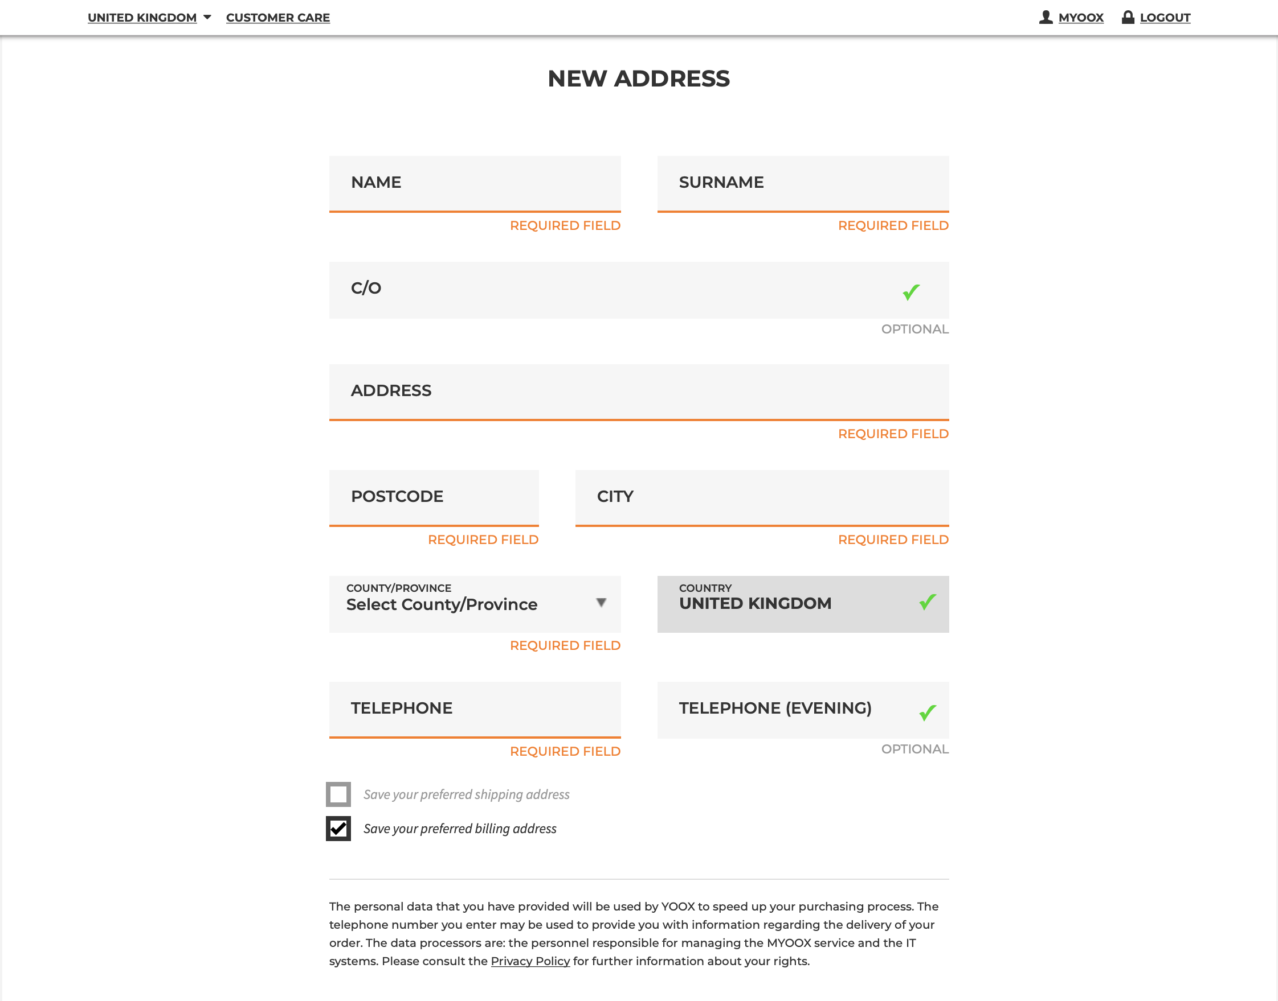

Figure 20: Customer Page – Address

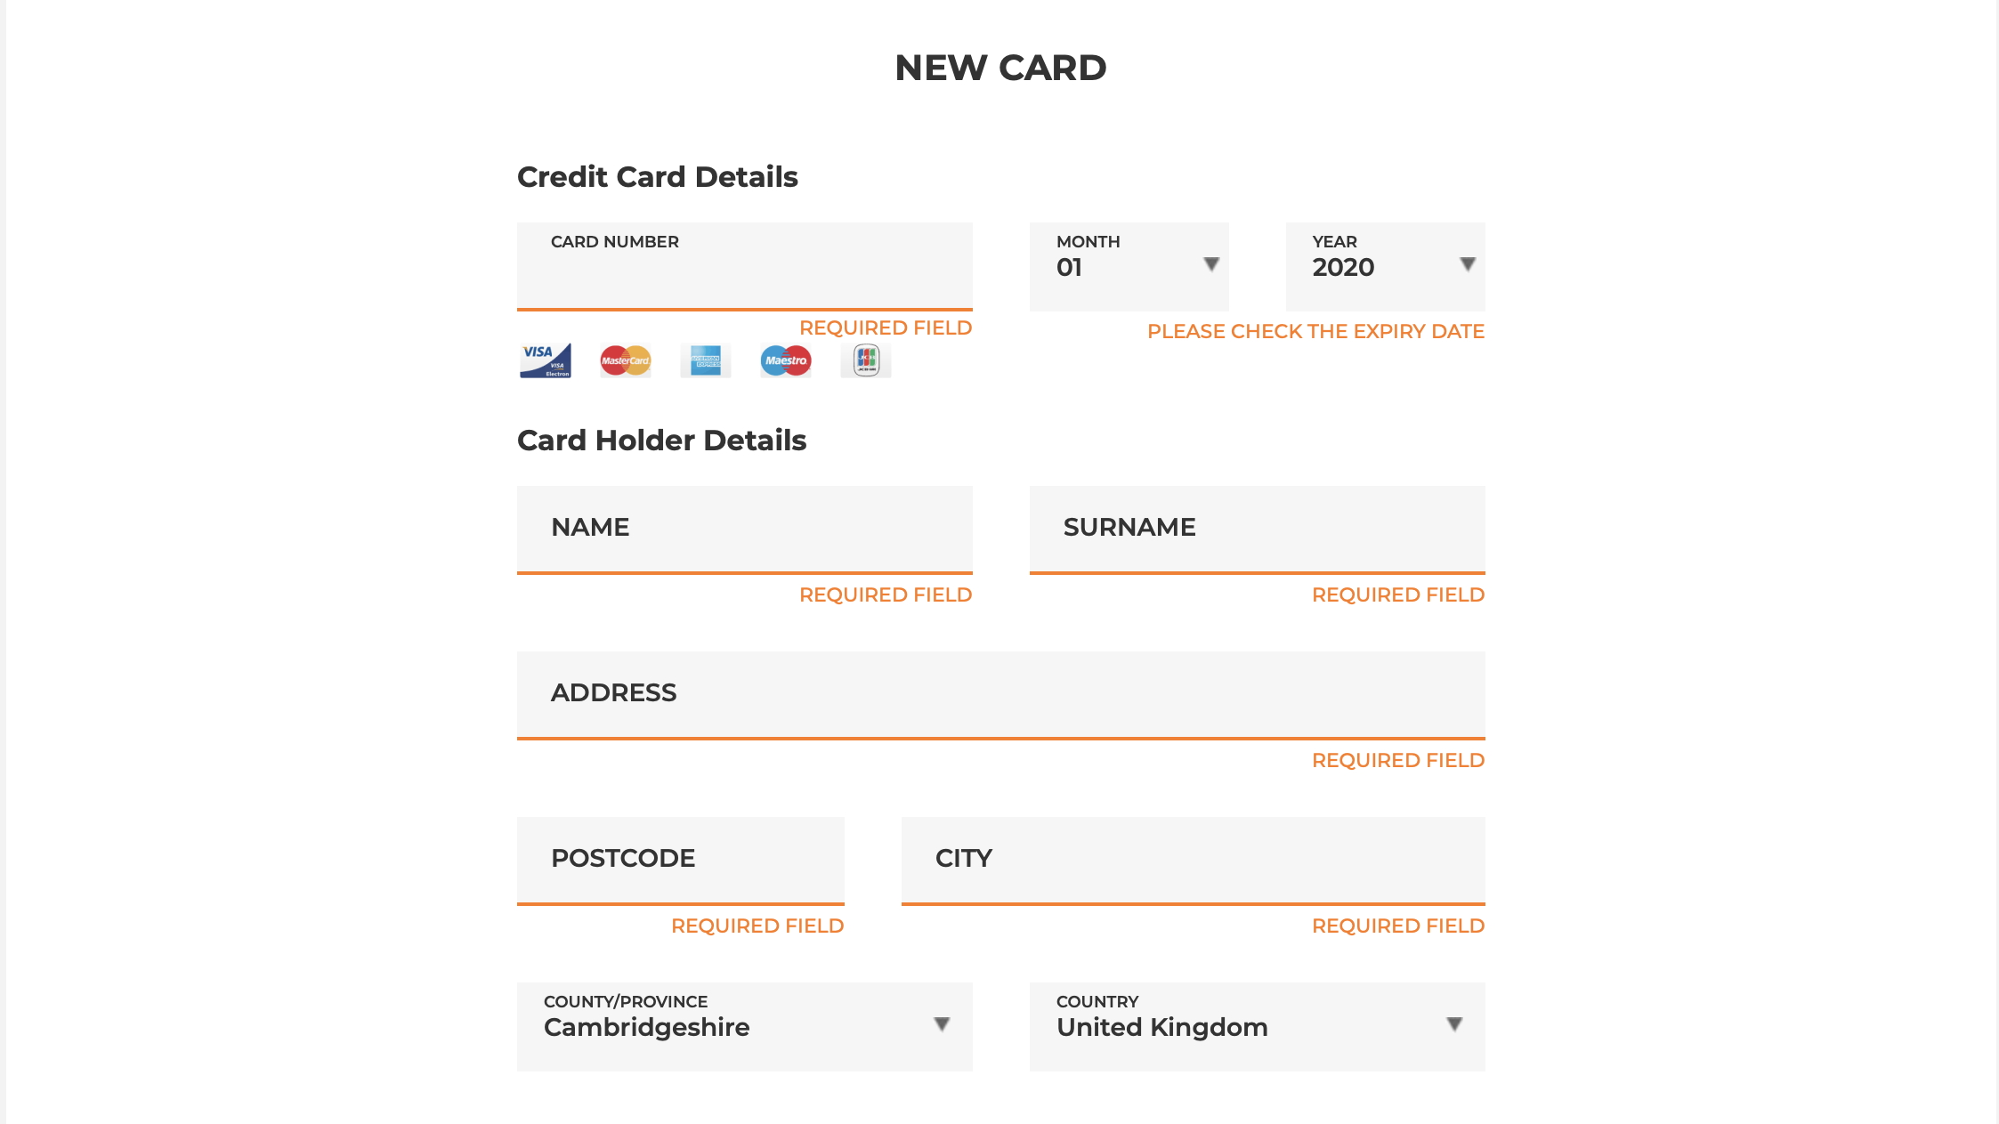

Figure 21: Customer Page – Card Details

**ARTICLE – Screenshot**

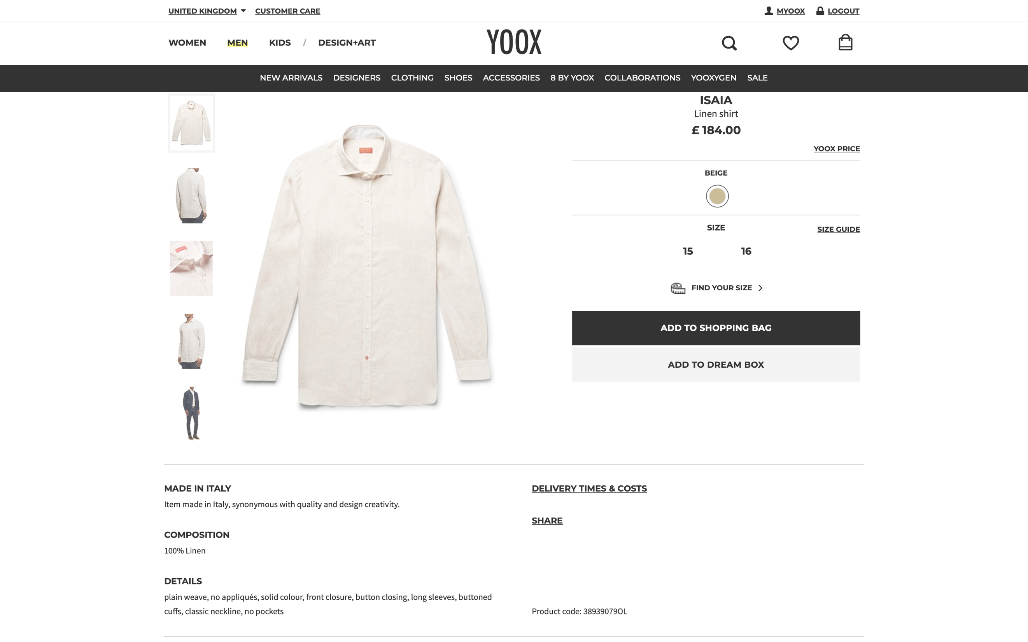

Figure 22: Article Page

**BRAND – Screenshot**

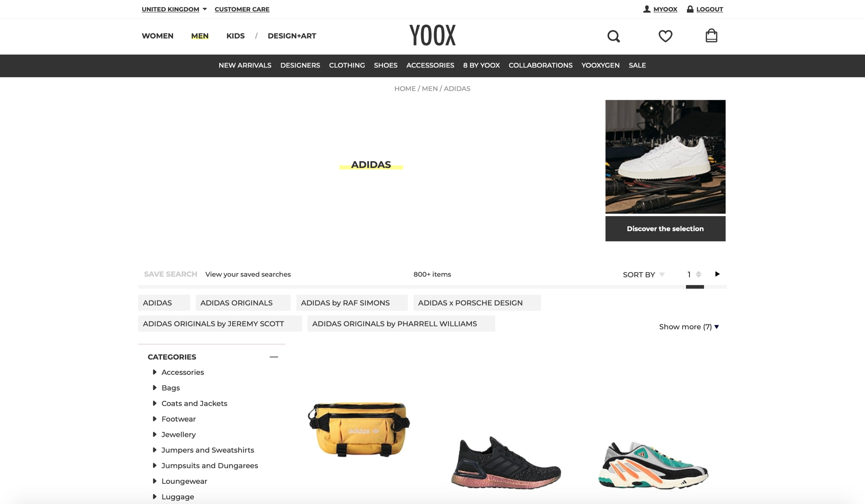

Figure 23: Brand Page

**CATEGORY – Screenshot**

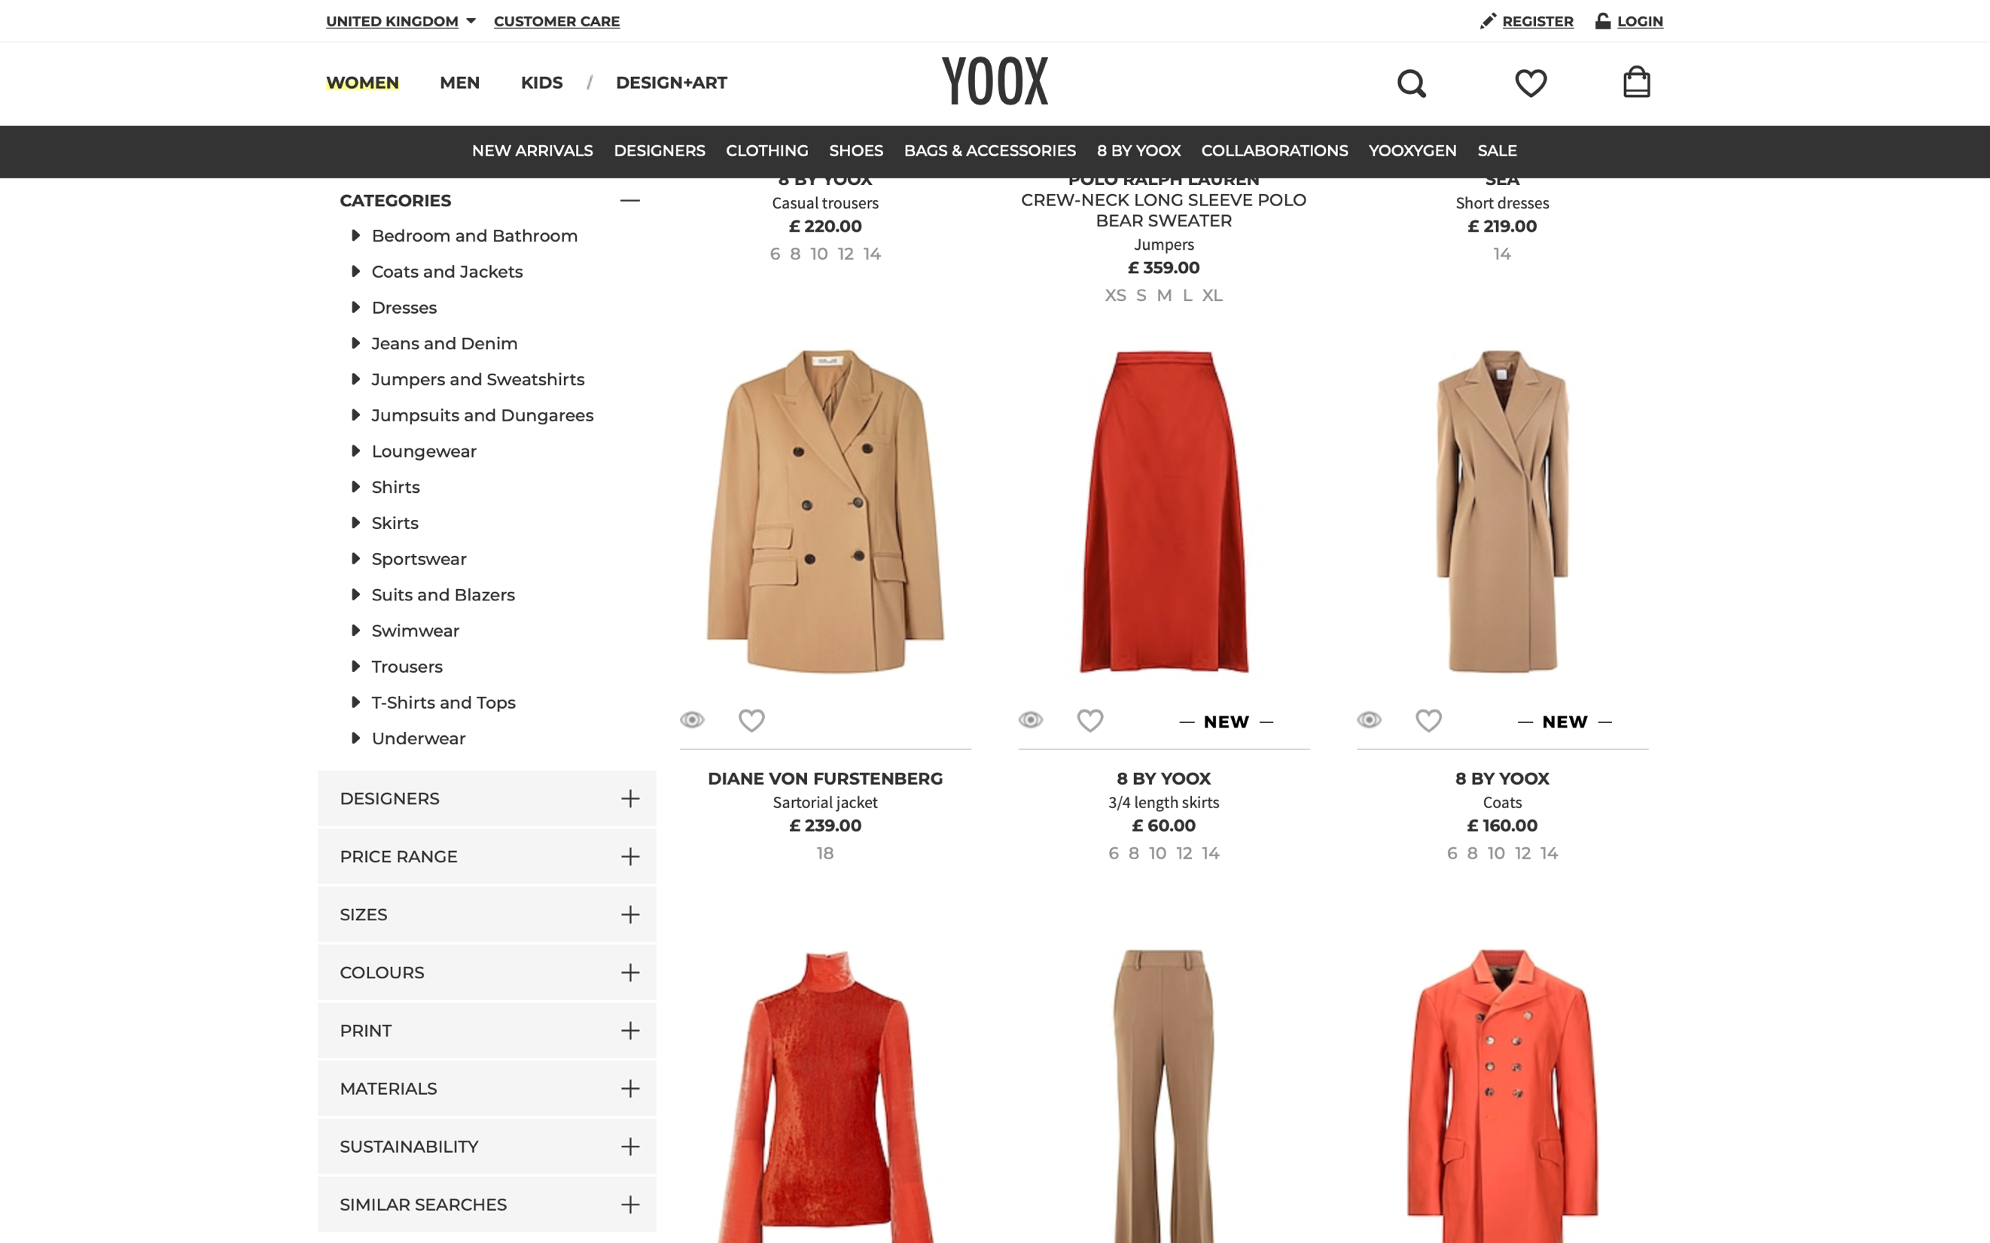

Figure 24: Category Page

**SHOPPING BAG / ORDER – Screenshots**

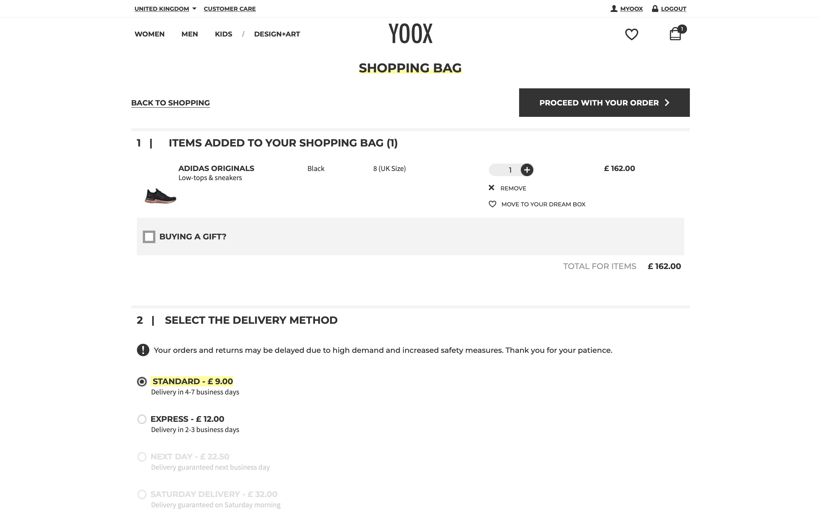

Figure 25: Shopping Bag / Order Page -1

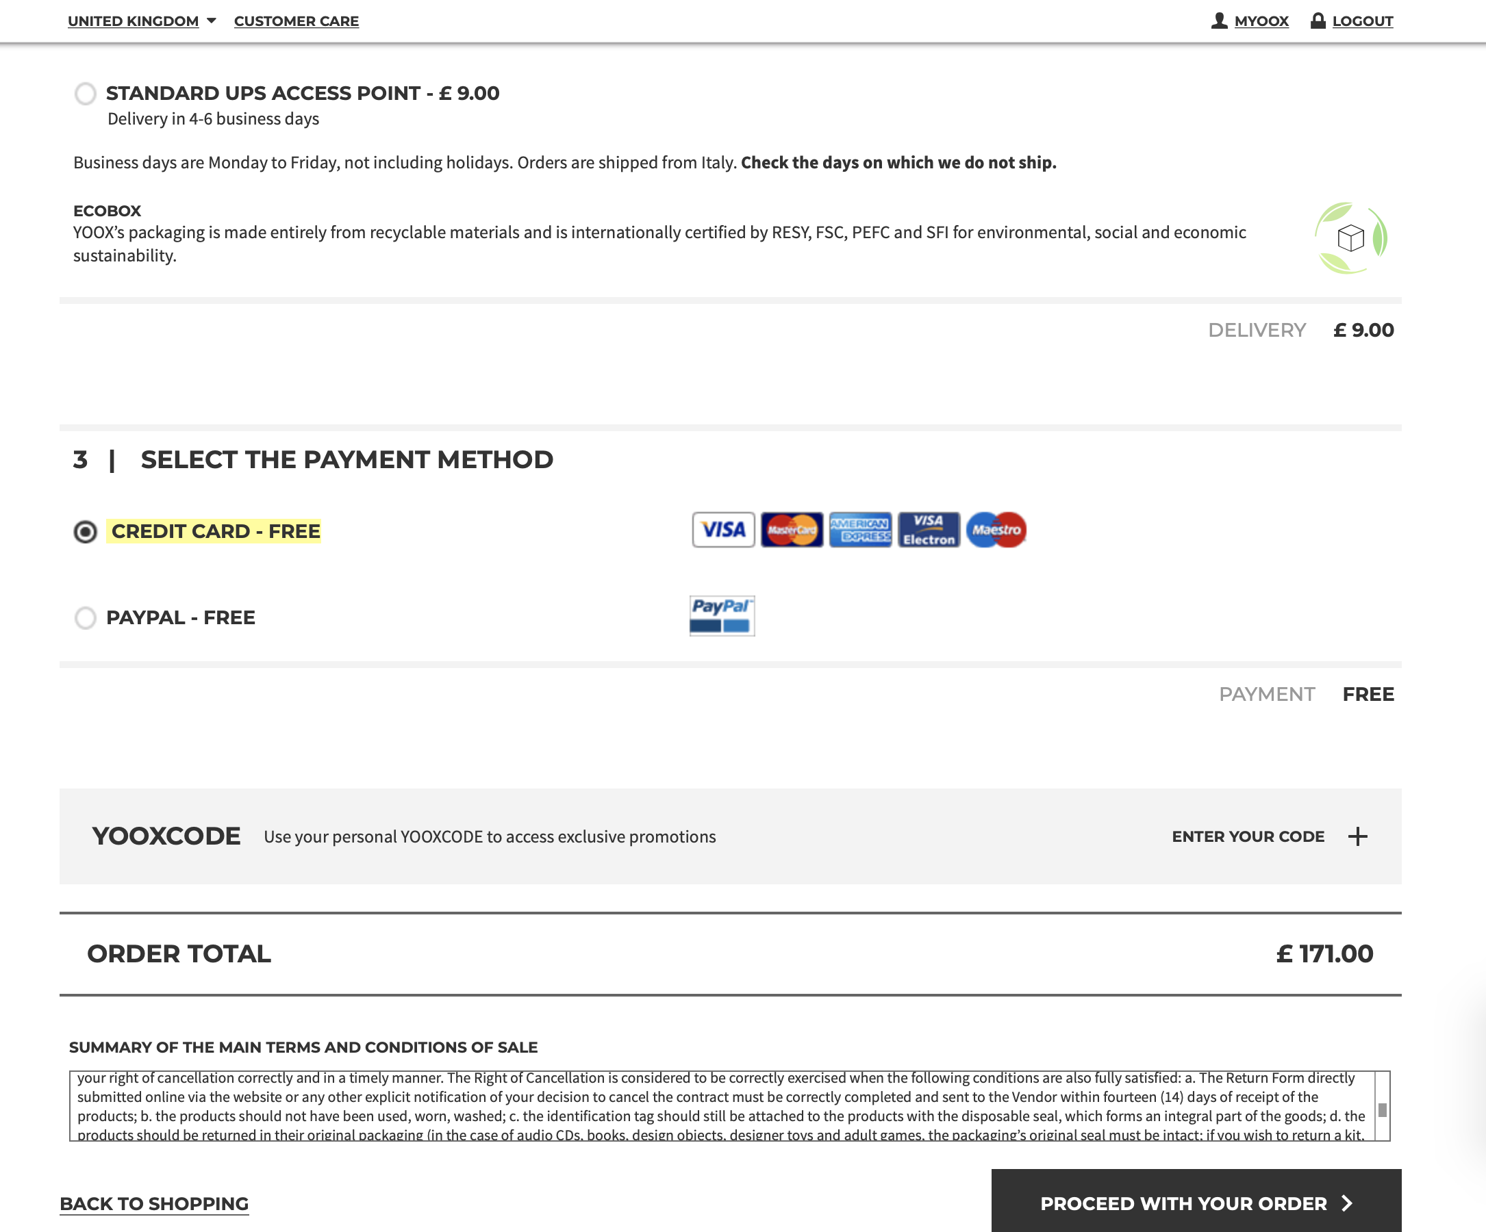

Figure 26: Shopping Bag / Order Page -2

## 1.3 Finalised List

### ***1.3.1 The generic list***

Table 7 shows the Generic list obtained by collecting the most important attributes from the three websites analysed in the previous sections.

Some attributes were removed from the list and the justification is presented in Section 1.3.2. Likewise, some attributes were added in order to keep in line with the requirements of the assignment.

Article’s details field is reduced to a general description of the item rather than a composite attribute containing the information stored in the websites analysed.

Table 7: Generic List

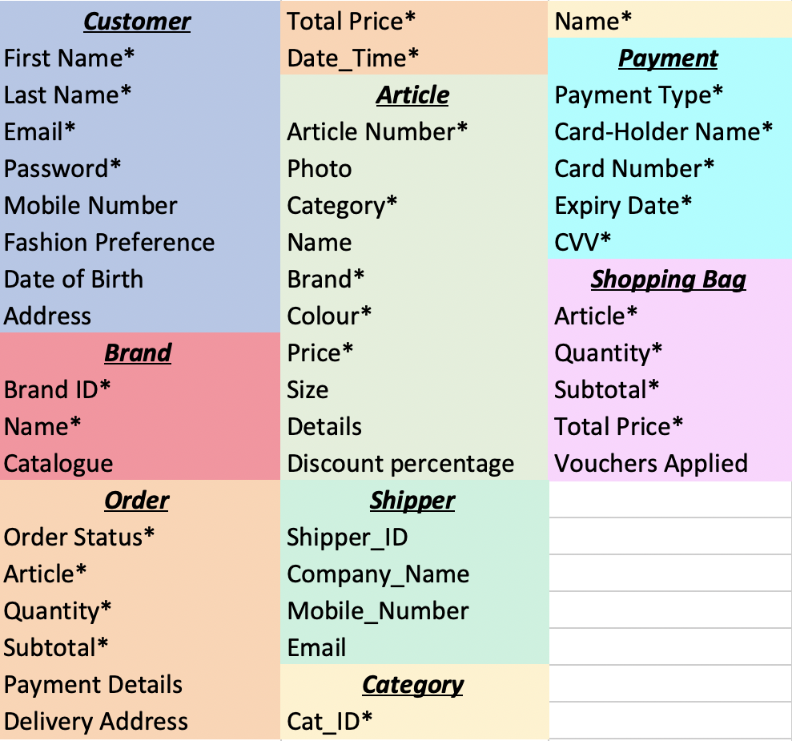

### ***1.3.2 Attributes rejected***

Table 8 shows all the attributes rejected sorted by their entities.

“Country” were rejected because, for the list purposed, it can be part of the composite attribute “Address” while “Following Brands”, “Article Rating” and “Reviews” were rejected as a uniquely feature of Zalando, hence not relevant for a fashion eCommerce database. Similarly, Brand description were rejected because it is present only on the ASOS website.

“Delivery Option”, “Transaction Status” and “Order Tracking” from the Order entity as well as “Delivery Day”, “Delivery Type” and “Delivery Price” from the Shopping Bag entity were removed as managed by a third-party courier, which is beyond of the scope of the following Report.

Table 8: Data – Fields rejected

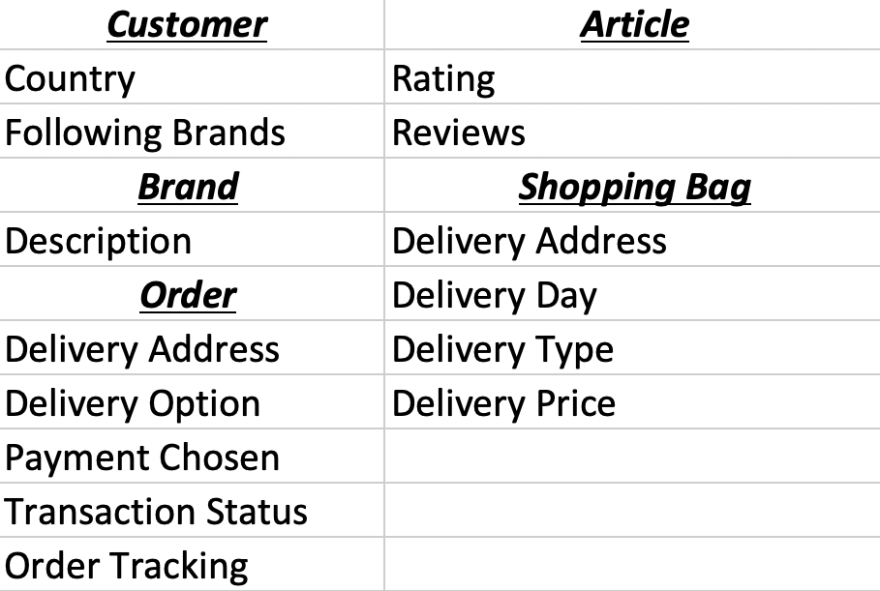

### ***1.3.3 Attributes added***

All the Delivery related attributes removed were replaced by a new entity called “Shipper”, whose aim is to keep track of the Companies that manage the item delivery.

“Date_Time” and “Discount percentage” were added to respectively store the day and time when a new order is created and the discount percentage of an item, should it be on sale.

Even though the Payment details were treated as composite attributes in ASOS and Yoox websites, they are collected and displayed as a new entity since it is something which belongs to the customer. However, it is explained in Section 2.1.2

Table 9: Data-Fields added

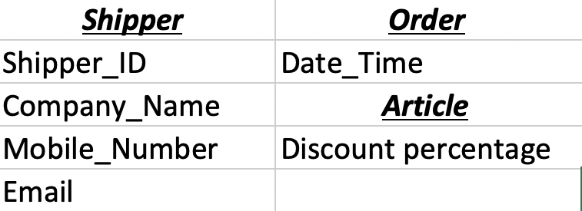

# 2. Database Design

## 2.1 Entity Relationship Modelling

In the following subsections, three Entity Relationship models are presented.

The initial one presented in Figure 27 aims to give a simple graphical representation of the Entities and Relationships gathered from the system.

From the ERD, it is possible to build the Extend ERD, which includes several extended notations such as the type and the cardinality of the relationships, the primary and the foreign keys (Figure 28).

Finally, the model is reviewed using the Normalisation techniques. The resulting EERD is presented in Figure 29.

### **2.1.1 Initial Entity Relationship Model**

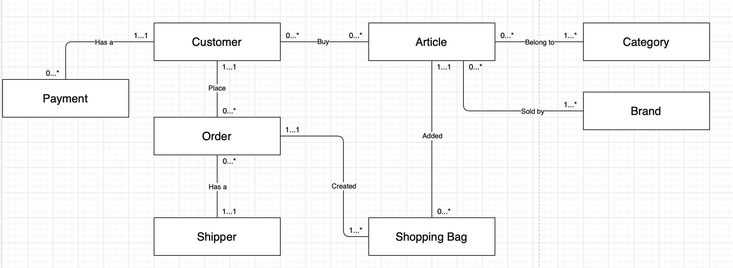

Figure 27: Initial Entity Relationship Diagram

In Figure 27, the Initial ERD is presented. How it is possible to see, all the entities gathered in Section 2.3.1 have been graphically represented as well as the relationships among them.

### **2.1.2 Extended Entity Relationship Model**

The Extended Entity Relationship Diagram is presented in Figure 28. The development process is composed by 5 main steps:

1. **Identify and define the entities:** The Address and Payment attributes are now defined as Entities;
2. **Identify the interaction among the entities**: Association, aggregation and compositions relationships;
3. **Identify the cardinality of the entities:** They can be 1 to 1, 1 to Many and Many to Many;
4. **Identified Primary Keys:** The attribute which makes unique an instance of an entity;
5. **Identified the Foreign Keys:** The attribute which relates one entity to the other;
6. **Extending Attributes:** Defined as Multi-valued and Derived attributes.

As mentioned in step 2, the relationships must be extended.

According to Guru99 (2020):

* Aggregation represents an “Has a” relationship, which means that a class belongs to the other but they have two independent lives. Therefore, if an instance of one of those entities is deleted, the related one will not be affected.
* Composition, instead, represents an “Is part of” relationship, which means that a class belongs to the other and their lives depend each other. Therefore, if an instance of one of those entities will be deleted, the related one should be deleted as well.

**Composition relationships**

Address and Payment entities are part of the Customer entity. In this respect, if customers delete their own account, the database will no longer have reason to keep their information.

Article entity is part of the Brand because, if the Brand is deleted from the Database, all its articles need to be deleted as well.

**Aggregation relationships**

Shipper has an order, as well as the Country has a City and the City has an address. Although these entities are strictly connected, they have an independent life.

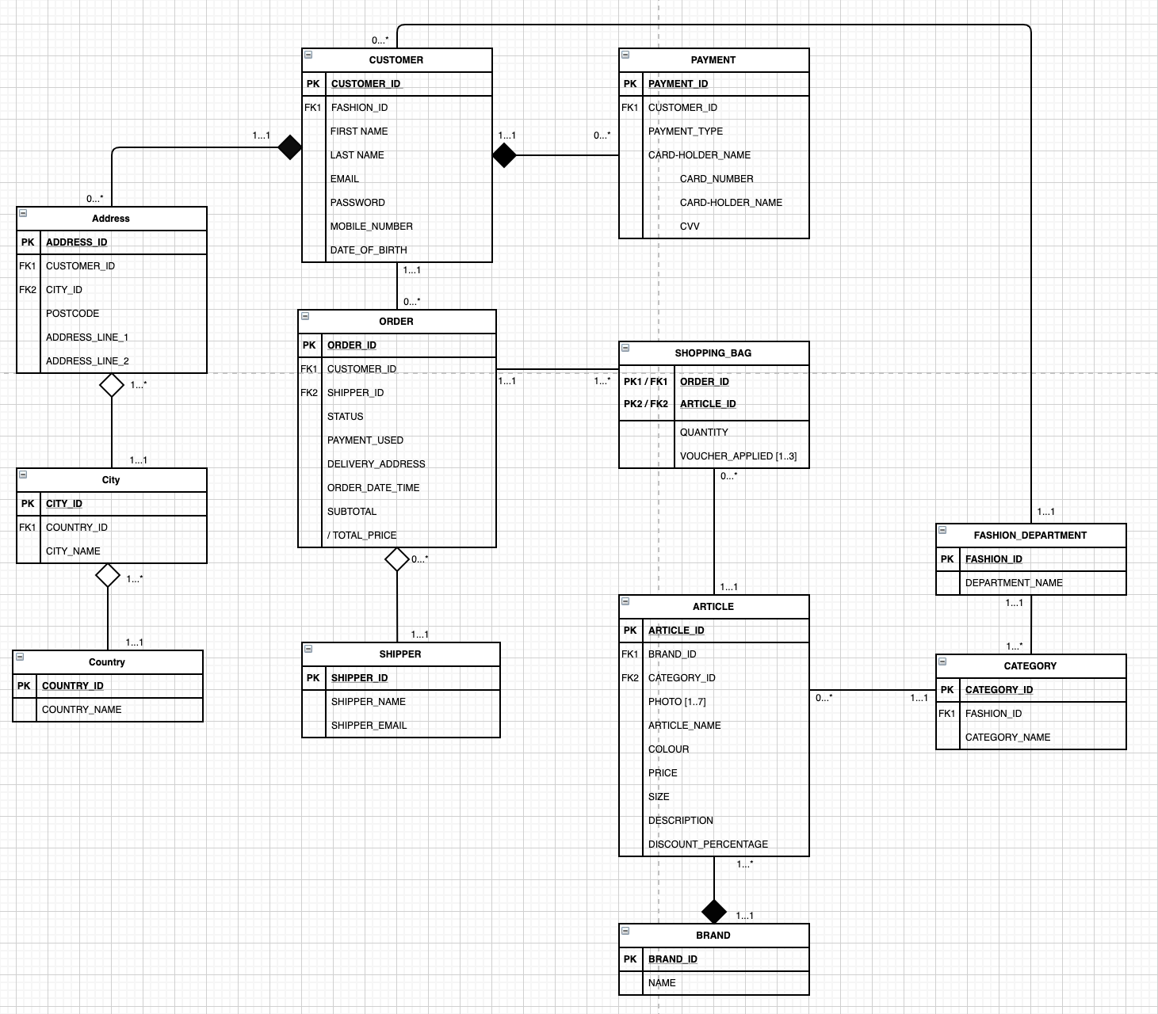

Figure 28: Extended Entity Relationship Diagram

## 2.2 Normalised Model

Normalisation is a multi-level process which aims at decomposing tables so to eliminate data redundancy and to improve consistency (Abhisheck Ahlawat, 2020).

In the proposed system, the EERD has been normalised following 3 normal forms (Connolly, T.M. Begg, C., 2015):

**First Normal Form (1NF)**

An entity is in 1NF if, and only if, it has an identifying key and there are no repeating attributes.

All the entities in the proposed EERD, have a unique identifier but there are 2 repeating attributes: “Voucher_Applied” in the “Shopping Bag” Table and “Photo” in the “Article” Table.

It is important to notice that, even though “Colour” is a single value attribute. It has become an entity as it would be easy to store all the colours and then each article “has-a” colour.

**Second Normal Form (2NF)**

An entity is in 2NF if, and only if, it is in 1NF and has no attributes which require only part of the key to identify them uniquely.

In this case, the EERD passed the 1NF and it has no attributes which require only part of the key to identify them uniquely.

**Third Normal Form (3NF)**

An entity is in 3NF if, and only if, it is in 2NF and no non-key attribute depends on any other non-key attribute.

In the proposed system, “Payment_Used” and “Delivery_Address” attributes in the Order table depend on other non-key attributes. However, they are left voluntarily because of legal purposes. In this respect, if customers make an order and then they change their payment method or their address in the account, these data will be automatically changed in the order previously made leading both to wrong information and to problems when, for instance, customers request for a refund.

These composite attributes have the same fields presented in the “Address” and “Payment” tables.

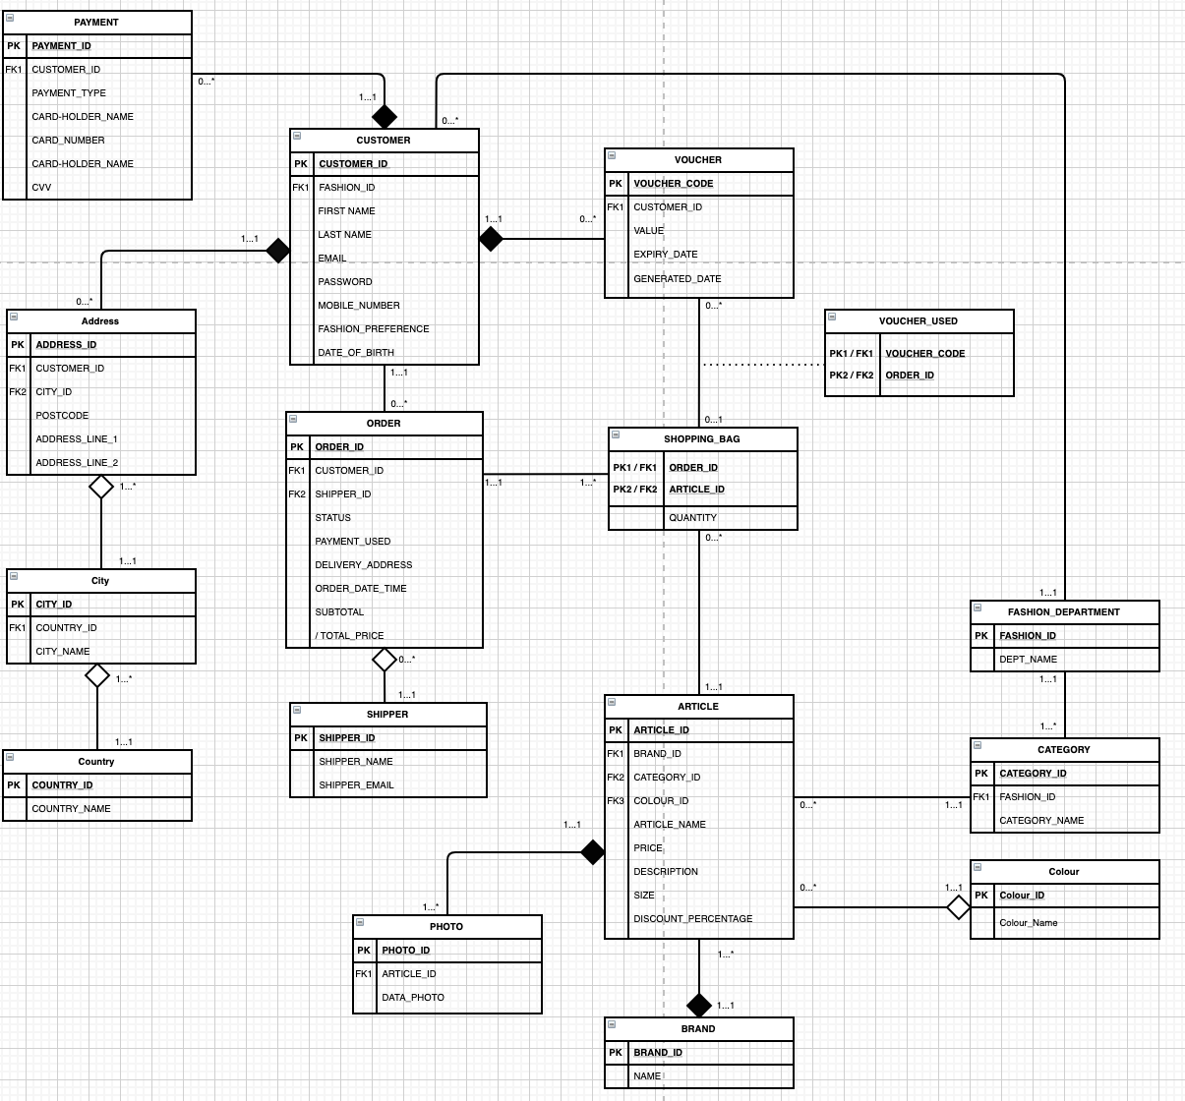

Figure 29: Normalised Extended Entity Relationship Diagram

## 2.3 Database Schema

### ***2.3.1 Payment Table***

|  |  |  |
| --- | --- | --- |
| **Payment** | | |
| **Attribute Name** | **Type** | **Description** |
| Payment_ID | Varchar(10) | Primary Key, unique |
| Customer_ID | Varchar(10) | Foreign Key from Customer table – holds Customer’s indexed |
| Payment_Type | ENUM | Stores the circuit - (American Express, Visa, Master Card) |
| Card_Number | Bigint(16) | Stores the number of the card |
| Card-holder_Name | Varchar(10) | Stores the name of the owner of the card |
| CVV | Smallint(3) | Stores the CVV which belongs to the card |

### ***2.3.2 Customer Table***

|  |  |  |
| --- | --- | --- |
| **Customer** | | |
| **Attribute Name** | **Type** | **Description** |
| Customer_ID | Varchar(10) | Primary Key, unique |
| Fashion_ID | Int(1) | Foreign Key from Fashion_Department table – holds Fashion_Department’s indexed |
| First Name | Varchar(50) | Stores the customer’s name |
| Last Name | Varchar(50) | Stores the customer’s surname |
| Email | Varchar(50) | Stores the customer’s email |
| Password | Varchar(200) | Stores the customer’s password |
| Mobile_Number | Varchar(20) | Stores the customer’s mobile number |
| Date_of_Birth | Datetime | Stores the customer’s date of birth |

### **2.3.3 Address Table**

|  |  |  |
| --- | --- | --- |
| **Address** | | |
| **Attribute Name** | **Type** | **Description** |
| Address_ID | Varchar(10) | Primary Key, unique |
| Customer_ID | Varchar(10) | Foreign Key from Customer table – holds Customer’s indexed |
| City_ID | Smallint(5) | Foreign Key from City table – holds City’s indexed |
| Postcode | Mediumint(6) | Stores the postcode belonging to the address |
| Address_Line_1 | Varchar(20) | Stores the first address line |
| Address_Line_2 | Varchar(20) | Stores the second address line |

### **2.3.4 City Table**

|  |  |  |
| --- | --- | --- |
| **City** | | |
| **Attribute Name** | **Type** | **Description** |
| City_ID | Smallint(5) | Primary Key, unique |
| Country_ID | Tinyint(2) | Foreign Key from Country table – holds Country’s indexed |
| City_Name | Varchar(10) | Stores the name of the city |

### **2.3.5 Country Table**

|  |  |  |
| --- | --- | --- |
| **Country** | | |
| **Attribute Name** | **Type** | **Description** |
| Country_ID | Tinyint(2) | Primary Key, unique |
| Country_Name | Varchar(10) | Stores the name of the country |

### **2.3.6 Order Table**

|  |  |  |
| --- | --- | --- |
| **Order** | | |
| **Attribute Name** | **Type** | **Description** |
| Order_ID | Varchar(10) | Primary Key, unique |
| Customer_ID | Varchar(10) | Foreign Key from Customer table – holds Customer’s indexed |
| Shipper_ID | Mediumint(5) | Foreign Key from Shipper table – holds Shipper’s indexed |
| Status | Varchar(20) | Stores the status of the order |
| Payment_Used | - | Composite Attribute – All the fields in Payment Table |
| Delivery_Address | - | Composite Attribute – All the fields in Address Table |
| Order_Date_Time | Datetime | Stores the date and the time when the order was created |
| Subtotal | Decimal(10,2) | Stores the amount of the order, without taxes |
| Total_Price | Decimal(10,2) | Stores the amount of the order, with taxes |

### **2.3.7 Shipper Table**

|  |  |  |
| --- | --- | --- |
| **Shipper** | | |
| **Attribute Name** | **Type** | **Description** |
| Shipper_ID | Mediumint(5) | Primary Key, unique |
| Shipper_Name | Varchar(50) | Stores the name of the Shipper |
| Shipper_Email | Varchar(50) | Stores the email of the Shipper |

### **2.3.8 Voucher Table**

|  |  |  |
| --- | --- | --- |
| **Voucher** | | |
| **Attribute Name** | **Type** | **Description** |
| Voucher_Code | Bigint(16) | Primary Key, unique |
| Customer_ID | Varchar(10) | Foreign Key from Customer table – holds Customer’s indexed |
| Value | Decimal(10,2) | Stores the value of the Voucher |
| Expiry_Date | Datetime | Stores the expiry date of the Voucher |
| Generated_Date | Datetime | Stores the date and the time when the Voucher was created |

### **2.3.9 Voucher_Used Table**

|  |  |  |
| --- | --- | --- |
| **Voucher_Used** | | |
| **Attribute Name** | **Type** | **Description** |
| Voucher_Code | Bigint(16) | Composite Key from Voucher Table – holds Voucher’s code |
| Order_ID | Varchar(10) | Composite Key from Order table – holds Order’s indexed |

### **2.3.10 Shopping_Bag Table**

|  |  |  |
| --- | --- | --- |
| **Shopping_Bag** | | |
| **Attribute Name** | **Type** | **Description** |
| Order_ID | Varchar(10) | Composite Key from Order table – holds Order’s indexed |
| Article_ID | Varchar(10) | Composite Key from Article table – holds Article’s indexed |
| Quantity | Int(1) | Stores the number of pieces for each item into the Bag |

### **2.3.11 Article Table**

|  |  |  |
| --- | --- | --- |
| **Article** | | |
| **Attribute Name** | **Type** | **Description** |
| Article_ID | Varchar(10) | Primary Key, unique |
| Brand_ID | Varchar(10) | Foreign Key from Brand table – holds Brand’s indexed |
| Category_ID | Mediumint(5) | Foreign Key from Category table – holds Category’s indexed |
| Photo_ID | Varchar(10) | Foreign Key from Photo table – holds Photo’s indexed |
| Colour_ID | Int(5) | Foreign Key from Colour table – holds Colour’s indexed |
| Article_Name | Varchar(50) | Stores the name of the Article |
| Price | Decimal(10,2) | Stores the price of the Article |
| Size | ENUM | Stores the size of the Article - (XS, S, M , L, XL, XXL) |
| Description | Varchar(5000) | Stores the description of the Article |
| Discount_Percentage | Decimal(5,2) | Stores the discount of the Article, in percentage |

### **2.3.12 Photo Table**

|  |  |  |
| --- | --- | --- |
| **Photo** | | |
| **Attribute Name** | **Type** | **Description** |
| Photo_ID | Varchar(10) | Primary Key, unique |
| Article_ID | Varchar(10) | Foreign Key from Article table – holds Article’s indexed |
| Data_Photo | Varbinary (MAX) | Stores the data of the photo |

### **2.3.13 Colour Table**

|  |  |  |
| --- | --- | --- |
| **Colour** | | |
| **Attribute Name** | **Type** | **Description** |
| Colour_ID | Int(5) | Primary Key, unique |
| Colour_Name | Varchar(50) | Stores the name of the colour |

### **2.3.14 Brand Table**

|  |  |  |
| --- | --- | --- |
| **Brand** | | |
| **Attribute Name** | **Type** | **Description** |
| Brand_ID | Varchar(10) | Primary Key, unique |
| Name | Varchar(50) | Stores the name of the Brand |

### **2.3.15 Category Table**

|  |  |  |
| --- | --- | --- |
| **Category** | | |
| **Attribute Name** | **Type** | **Description** |
| Category_ID | Mediumint(5) | Primary Key, unique |
| Fashion_ID | Int(1) | Foreign Key from Fashion table – holds Fashion’s indexed |
| Category_Name | Varchar(10) | Stores the name of the Category |

### **2.3.16 Fashion_Department Table**

|  |  |  |
| --- | --- | --- |
| **Fashion_Department** | | |
| **Attribute Name** | **Type** | **Description** |
| Fashion_ID | Int(1) | Primary Key, unique |
| Dept_Name | ENUM | Stores the name of the Department - (Men, Women, Kids) |

# 3. Database Implementation

The following ‘eCommerce’ database, has been implemented using phpMyAdmin, version 5.0.4. MariaDB, which is the database server used, is one of the most popular open source relational databases created by the developers of MySQL (MariaDB Foundation, 2020).

Figure 30, shows the implemented tables of the eCommerce Database. Data were inserted for testing purposes.

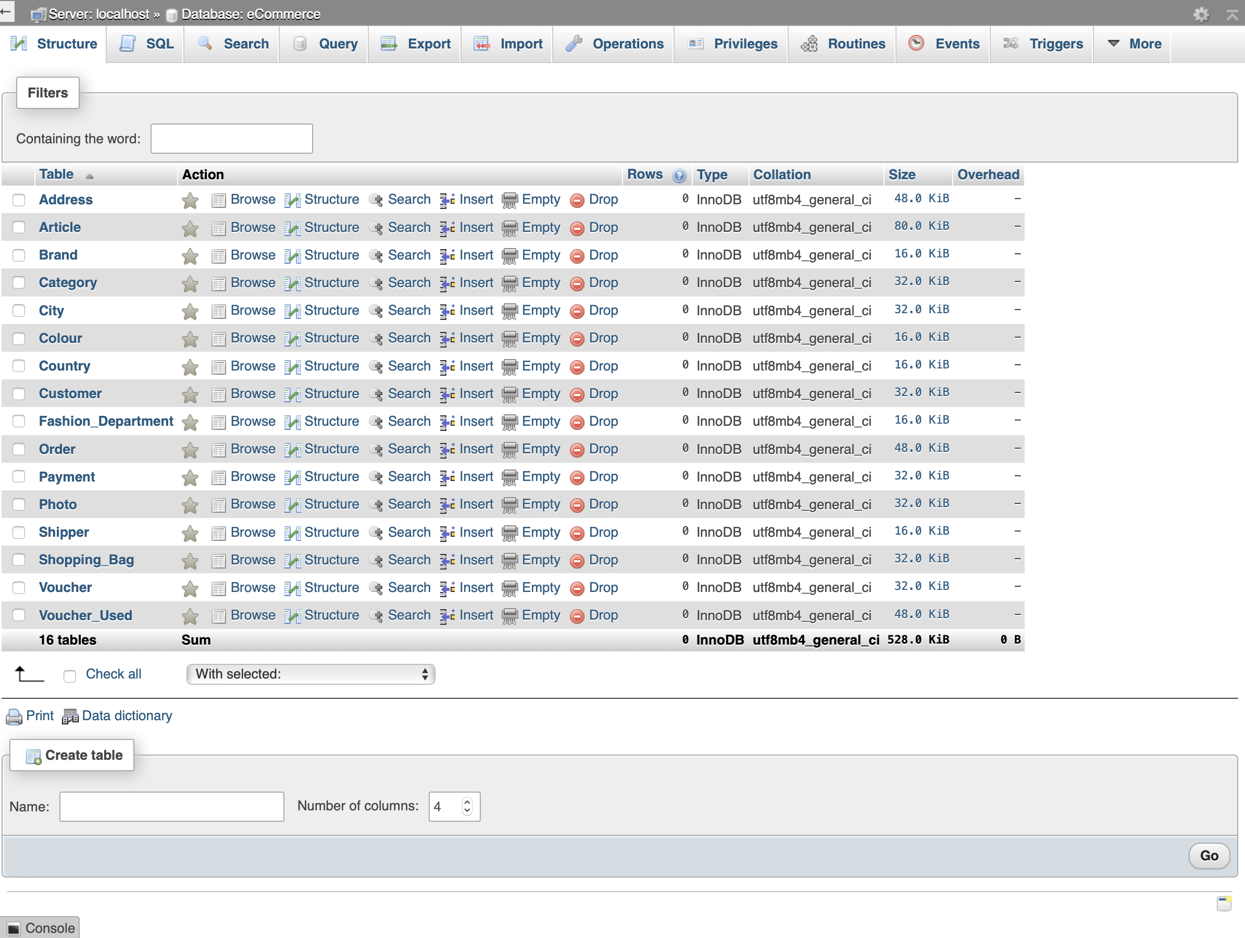

Figure 30: eCommerce Database's Tables

While the completed eCommerce database’s tables with data are presented in Section 3.1, the output generated by dumping SQL code of individual tables as well as indexes, auto increments and constraints is represented in Section 3.2.

## 3.1 Tables with Data

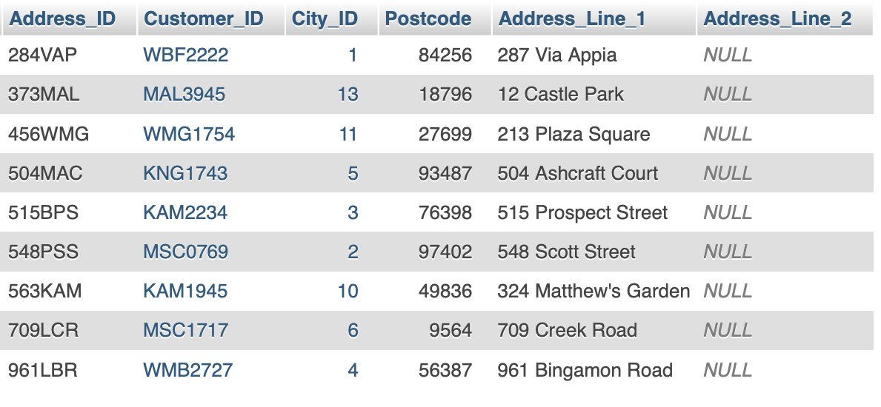

Figure 31: Address Table

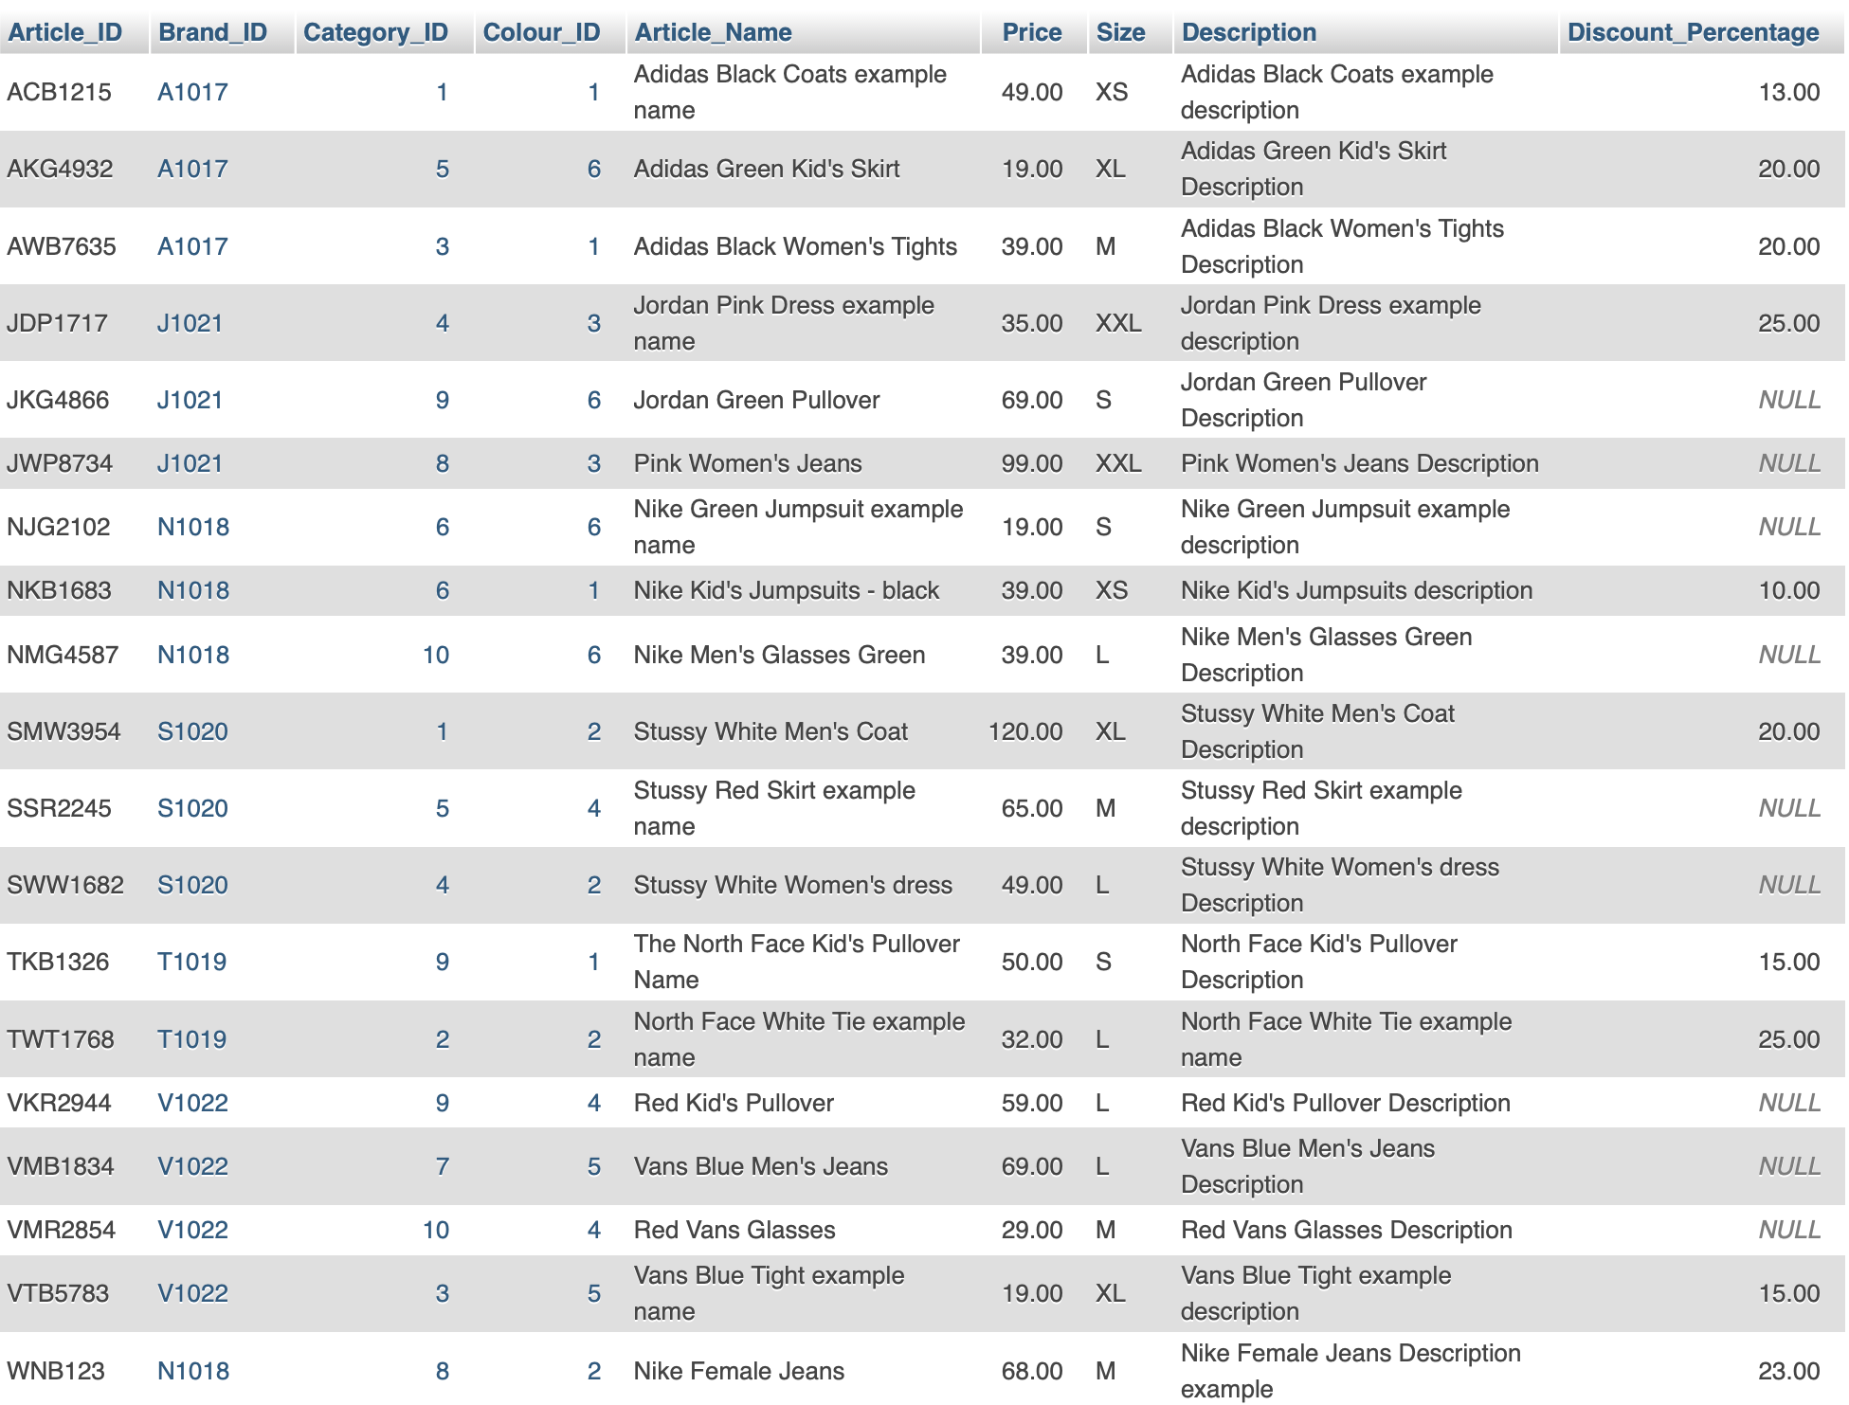

Figure 32: Article Table

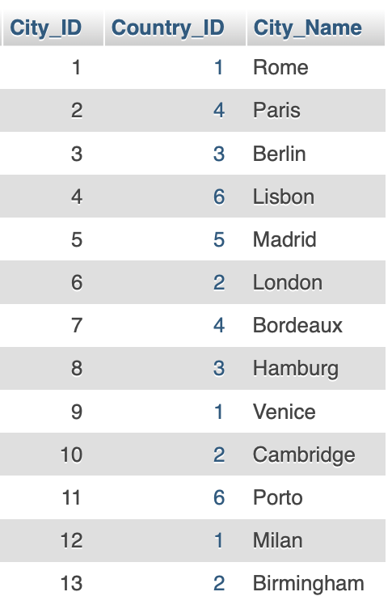 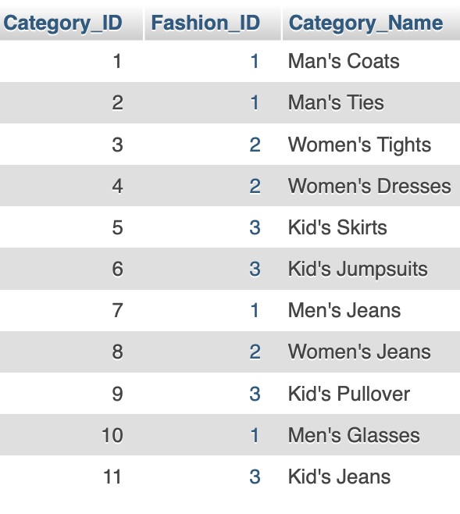

Figure 33: City Table Figure 34: Category Table

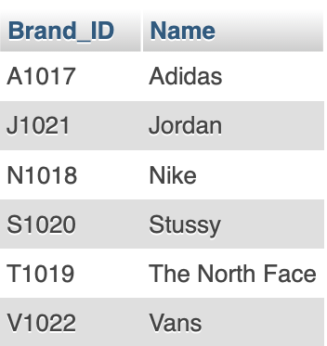 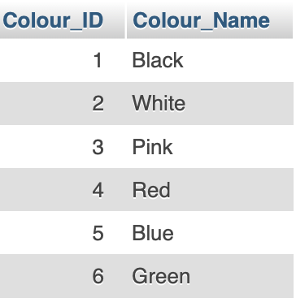

Figure 35: Brand Table Figure 36: Colour Table

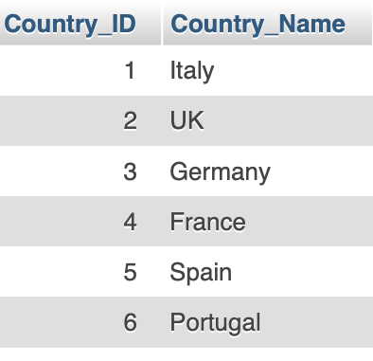 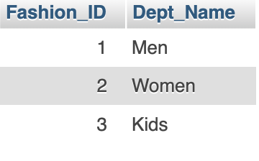

Figure 37: Country Table Figure 38: Fashion_Department Table

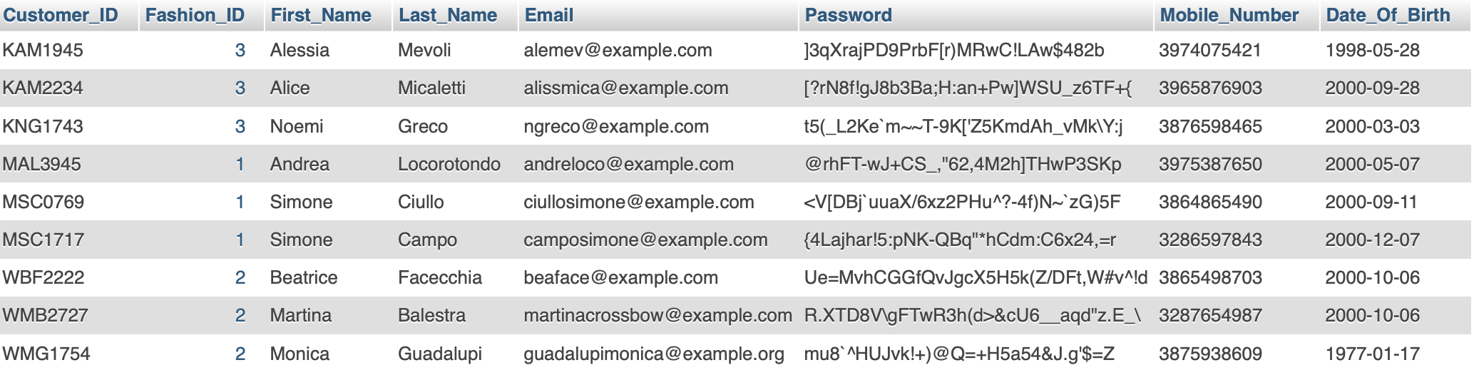

Figure 39: Customer Table

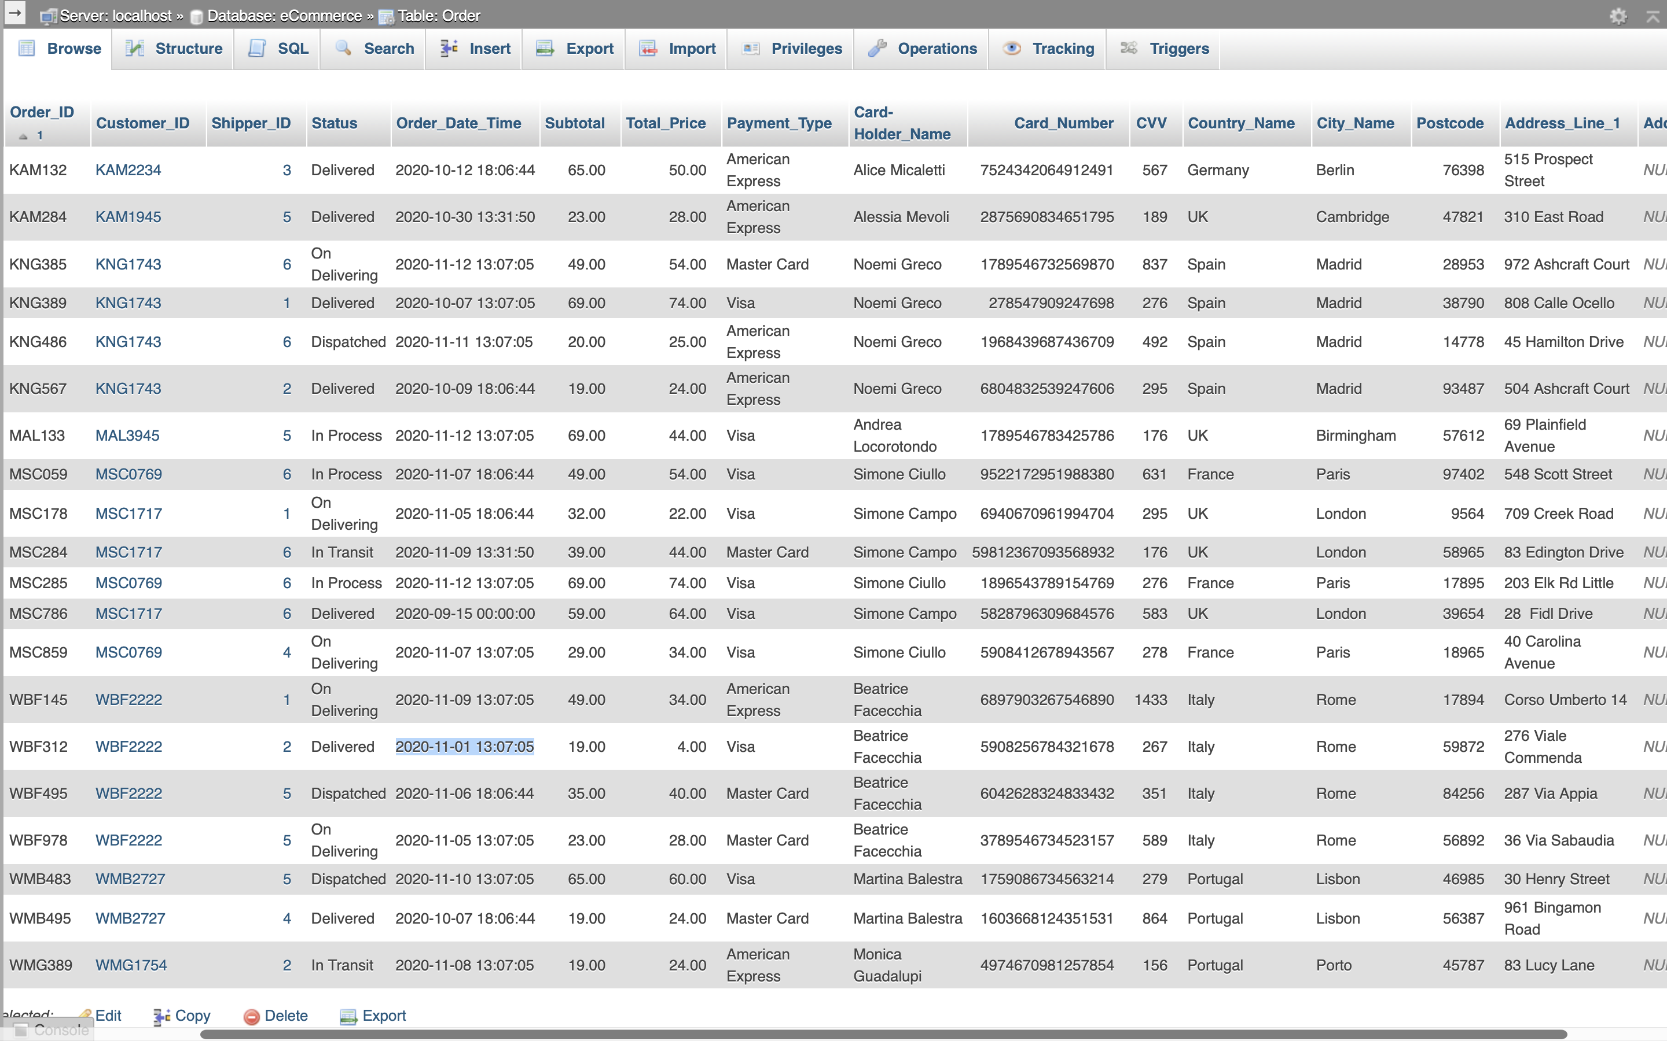

Figure 40: Order Table

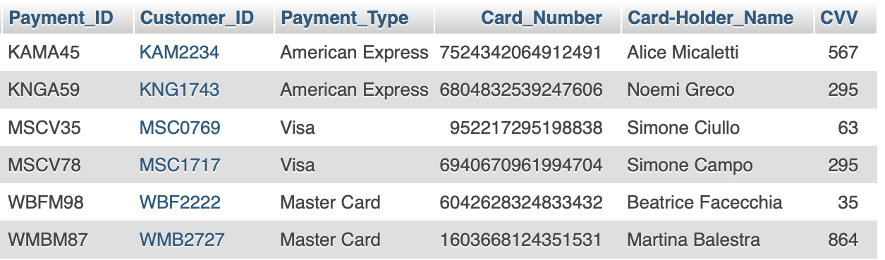

Figure 41: Payment Table

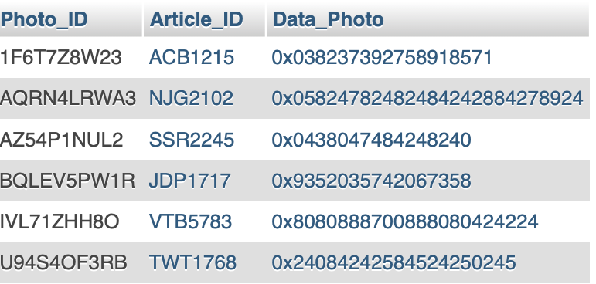

Figure 42: Photo Table

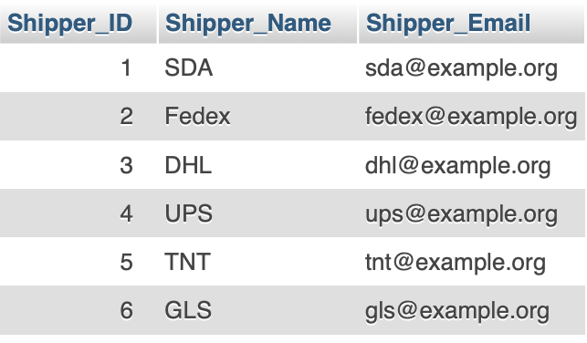

Figure 43: Shipper Table

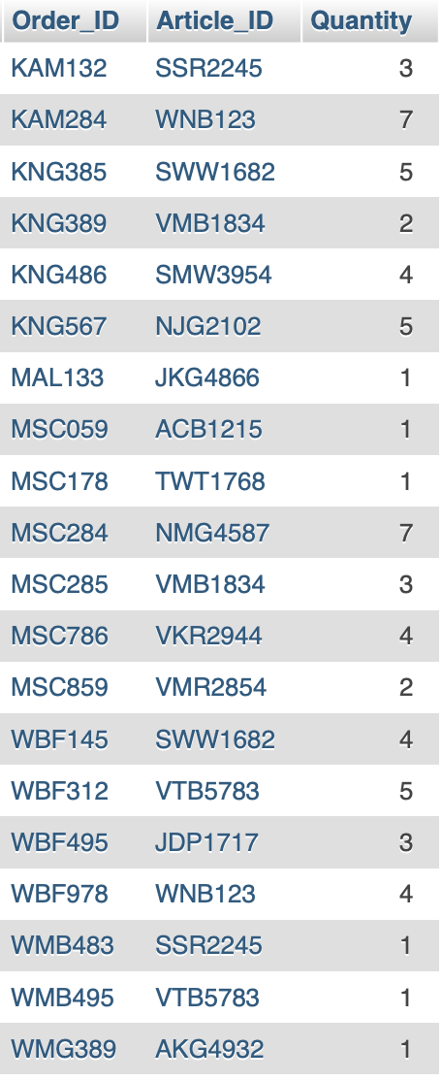

Figure 44: Shopping_Bag Table

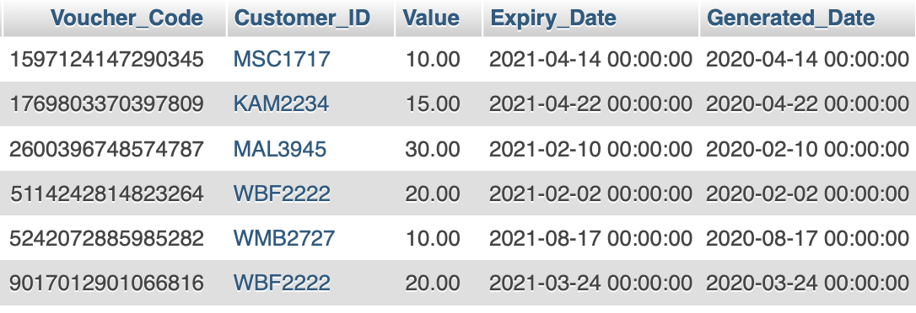

Figure 45: Voucher Table

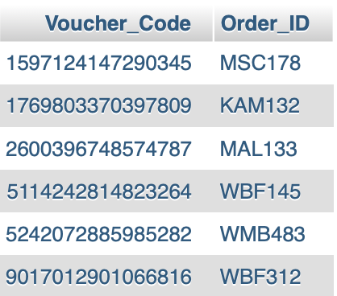

Figure 46: Voucher_Used Table

## 3.2 Create Table Statements

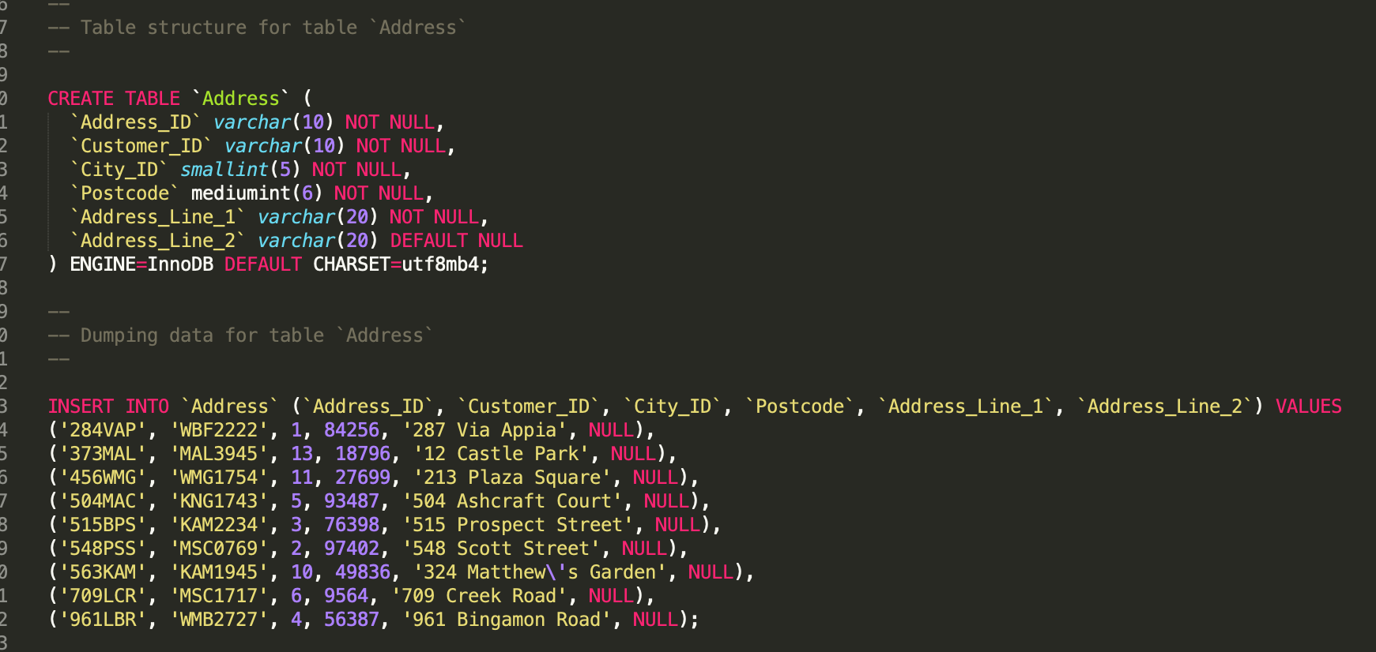

Figure 47: Details of the implementation of Address Table.

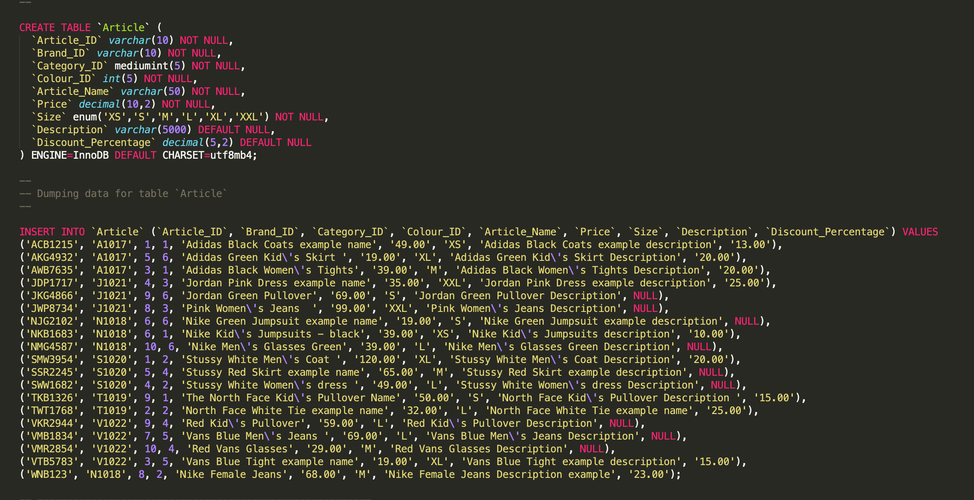

Figure 48: Details of the implementation of Article Table.

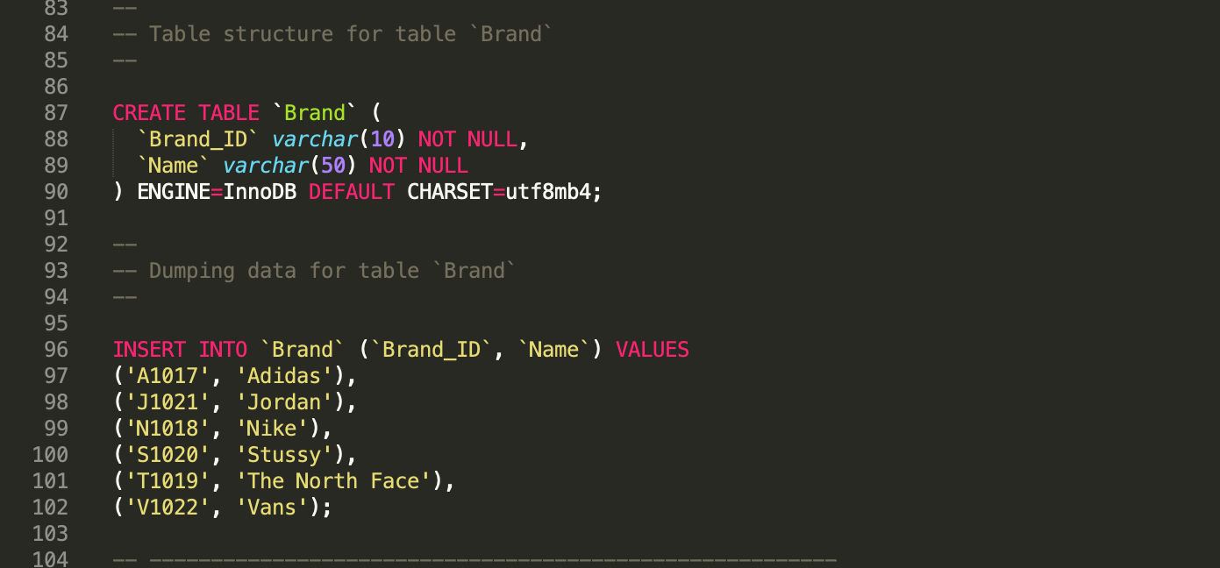

Figure 49: Details of the implementation of Brand Table.

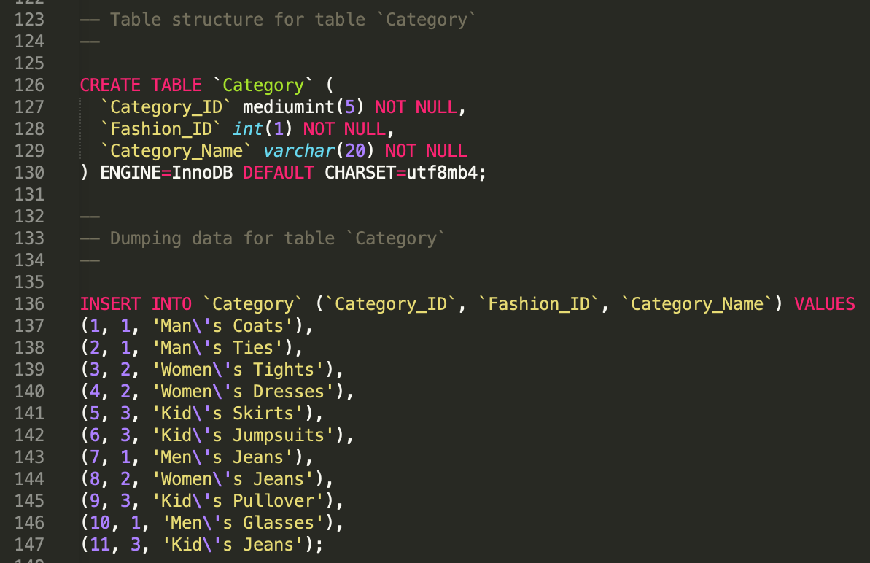

Figure 50: Details of the implementation of Category Table.

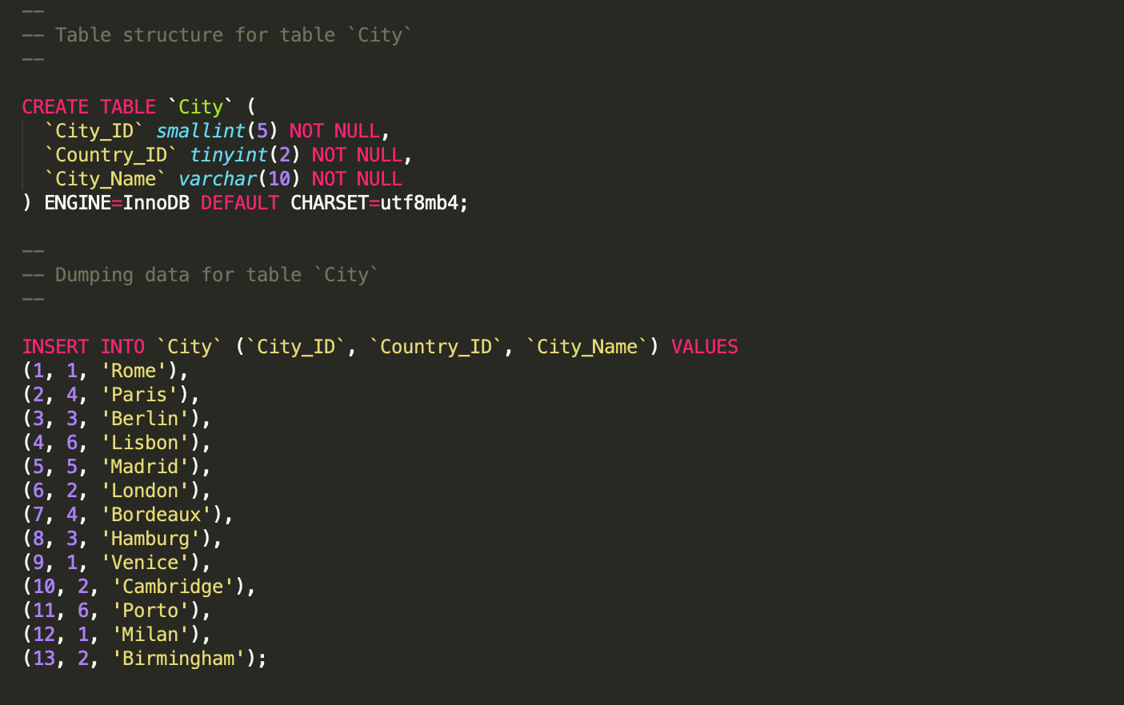

Figure 51: Details of the implementation of City Table.

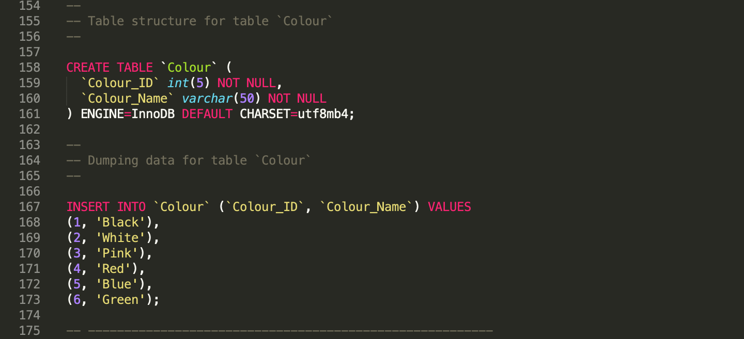

Figure 52: Details of the implementation of Colour Table.

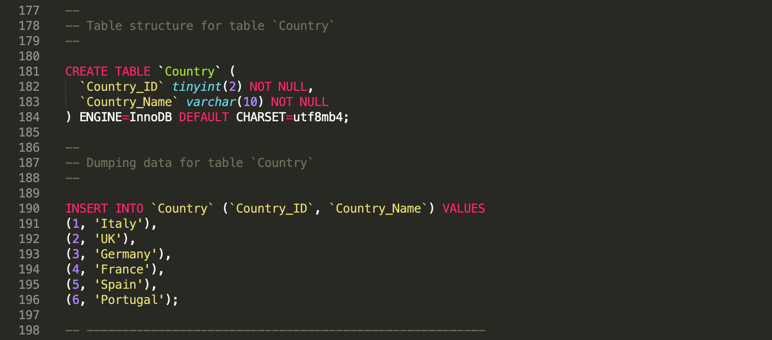

Figure 53: Details of the implementation of Country Table.

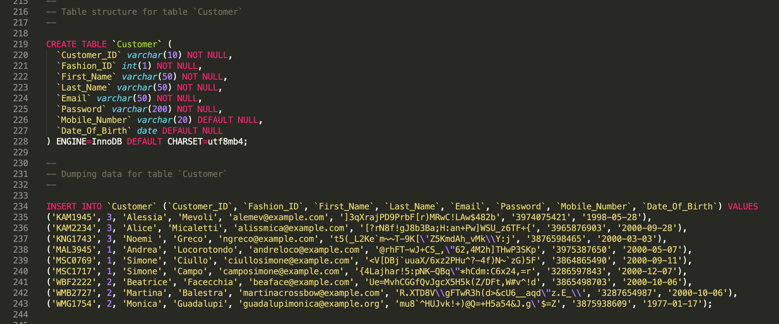

Figure 54: Details of the implementation of Customer Table.

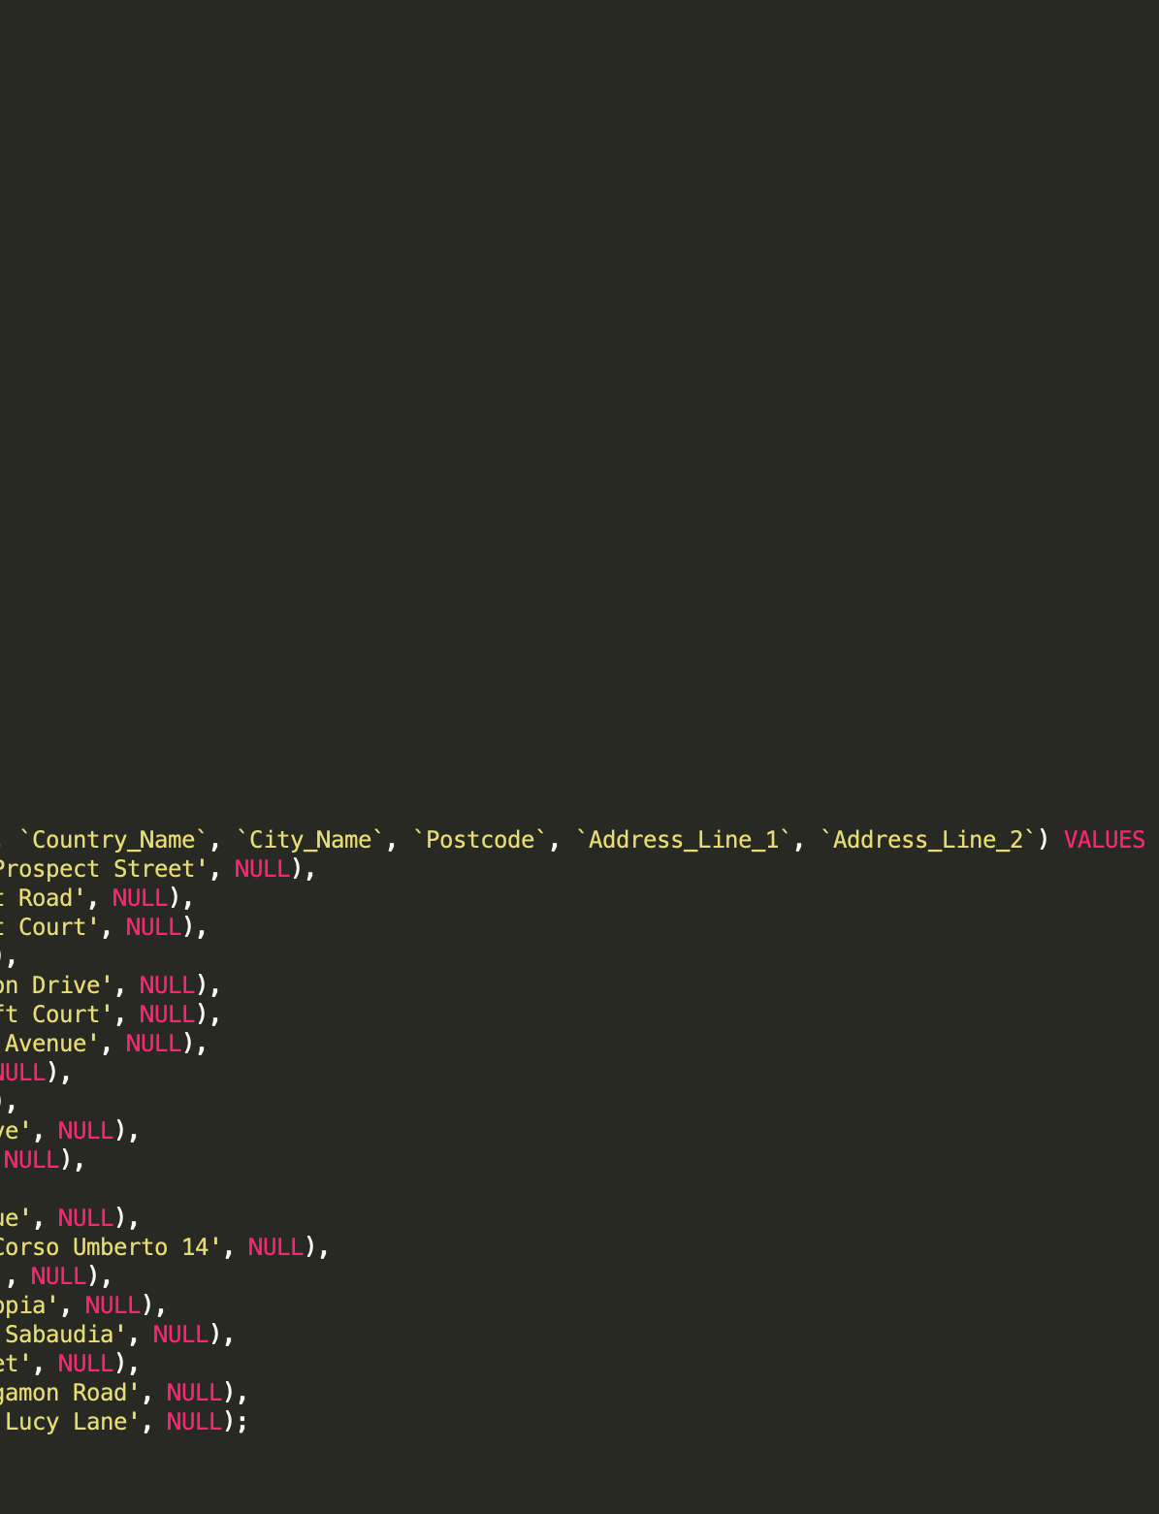

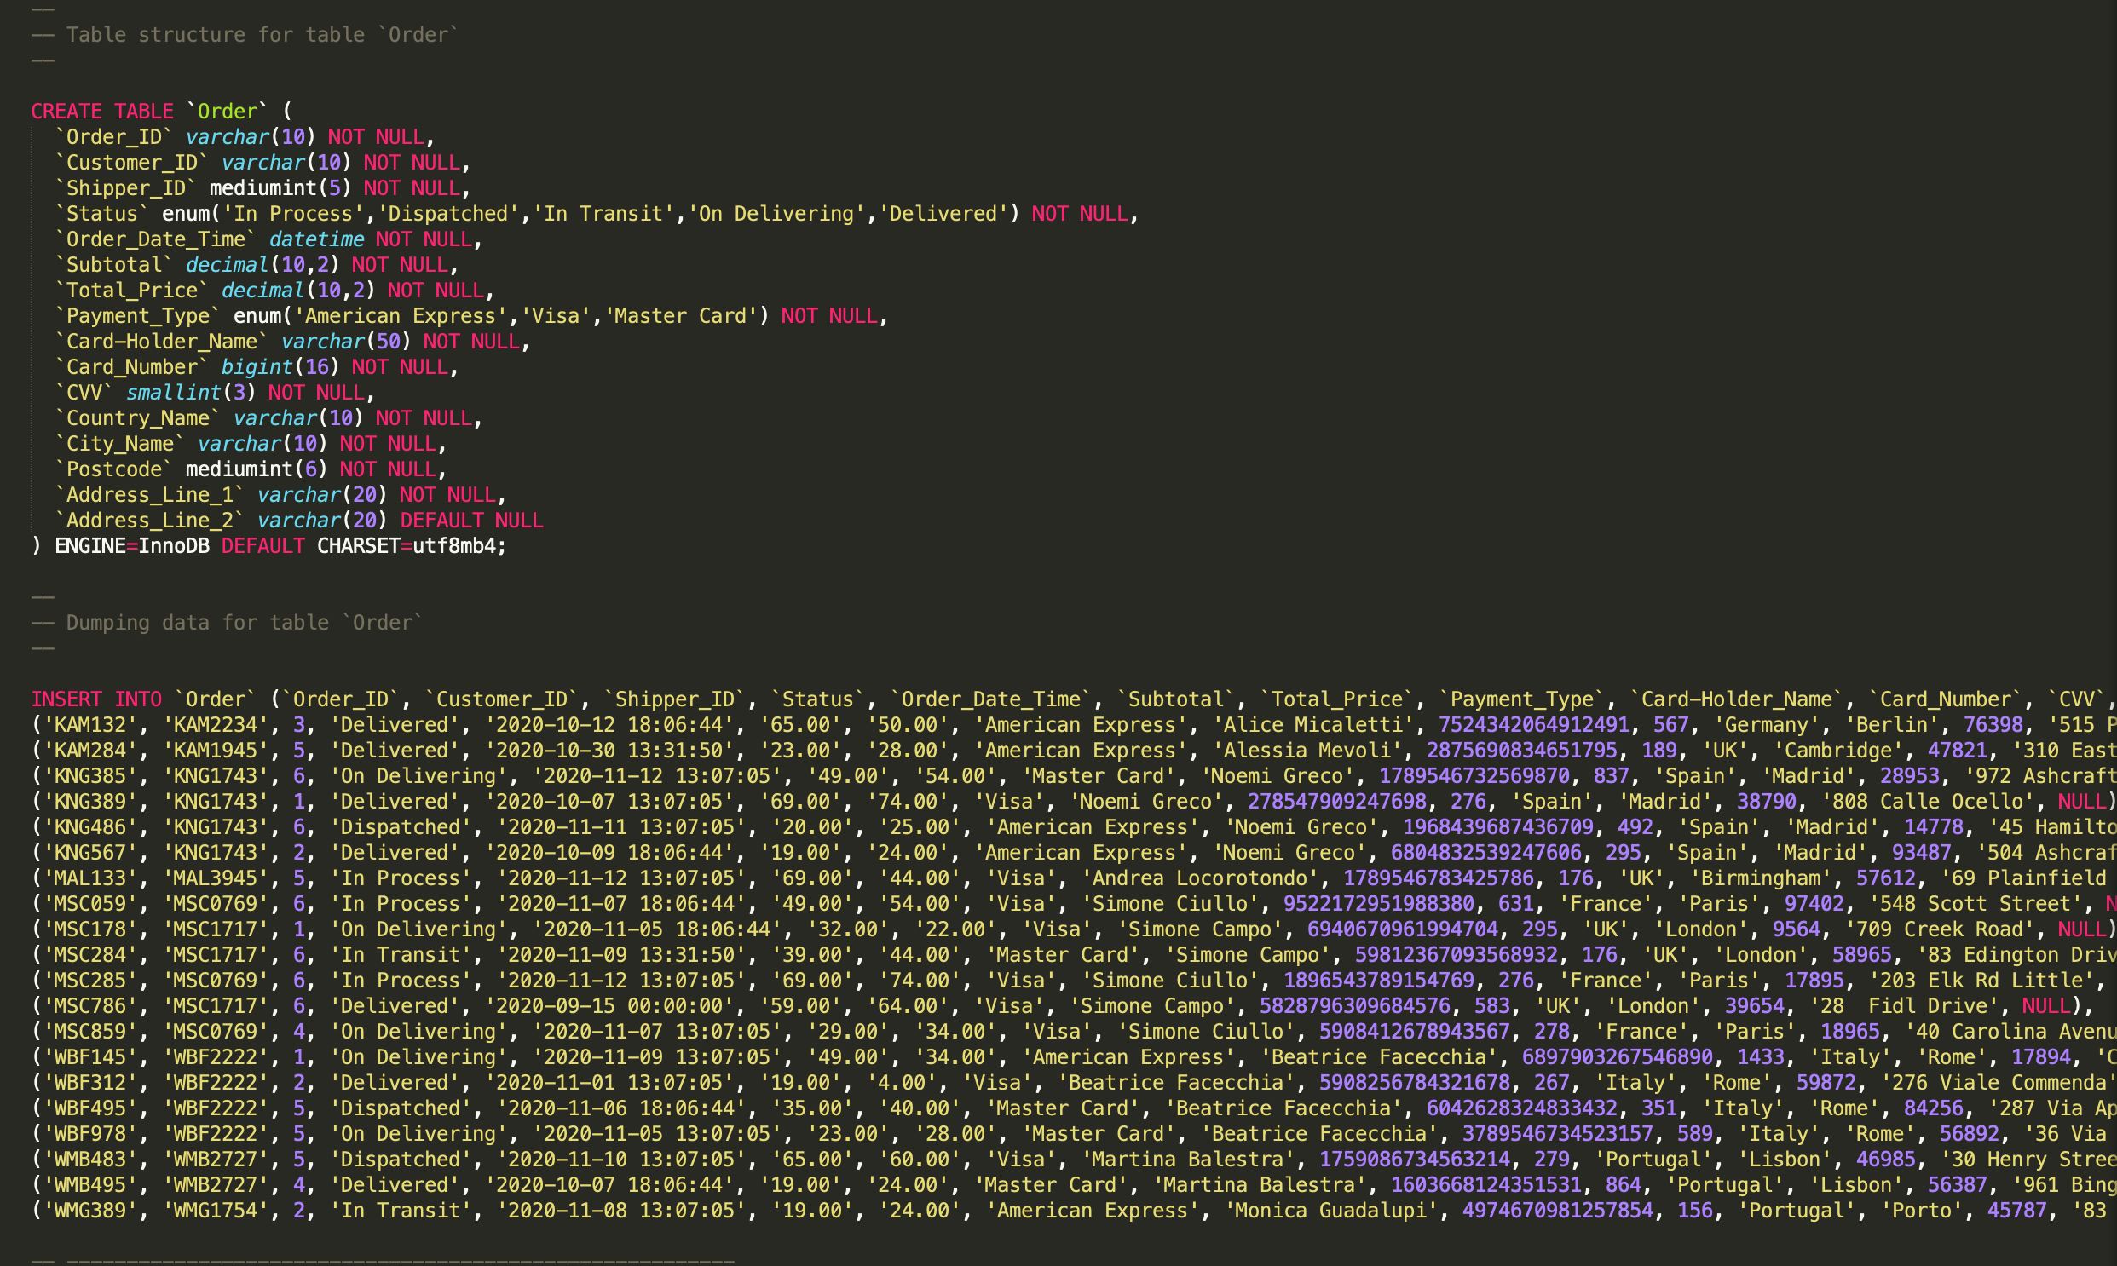

Figure 55: Details of the implementation of Order Table.

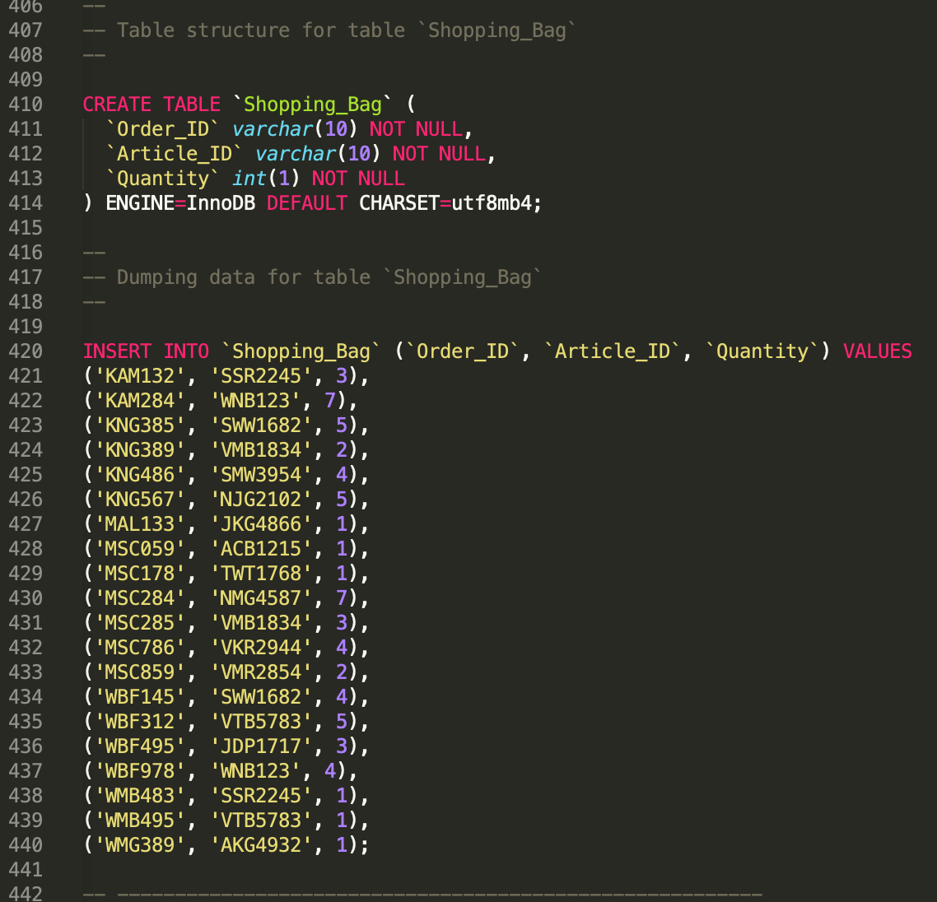

Figure 56: Details of the implementation of Fashion_Department Table.

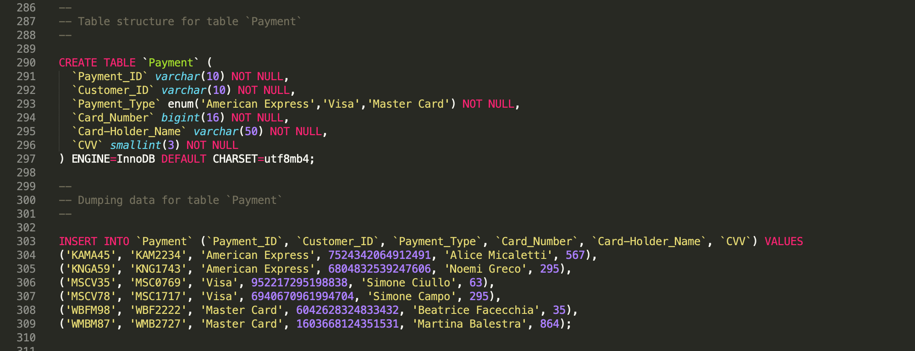

Figure 57: Details of the implementation of Payment Table.

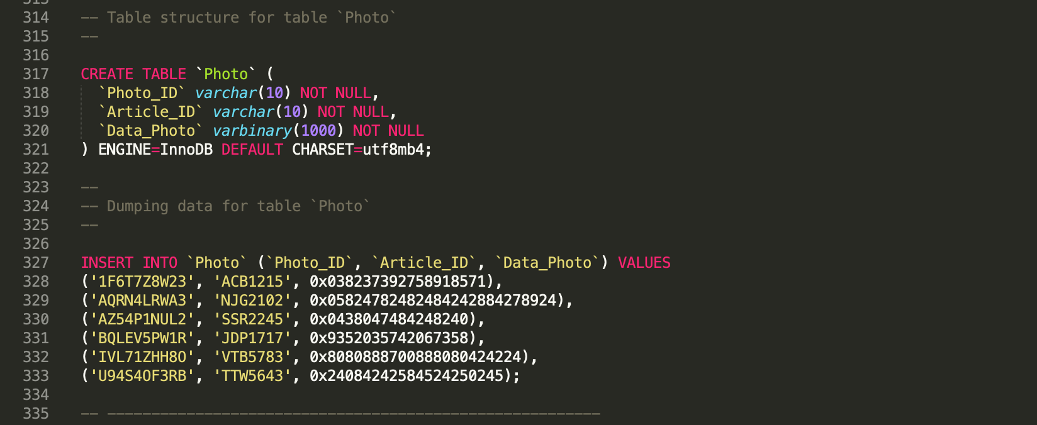

Figure 58: Details of the implementation of Photo Table.

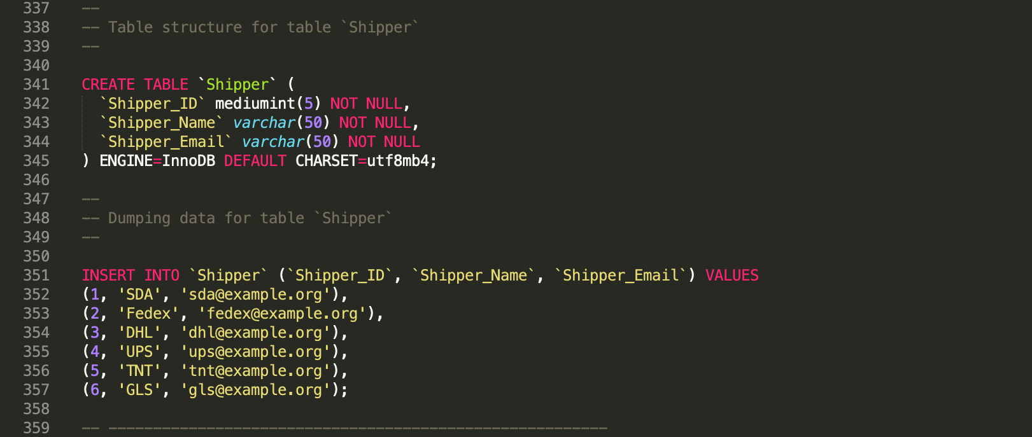

Figure 59: Details of the implementation of Shipper Table.

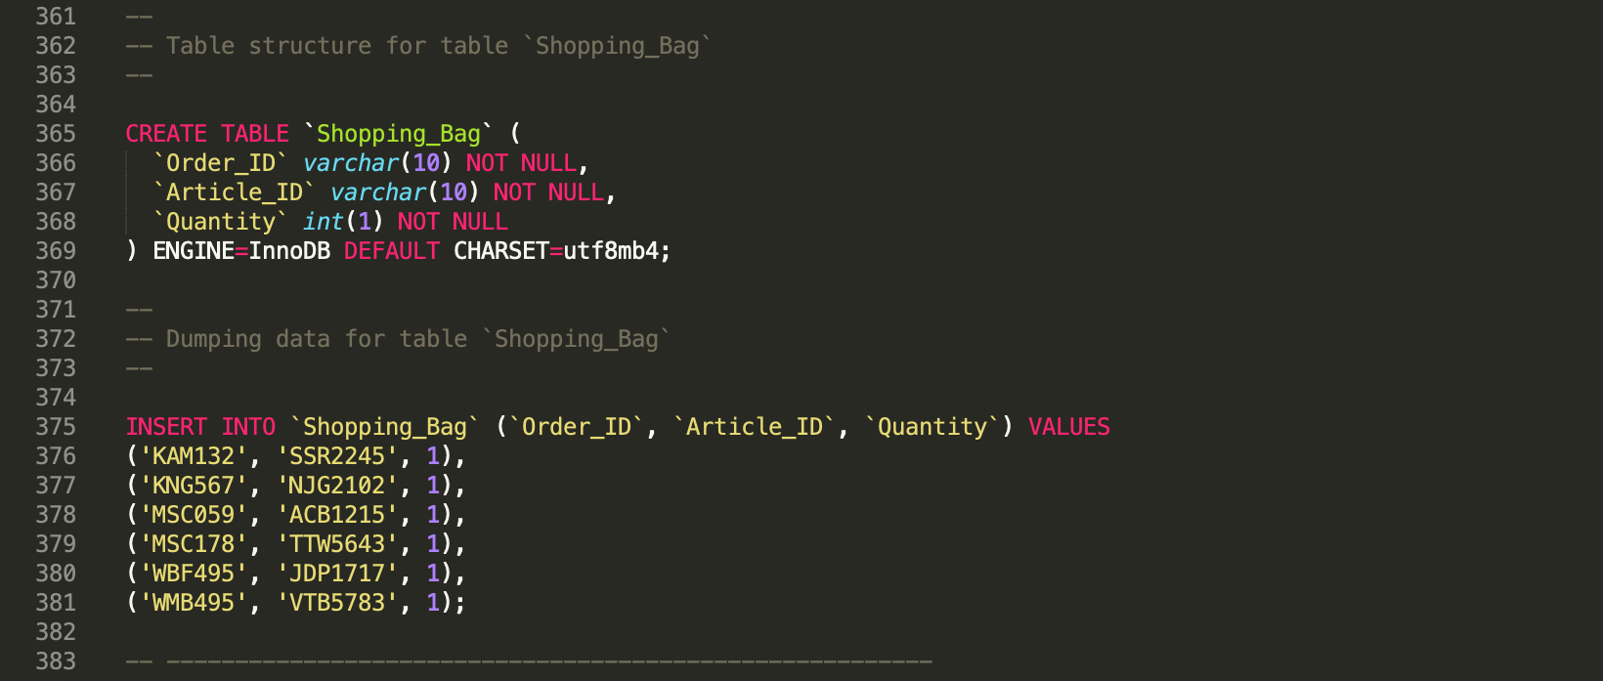

Figure 60: Details of the implementation of Shopping_Bag Table.

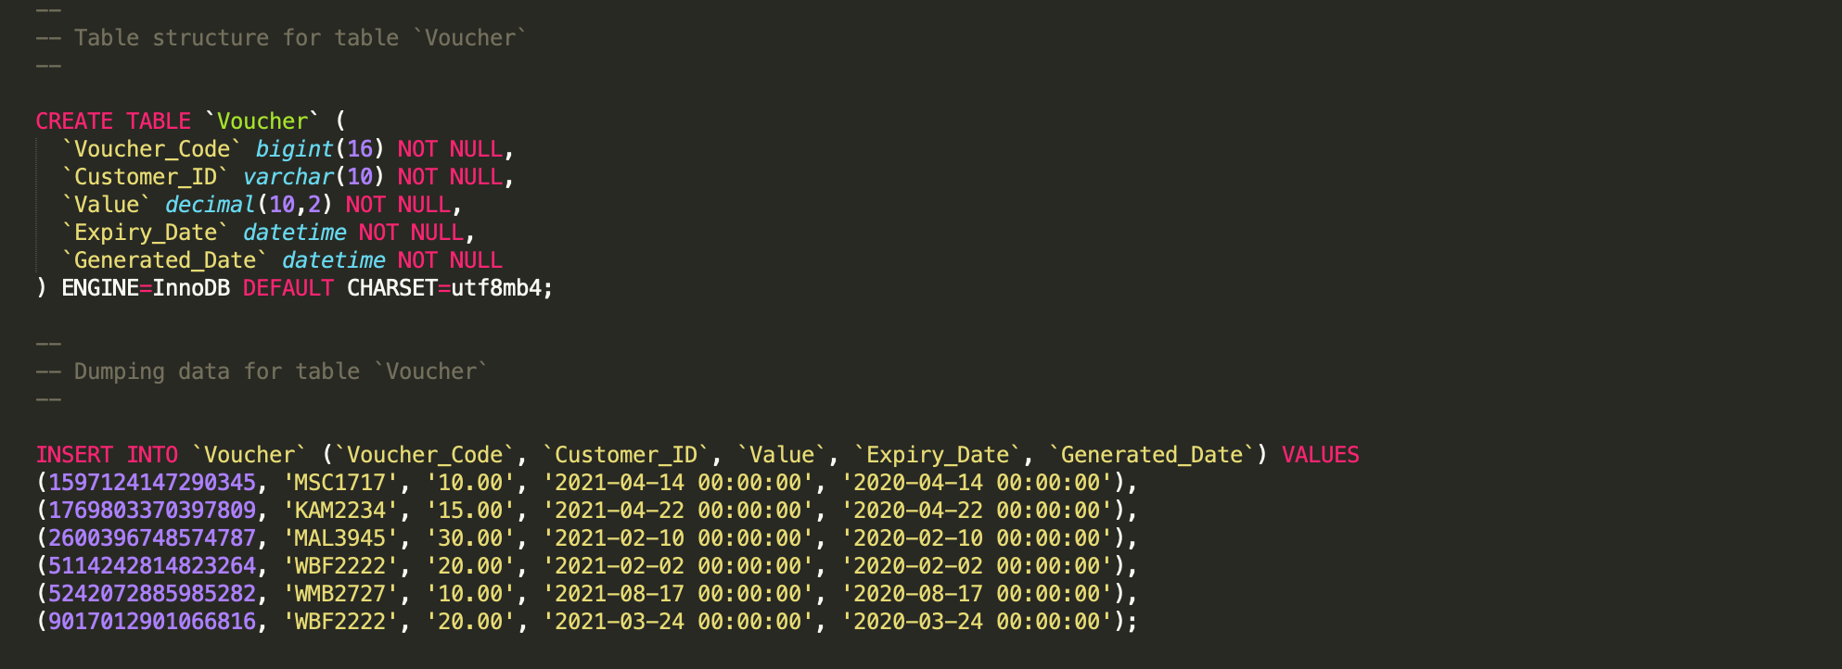

Figure 61: Details of the implementation of Voucher Table.

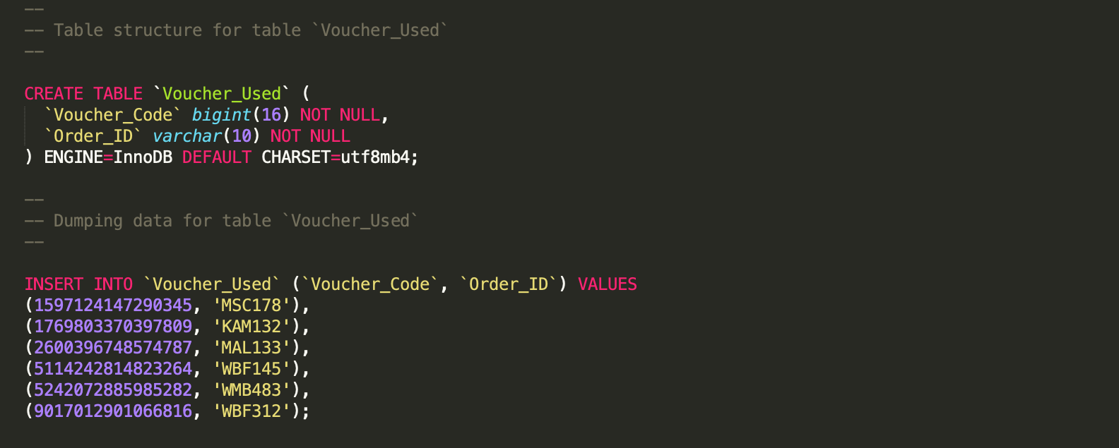

Figure 62: Details of the implementation of Voucher_Used Table.

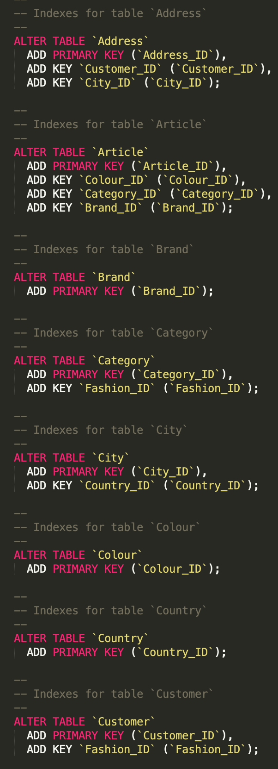

Figure 63: Details of the indexes.

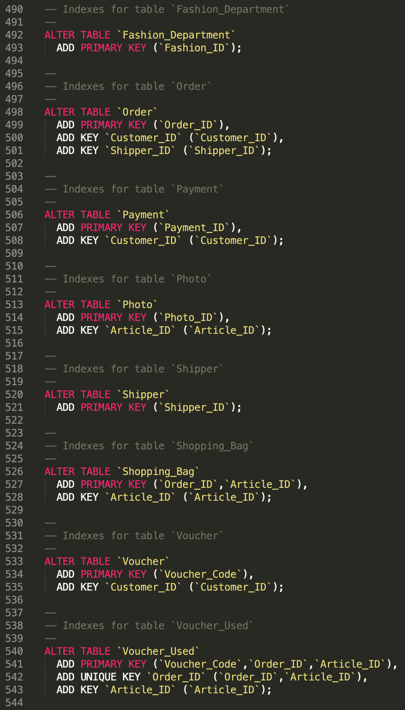

Figure 64: Details of the indexes.

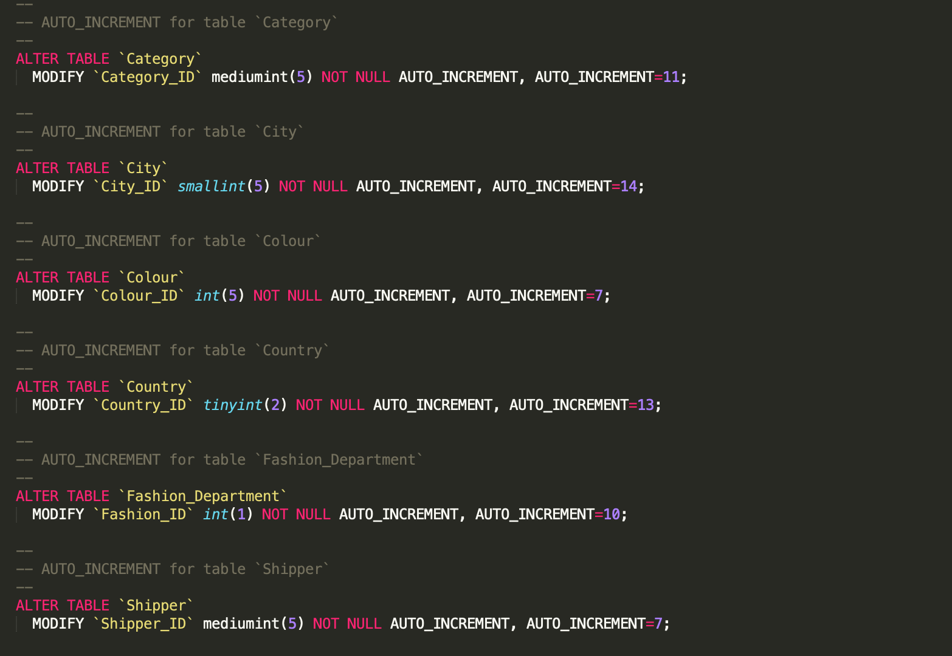

Figure 65: Details of auto increment.

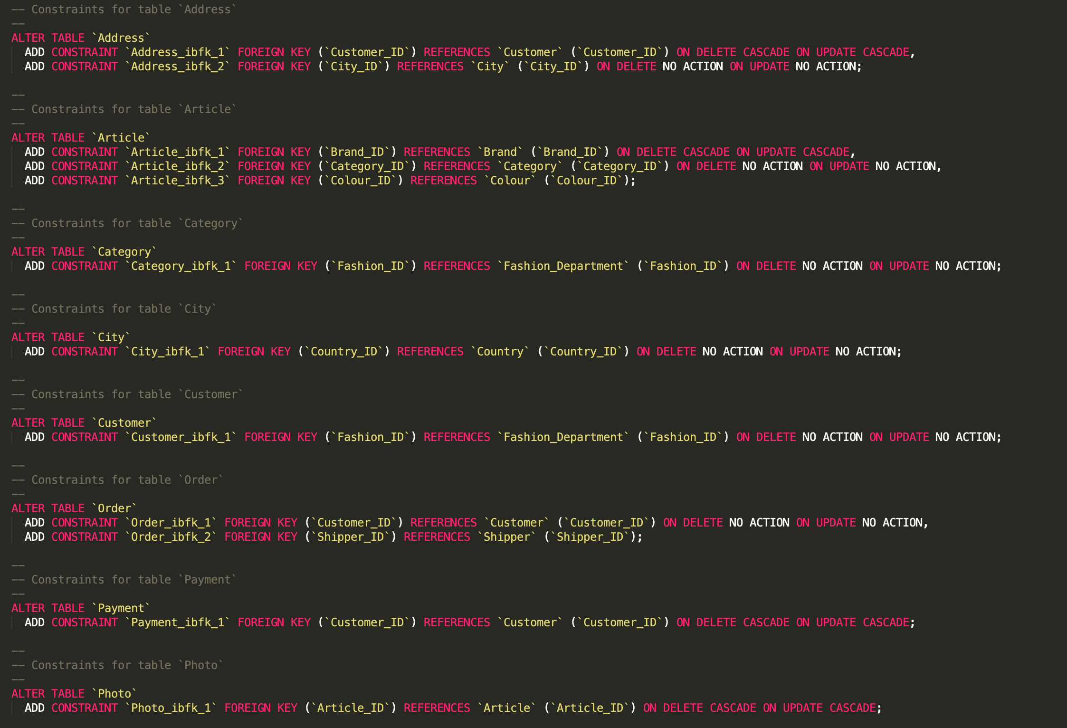

Figure 66: Details of the constraints.

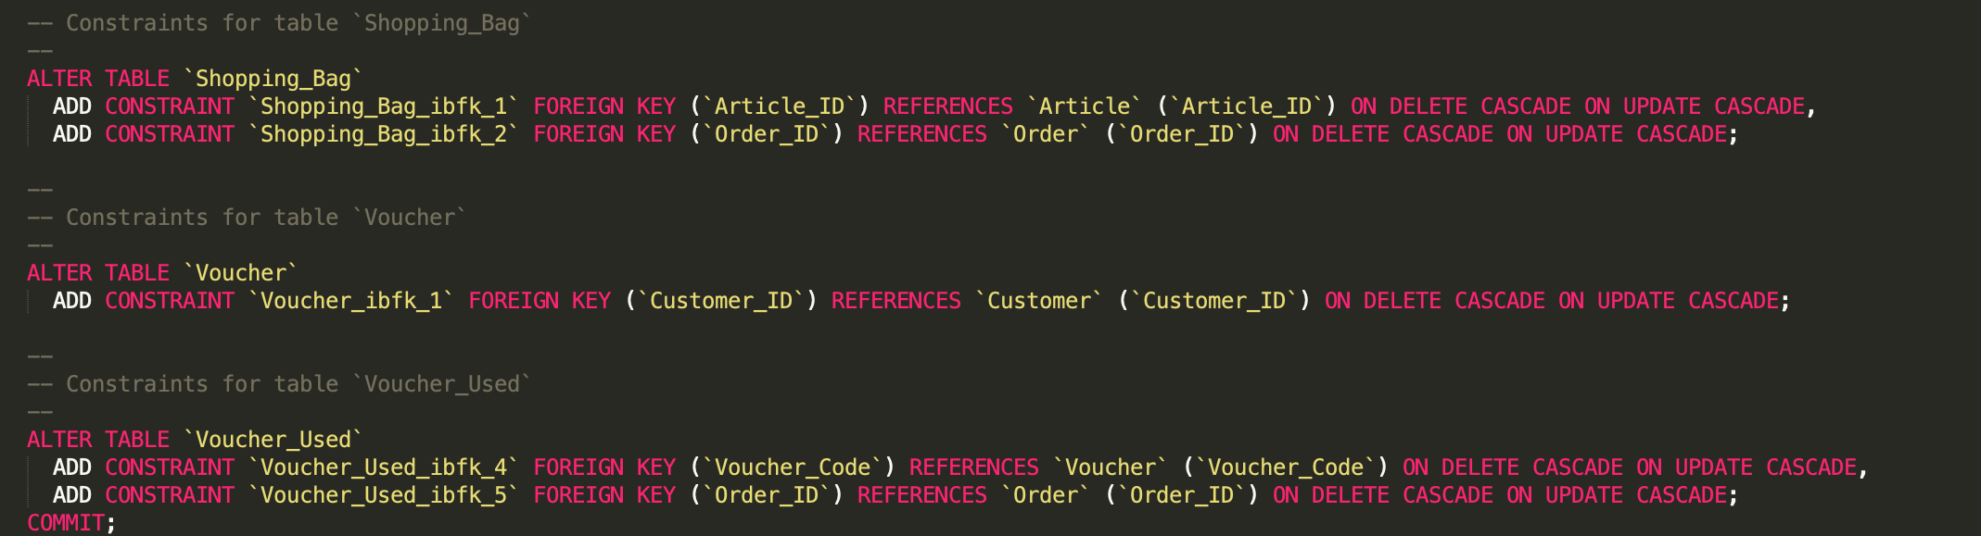

Figure 67: Details of the constraints.

# 4. SQL Queries

## 4.1 Query 1

### 4.1.1 Business Purpose of this Query

As a Product Analyst, I want to see the number of items sold per department so that I can establish the latest customer trends.

### 4.1.2 Query in natural language

Display the number of items sold per department.

### 4.1.3 SQL and output

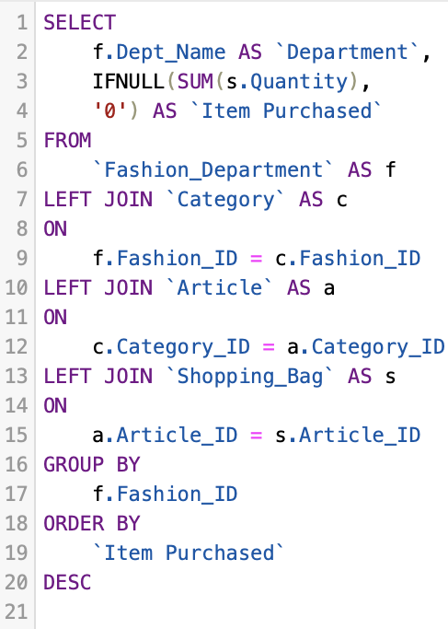 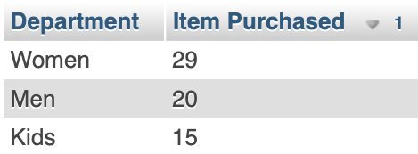

Figure 68: Query 1 SQL Code Figure 69: Query 1 Output

### 4.1.4 Explanation of the query output

The following query works as expected. In this respect, the number of items purchased is obtained by summing the quantity stored in the shopping bag table.

These values are then grouped by their fashion department and ordered in a descendent way so that it is easy to identify the best seller department.

## 4.2 Query 2

### **4.2.1 Business Purpose of this Query**

As a Product Brand Coordinator, I want to see the best-selling products per Brand so that I can contact the rep and let him know whether they should invest more on that product.

### **4.2.2 Query in natural language**

Display the top three articles sold by all the Brands

### **4.2.3 SQL and output**

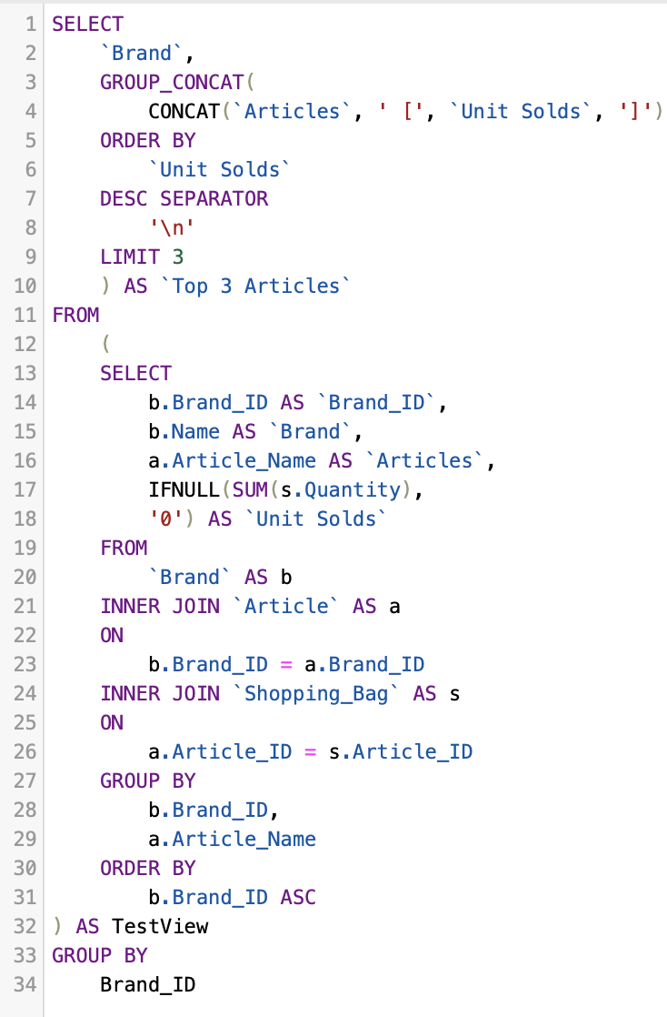 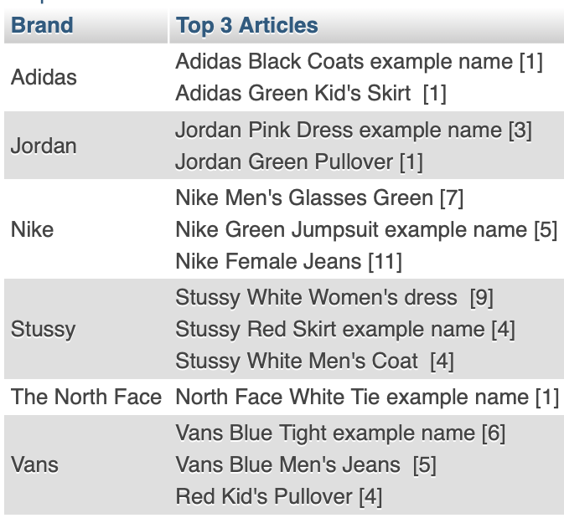

Figure 70: Query 2 SQL Code Figure 71: Query 2 Output

### **4.2.4 Explanation of the query output**

The following query produced output as expected, only the top three articles are selected out of all the available ones and then they are grouped by their Brand, whose are alphabetically ordered.

For better a comprehension, they are sorted by the number of units sold, whose value is represented next to the article’s name surrounded by square brackets.

## 4.3 Query 3

### **4.3.1 Business Purpose of this Query**

As a Brand Operational Strategist, I want to see in which Country a Brand sold more than three articles.

### **4.3.2 Query in natural language**

Displays the countries where a Brand sold more than three articles.

### **4.3.3 SQL and output**

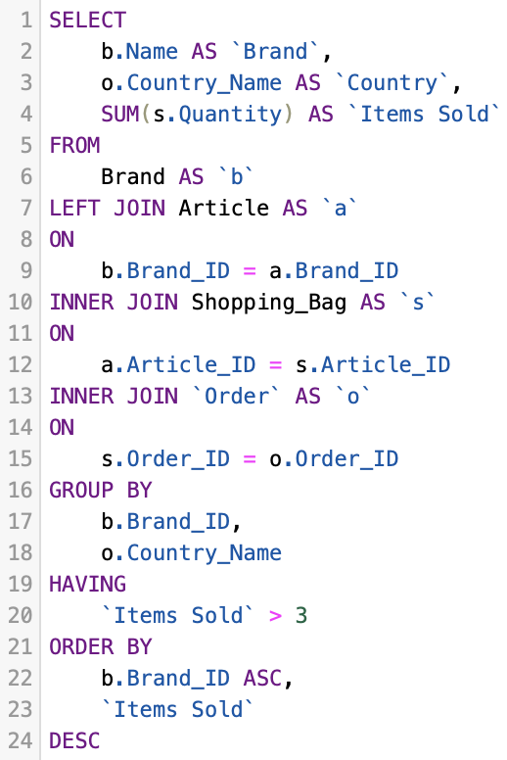 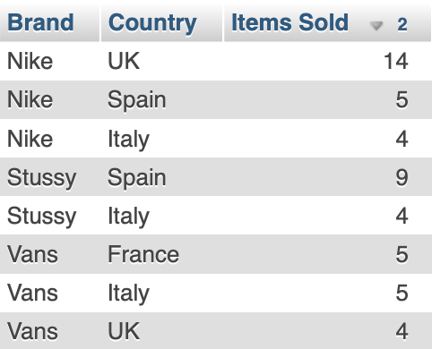

Figure 72: Query 3 SQL Code Figure 73: Query 3 Output

### 4.3.4 Explanation of the query output

Similarly Query 1, the number of items purchased is obtained by summing the quantity stored in the shopping bag table. Then, they are grouped by both their brand and the country from where they have been delivered. The articles are then filtered so that only those ones sold more than three times are displayed.

Finally, Brands are alphabetically ordered and their items are sorted in a descendent way.

## 4.4 Query 4

### **4.4.1 Business Purpose of this Query**

As a Customers Engagement Manager, I want to see the top three active users, who have placed more orders and send an email so that I can give them a special discount for their next order;

### **4.4.2 Query in natural language**

Display ID, Full Name, Email and Number of Orders of the top three active users.

### **4.4.3 SQL and output**

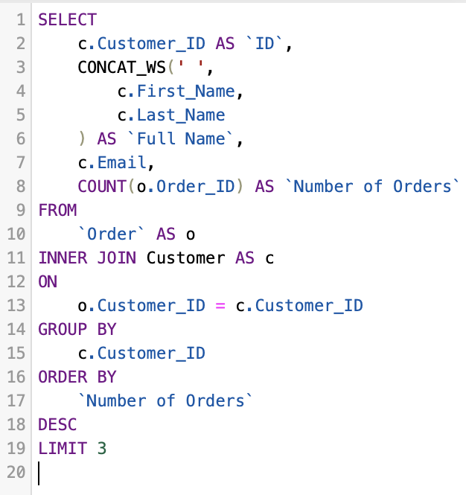

Figure 74: Query 4 SQL Code

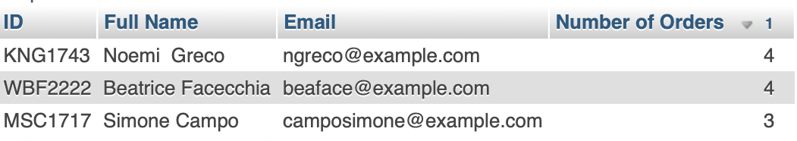

Figure 75: Query 4 Output

### **4.4.4 Explanation of the query output**

The following query counts all the orders placed by customers in the system and then it orders them in a descendent way. The list is then filtered such that only the first three rows are extracted showing then only the top three active users.

## 4.5 Query 5

### **4.5.1 Business Purpose of this Query**

As a Warehouse Coordinator, I want to contact all the customers who have an order ‘On Delivering’ via email to notify them about the shipment.

### **4.5.2 Query in natural language**

Display the Customers’ ID, Full Name and Email along with the Order IDs whose status is “On Delivering”.

### **4.5.3 SQL and output**

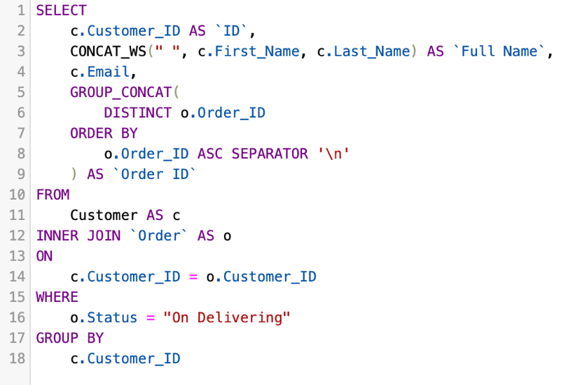

Figure 76: Query 5 SQL Code

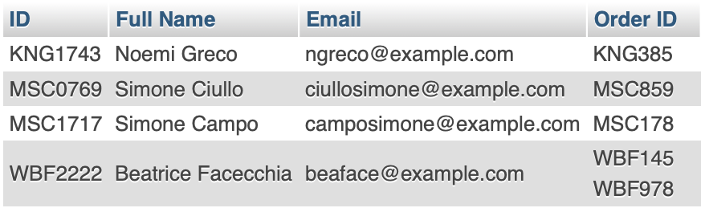

Figure 77: Query 5 Output

### **4.5.4 Explanation of the query output**

The query produced output as expected. In fact, the table below shows all the records form the order table. Only 5 of them have the status ‘On Delivering’.

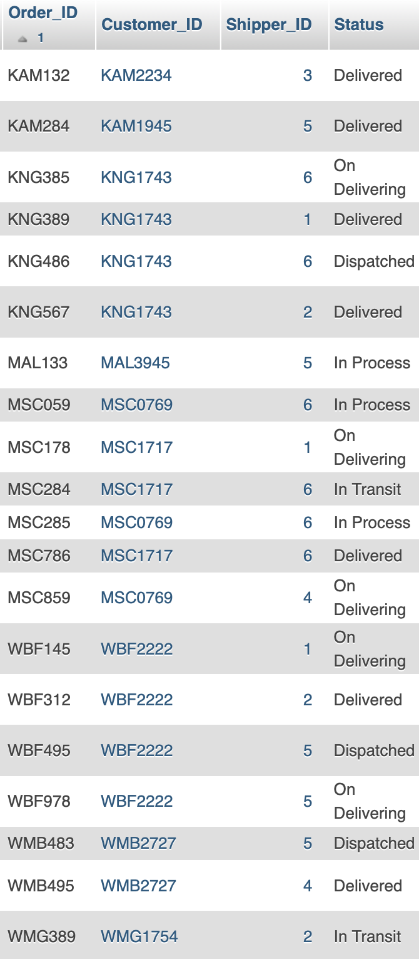

Figure 78: Query 5 Output proof

# Conclusion

In conclusion, the Author feels to have excellently met the learning outcomes defined in the database design and implementation module.

Designing a qualitative database and analysing an existing one in order to make improvements are skills that every good software and web developer should have. The author is proud to submit this piece of work, which was created with passion and intention to excel.

While browsing websites, the author now critically looks at their structures so to understand the inner working, trying to come up with creative solutions to eventual weaknesses.

# References

Ola Mazur, 2019. *A complete guidebook on online eCommerce marketplaces.* [online] Available At: <<https://divante.com/blog/a-complete-guidebook-on-online-ecommerce-marketplaces/>> [Accessed 1 December 2020].

Forbes, 2020. *Zalando*. [online] Available at: <<https://www.forbes.com/companies/zalando/#2c0443f3bc05>> [Accessed 15 October 2020].

SimilarWeb 2020. *Zalando.de Analytics – Market Share Data & Ranking*. [online] Available at: <<https://www.similarweb.com/website/zalando.de/#overview>> [Accessed 15 October 2020].

Forbes, 2020. *ASOS*. [online] Available at:

<<https://www.forbes.com/companies/asos/#1143756b3cb9/>> [Accessed 16 October 2020].

Tubga Sabanoglu, 2020. *ASOS – Statistics & Facts*. [online] Available at:

<<https://www.statista.com/topics/6330/asos/>> [Accessed 16 October 2020].

Martin Luenendonk, 2016. *Yoox | Understanding it’s history and uniqueness*. [online] Available at: <<https://www.cleverism.com/yoox-ecommerce-retailer/>> [Accessed 18 October 2020].

Guru99, 2020. *UML Association vs Aggregation vs Composition with EXAMPLE.* [online] Available at: <<https://www.guru99.com/association-aggregation-composition-difference.html>> [Accessed 2 November 2020].

Abhisheck Ahlawat, 2020. *Normalization of Database*. [online] Available at:

<<https://www.studytonight.com/dbms/database-normalization.php>> [Accessed 8 November 2020].

Connolly, T.M. Begg, C., 2015. Database Systems: practical approach to design, implementation, and management. [e-book] Sixth Edition, Global edition. ed. Harlow: Pearson Education Limited. Available through: Primo.

MariaDB Foundation, 2020. *MariaDB Server: The open source relational database.* [online] Available at: <<https://mariadb.org>> [Accessed 15 November 2020].